Gissel Reynoso
FAMU-FSU College of Engineering 2525 Pottsdamer St. Tallahassee, FL. 32310

Team 512: RE-RASSOR Shoulder Phase II
4/21/2023

Abstract
The purpose of the RE-RASSOR (Research and Education- Regolith Advanced Surface Systems Operations Robot) Project is to design an educational model of NASA’s RASSOR, introducing STEM concepts in middle and high schools. The RASSOR is a remote-controlled robot used on the moon to lift and transport large loads of rocky material in low gravity. The RE-RASSOR Shoulder Project focuses on creating a smaller scale model of the arm and shoulder. This educational model is 3D printable, affordable, and easy to reproduce. The goal of the arm and shoulder system is to lift 25 pounds. The project sponsor, the Florida Space Grant Consortium (FSGC), shares their existing 3D printable part files with the team. These files include the shoulder joint, shoulder blades, and arm. The team adds a motor and a gearbox system that fits within the shoulder joint. The motor, used to power the gearbox, moves based on computer code. The gearbox increases the torque that comes from the motor. This torque allows for the upward and downward motion of the arm so it can lift weight. Team members use Computer Aided Design (CAD) to model and test the parts within the gearbox. The engineers calculate the proper sizes for the gears and housing. Then, testing the motion of the gears takes place to make sure they turn easily. The team also tests the amount of force that the arm and shoulder can withstand, determining if the system can lift 25 pounds. Schools can easily reproduce this model using a 3D printer. The parts can print in classrooms using easy to access, readily available printing files. After the parts print, students can follow the simple instruction manual to assemble the RE-RASSOR model. Upon assembly, the educational model can lift up to 25 pounds. Showing how the RASSOR works gives students exposure to real life technology, inspiring these students to choose STEM related fields.
Keywords: 3D-printing, education, robot

Disclaimer
Not all parts were created by Team 512. The original gearbox part files were acquired from Phase I and modified. The Florida Space Grant Consortium provided the files [1] for the boom, knuckle, shoulder flange T-joint, shoulder blades, and chassis. The 3D printed bearing part file was retrieved from Daniel Amuedo [2], then modified to be compatible with the design.
Team 512, our sponsors, and our adviser assumes no responsibility or liability for any errors or omissions with the content of this project. The information contained within this evidence manual is provided on an "as is" basis with no guarantees of completeness, accuracy, or usefulness.

Acknowledgement
Our team would like to acknowledge the many advisors, professors and friends that helped us accomplish our goals. To begin we would like to thank Mr. Mike Conroy from the Florida Space Institute for his time and efforts to ensure our questions were answered and our needs met. Mike checked in on us along the way through bi-weekly meetings where we addressed any concerns.
Secondly, we would like to thank Dr. Carl Moore for being a great adviser. Through bi-weekly meetings, he was there to give us valuable insight and advice along the way. He helped us to foresee and address any potential issues before they would occur when creating our design.
We would also like to thank Dr. Patrick Hollis for being a subject matter expert that was always there to help address any issues or concerns we ran into with our gears, bearings, or CAD files. Dr. Hollis volunteered to meet with us, review our design, and provide us with his spur gear CAD files.
We would additionally like to extend our thanks to Dr. Shayne McConomy for the many hours of dedication to our project, presentations, and personal growth. Dr. McConomy is an outstanding Senior Design professor and puts in his best effort for his students. The Mechanical Engineering Senior Design Program truly would not be the same without him.
Lastly, we would like to thank the FAMU-FSU Mechanical Engineering Class of 2023 for helping throughout the process by giving fresh perspectives and unconditional support.

Table of Contents
Abstract ii
Disclaimer iv
Acknowledgement v
List of Tables xiv
List of Figures xv
Notation xvi
Chapter One: EML 4551C 1
1.1 Project Scope 1
1.2 Customer Needs 3
1.3 Functional Decomposition 7
1.4 Target Summary 13
1.5 Concept Generation 22
Concept 1. 24
Concept 2. 24
Concept 3. 24
Concept 4. 25
Concept 5. 25
Concept 6. 25
Concept 7. 25
Concept 8. 25
Concept 9. 26
Concept 10. 26
Concept 11. 26
Concept 12. 26
Concept 13. 26
Concept 14. 27
Concept 15. 27
Concept 16. 27
Concept 17. 27
Concept 18. 27
Concept 19. 28
Concept 20. 28
Concept 21. 28
Concept 22. 28
Concept 23. 28
Concept 24. 29
Concept 25. 29
Concept 26. 29
Concept 27. 29
Concept 28. 29
Concept 29. 30
Concept 30. 30
Concept 31. 30
Concept 32. 30
Concept 33. 30
Concept 34. 31
Concept 35. 31
Concept 36. 31
Concept 37. 31
Concept 38. 31
Concept 39. 32
Concept 40. 32
Concept 41. 32
Concept 42. 32
Concept 43. 32
Concept 44. 33
Concept 45. 33
Concept 46. 33
Concept 47. 33
Concept 48. 33
Concept 49. 34
Concept 50. 34
Concept 51. 34
Concept 52. 34
Concept 53. 34
Concept 54. 35
Concept 55. 35
Concept 56. 35
Concept 57. 35
Concept 58. 35
Concept 59. 36
Concept 60. 36
Concept 61. 36
Concept 62. 36
Concept 63. 36
Concept 64. 36
Concept 65. 37
Concept 66. 37
Concept 67. 37
Concept 68. 37
Concept 69. 37
Concept 70. 38
Concept 71. 38
Concept 72. 38
Concept 73. 38
Concept 74. 38
Concept 75. 39
Concept 76. 39
Concept 77. 39
Concept 78. 39
Concept 79. 39
Concept 80. 39
Concept 81. 40
Concept 82. 40
Concept 83. 40
Concept 84. 40
Concept 85. 40
Concept 86. 41
Concept 87. 41
Concept 88. 41
Concept 89. 41
Concept 90. 41
Concept 91. 41
Concept 92. 42
Concept 93. 42
Concept 94. 42
Concept 95. 42
Concept 96. 42
Concept 97. 42
Concept 98. 43
Concept 99. 43
Concept 100. 43
Medium Fidelity Concepts. 44
High Fidelity Concepts. 46
1.6 Concept Selection 49
1.8 Spring Project Plan 56
Chapter Two: EML 4552C 58
2.1 Spring Plan 58
Project Plan. 58
Build Plan. 58
2.2 Restated Project Definition and Scope 60
2.3 Results 61
2.4 Discussion 64
2.5 Conclusions 66
2.6 Future Work 68
Appendices 70
Appendix A: Code of Conduct 71
Appendix B: Functional Decomposition 78
Appendix C: Target Catalog 81
Appendix D: Concept Selection 85
Appendix E: Operations Manual 90
Component Description 92
​ 3D-Printed Components 92
Fastener Components 98
Electrical Components 100
Other Components 102
Wiring Diagram 105
Code for Arduino MEGA Microcontroller 106
Required Tools 107
Integration 108
3D-Printing Parts 108
Assembly 110
Operation 119
Troubleshooting 122
Appendix F: Engineering Drawings 124
Appendix G: Calculations 136
Appendix H: Risk Assessment 141
References 152

List of Tables
Table 1 Summary of interpreted needs from the customer………………………………..……………3
Table 2 Cross-reference table of the functions versus the systems…………………………….…….9
Table 3 Critical targets and metrics……………………………………………………………………..13
Table 4 Other targets and metrics……………………………………………………………………….22
Table 5 Morphological chart……………………………………………………………………………..23
Table 6 High fidelity and medium fidelity concepts…………………………………………………...43
Table 7 House of quality chart……………………………………...……………………………………50
Table 8 Pugh chart…………………………………………………………………………………………52
Table 9 AHP criteria comparison matrix……………………………………………………………….53
Table 20 Final rating matrix……………………………………………………………………………..54
Table 31 Spring project plan……………………………………………………………………………..56
Table 42 Data obtained from testing the gearbox at various speeds………………………………..61
Table 53 Data obtained from testing the arm with various weights………………………………...62
Table 64 Data obtained from testing the system……………………………………………………….63

List of Figures
Figure 1. Functional Decomposition Hierarchy Chart…………………………………………….8
Figure 2. A hybrid gearbox with deflection springs facing in opposite directions from one another……………………………………………………………………………………………47
Figure 3. A hybrid forward-reverse gearbox consisting of two stacked harmonic gearboxes with a sun gear and four planetary gears in mesh…………………………………………………….....48
Figure 4. A hybrid forward-reverse gearbox, which uses stacked harmonic and planetary gears with larger gear teeth……………………………………………………………………...……..49
Figure 5. Final Concept Selection – Concept 78 (Phase II Big Baseplate)…………...…………56
Figure 6. Cycloidal gearbox design……………………………………………………………...65
Figure 7. Cycloidal gearbox attached to the NEMA 23 motor…………………………………..66

Notation
3D | Three-Dimensional
ADC | Analog to Digital Converter
AHP | Analytical Hierarchy Process
BB | Bullet Ball
CAD | Computer Aided Design
FAMU | Florida Agricultural and Mechanical University
FSGC | Florida Space Grant Consortium
FSI | Florida Space Institute
FSU | Florida State University
NASA | National Aeronautics and Space Administration
NEMA | National Electrical Manufacturers Association
PLA | Polylactic Acid
PTC | Parametric Technology Corporation
RASSOR | Regolith Advanced Surface Systems Operations Robot
RE | Research and Education
STEM | Science, Technology, Engineering, and Mathematics
STL | Stereolithography
UCF | University of Central Florida

Chapter One: EML 4551C

1.1 Project Scope
Project Description.
Team 512’s senior design capstone project is to design a scaled down model of NASA’s Regolith Advanced Surface Systems Operations Robot (RASSOR) arm, for Research and Education (RE). The RASSOR arm is used to lift and transport heavy loads of regolith. The Phase II design will improve on RE-RASSOR Phase I by increasing the load capacity while decreasing the product weight, lowering costs, and providing a simple educational demonstration of how the RASSOR robot arm operates on the lunar surface.

Key Goals.
This project's primary objective is to enhance the RE-RASSOR Phase I Design and meet the requirements given by Team 512’s sponsor. The Phase II design must be straightforward and simple enough for educators to replicate. As a result, the final product must be entirely 3D printed using predominantly Polylactic Acid (PLA) material, a non-expensive thermoplastic. An additional goal for this project is to reduce the mass and cost of the product by using less material in the design, while keeping the lifting capacity of the arm intact. The arm must be able to lift 25 pounds, more than double the Phase I design. Another key goal is to avoid repeating the major issues that the previous team encountered: burning out the motors, gear teeth not meshing properly, and dynamic scaling issues. Team 512 will maintain the same harmonic planetary gearbox concept as Phase I, but change the individual gear designs.

Markets.
The primary markets that the RE-RASSOR Phase II project caters to are schools and other educational programs. This will be an inexpensive 3D printed model of a robotic arm utilized by schools to spark students’ interest in STEM. Our secondary markets include toy enthusiasts, hobbyists and families. These secondary markets can print and build the robot with the use of a simple 3D printer. Another secondary market is museums, such as the Kennedy Space Center Visitor Complex, who can print this project and display it to show current projects NASA is working on for a fraction of the price.

Assumptions.
For the purposes of the RE-RASSOR Phase II project, there are a number of assumptions that need to be made for the team to ensure a successful design. It is assumed that our primary markets will have access to 3D printers and compatible printing materials, along with other hardware components. The arm and shoulder will be connected in an affordable manner that is easily accessible to educators. In addition, it is assumed that the 25 pounds lifted by the arm is a concentrated weight.
The shoulder and arm are the only aspect of consideration in our design, not the remaining components of the robot. Furthermore, our design is an enhancement from Phase I, not a complete rebuild.

Stakeholders.
The stakeholders for this project include the sponsor Mike Conroy (Florida Space Grant Institute), the adviser Dr. Carl Moore (FAMU-FSU College of Engineering), and the senior design instructor Dr. Shayne McConomy (FAMU-FSU College of Engineering). Other stakeholders for this project are the Florida Space Grant Consortium (FSGC), the Florida Space Institute (FSI), the National Aeronautics and Space Administration (NASA), and educational facilities.

1.2 Customer Needs
To obtain the customer needs, Team 512 contacted the sponsor via Discord with a list of prepared project-related questions. These questions were selected to determine what the sponsor expected from our senior design project. It was determined that the most important customer needs are that the final product design will be inexpensive, durable, have a higher load capacity than Phase I, be compatible with the body, and be designed for educational use.
Below is a table that summarizes the questions that were posed to the sponsor, the statement that was given by the sponsor, and our team’s interpreted need. For the complete list of questions and customer statements, see Table A in the Appendix.

Table 7
Summary of interpreted needs from the customer.
Questions: | Customer Statements: | Interpreted Needs:
What are the requirements of the project? | The project requires heavy lifting capability from a gearbox made of entirely 3D printed parts. This is an educational model of NASA’s RASSOR, meant to be replicated at an inexpensive price. You will need a stepper motor, gearbox, 40-60 pounds of torque capability, reduction gears, and cheap bearings. | The product will lift a certain amount of weight and is entirely 3D printed. The product is inexpensive.
What is the goal of RE-RASSOR Phase II? | The goal of Phase II is to take the design from last year’s team and increase the weight carrying capabilities. | The product will lift a larger load than Phase I’s design, which had a lifting capability of 15 pounds.
What is our budget, and what is the ideal cost of the final product? | The final product should cost no more than $50 to reproduce, but the overall project budget is $909. | The product will be inexpensive.
What is the age limit? | It will be used by high school students and possibly middle school students. | Those in sixth grade and above will be assembling and operating the product.
What are the dimensions? | It can have an array of dimensions, as long as the final product can fit into the existing shoulder piece. The flange of the mating piece cannot be changed. | The product meets dimension requirements and will be compatible with the existing flange.
What is the expected range of motion of the arm? Are we holding the weight in place, once off the ground? | The arm should be able to move from a 0-degree angle to a 90-degree angle. The weight must be held in place once lifted off the ground. | The arm can lift the weight and hold it in place at various angles.
What is the biggest obstacle in this project? | In the past, the high amount of torque caused damage to the parts made of PLA. An excessive amount of force is used for having 3D printed parts. | The product design will withstand large forces and loads.
What were some undesirable aspects of Phase I? | Phase I had a 3D printed bearing that did not function to expectations. The bearing needs to be steel and needs to be inexpensive. Their gearbox would slip, and the gear teeth would not mesh properly. | Bearings will function smoothly.
What do we have to lift? | The arm will need to lift a concentrated weight of at least 25 pounds. | The arm will lift a concentrated mass of 25 pounds or more.
How long should the arm be? | The product should roughly be the size of your arm from elbow to wrist, about 12 inches. | The arm length resembles the length of the average person’s arm.

Inexpensive.
The final cost of the product is important because the product will be used for research and educational purposes in middle and high schools, where budgets may be limited. When the sponsor was asked about project budget and product cost, his response was, “the final product should cost no more than $50 to reproduce, but the overall project budget is $909.” Based on this response, it is interpreted that the final product will be inexpensive and affordable to the average user.

Durable.
After speaking to the sponsor, one can conclude the importance of durability. The team posed questions such as, “what are some undesirable aspects of Phase I?” and “what is the biggest obstacle in this project?” The sponsor’s need for durability and strength can be interpreted from his responses to these questions. He identified that the high torque and large load will cause excessive internal forces on the gears. These excessive forces may potentially damage parts made of PLA material. The sponsor also mentioned that the skipping of the gears in Phase I’s design and the use of plastic bearings were undesirable. From these statements, it is clear that the product be designed in such a way that it can withstand large torque, without damage. Where possible, the individual parts in the product will be made stronger, that way the completed assembly is able to withstand large wear.

Load Capacity.
When asked, “what is the goal of RE-RASSOR Phase II?” the sponsor stated that the product’s goal is to lift a load larger than Phase I’s design. Furthermore, when asked about lifting and range of motion requirements, the sponsor voiced a need for the arm to lift a concentrated mass and be able to hold it at various angles. From the sponsors response, it is vital that the arm has sufficient load capacity to lift the concentrated mass as the arm transitions up and down without jerking.

Compatible with the Body.
Upon completion of this project, the arm’s design will be compatible with the rover body. When asked about spatial dimensions, the sponsor stated that the arm, “can have an array of dimensions, as long as the final product can fit with the existing shoulder piece.” Thus, the product will be able to successfully attach to the shoulder of the rover body. When asked about length dimension requirements, the sponsor stated, “the product should roughly be the size of your arm from elbow to wrist.” Therefore, one can conclude that the arm length will resemble the length of an average person’s arm. The length of the arm will be proportional to the body so the robot can properly function.

Educational Use.
The end user of the product is important to take into consideration when designing the robotic arm. According to the sponsor, the final product, “is an educational model of NASA’s RASSOR,” with our primary market being high schools and middle schools. Therefore, the model is desired to be simple enough for an average student or teacher to be able to assemble. The final product will be user-friendly and operate in a way that resembles the function of NASA’s RASSOR.

1.3 Functional Decomposition
Explanation of Results.
With our customer needs in mind, a functional decomposition of the product was formed. Functional decomposition is critical to the design process, as it allows a complex system to be broken down into smaller parts and defines the functions that the final product will perform. A functional decomposition was necessary to design a scaled-down model of NASA’s RASSOR arm. The necessary information was gathered using statements from our sponsor, who expressed what he wants from the product and what he wants it to do. With the information given and through our interpreted needs, Team 512 began considering what functions our product will perform. Figure 1 shows the functional decomposition hierarchy chart that was obtained.

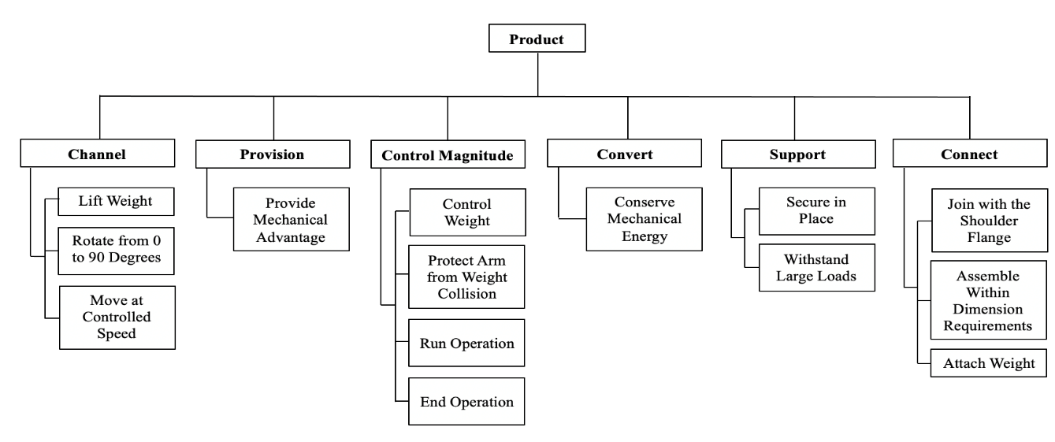
Figure 1. Functional Decomposition Hierarchy Chart.

In result, the systems derived were channel, provision, control magnitude, convert, support, and connect.
Channel and control magnitude are related as they are important for the product to be able to lift weight and protect the arm from collision. The arm’s motion relies on a signal to start and stop the operation. To prevent collision, the product must control the weight and rotate at a controlled speed. Support and connect also share a relationship, as it is necessary to join the arm to the shoulder flange within dimension requirements before the product is secured in place. The convert system shares relationships with nearly all the other systems, as the success of the product will be subject to the quality and functionality of the apparatus we implement to conserve mechanical energy. Table 2 below displays a cross-reference table that further illustrates how various functions relate to the various systems. If a function is required by a system, an X is placed in the corresponding box in the table.

Table 2
Cross-reference table of the functions versus the systems.
Functions | Systems
 | Channel | Provision | Control Magnitude | Convert | Support | Connect
Lift Weight | X | X |  | X |  | X
Rotate from 0 to 90 Degrees | X
Move at Controlled Speed | X |  | X
Control Weight | X | X | X | X | X | X
Protect Arm from Weight Collision | X |  | X |  | X | X
Run Operation | X | X | X | X
End Operation | X | X | X | X
Provide Mechanical Advantage | X | X | X | X
Conserve Mechanical Energy | X | X |  | X
Secure In Place |  |  |  |  | X | X
Withstand Large Loads |  | X |  | X | X
Join with the Shoulder Flange |  |  |  |  |  | X
Assemble Within Dimension Requirements |  |  |  |  |  | X
Attach Weight | X |  |  |  | X | X

The function that applies to the most systems is control weight. Therefore, when considering concepts, Team 512 must prioritize this function. To control weight, one must be able to attach weight to the arm, provide energy and convert it throughout the system, move weight, keep weight stable, and secure the product in place.

Connection to Systems.
As shown in Figure 1, the systems required are channel, provision, control magnitude, convert, support, and connect. The systems having the highest priority are channel, control magnitude, support, and connect. Each of these systems has a large impact on our project objectives, and the success of each of these systems will ultimately determine the success of our final product.
From the functional decomposition hierarchy chart, it is evident that the system with the most functions is channel. The functions within the channel system are related to the basic rotation and operation of the arm. Channel has three functions: lift weight, rotate arm 0 to 90 degrees, and move at a controlled speed. The channel functions suggest that when designing the product, it will be essential that the arm can lift weight while simultaneously rotating the arm up and down within the designated range.
The functions within the control magnitude system are responsible for the overall performance of the arm. These functions include controlling the weight, protecting the arm from weight collision, and starting or stopping the operation. This system describes the operation standards we have set for the arms movement. The support system includes securing the product in place and withstanding large loads. These two systems together determine how we are going to stabilize and secure our arm while it is being used. Being able to start and stop the arm while controlling the weight helps with the fluidity of the operation.
The connect system determines how the arm is going to be assembled. These functions include attaching the arm with the shoulder flange, remaining within dimension requirements, and attaching weight to the product. This system describes the design constraints we have when designing the arm. The system connect was determined to be an important system because the functions that fall under it are constraints determined by the current design of the RASSOR body. Being able to design our arm to attach within the required dimensions reduces the need to redesign the shoulder flange and parts that may connect.

Smart Integration.
Smart integration highlights functions with cross-system relationships. Referencing to Table 2, several of the functions for the product have these cross-system relationships, which can be ranked by functions with the lowest to the highest amount. The ranking of these functions is control weight, lift weight, protect arm from collision, run operation, end operation, provide mechanical advantage, conserve mechanical energy, withstand large loads, attach weight, move at controlled speed, secure in place, rotate from 0 to 90 degrees, join with the shoulder flange, and assemble within dimension requirements.
The opportunity for innovation in this product can be seen in the control weight and attach weight functions. These two could physically be combined in the design as something that will not only attach to some weight being lifted, but also stabilize it in place while the arm is in motion. Additionally, the run and end operation functions and the move at controlled speed functions can be combined and represented by some control mechanism that turns the arm on or off and allows one to moderate the speed of motion.

Action and Outcome.
From the interpreted needs and the functional decomposition hierarchy chart, it can be concluded that the final product will be secured in place. Once secured, the weight being lifted will be joint with the arm. The product will receive a signal to start, and the arm will lift some form of weight at a controlled speed, while simultaneously controlling it to avoid any collisions. The arm will rotate from 0 to 90 degrees until receiving a signal to stop the operation.

Function Resolution.
The most important function of the product is the need for it to lift weight. To accomplish this need, the product must be able to move in some capacity. To create a lifting motion, the arm will be able to rotate from the 0-degree position to the 90-degree position. A securing method will be utilized to hold the product in place during operation. In addition, the product will be able to attach some form of weight to be lifted.
The weight will be controlled to prevent the object from either colliding with the product or quickly dropping to the ground. The methods for operation of the product will be durable and controlled to prevent unintentional destruction of any product parts.
The product will have some form of signal to start and stop its movement. Its motion will utilize mechanical advantage to provide energy for the system. Once provided, energy cannot be created or destroyed. Therefore, the energy must be conserved throughout the system to continue motion. The motion will stop upon signaling.
The arm will comply with dimension requirements and fit together with the shoulder flange to perform the wholistic functions of the RE-RASSOR product. The arm will assemble within length requirements to remain proportional to the RE-RASSOR body.

1.4 Target Summary
It is critical to develop appropriate targets and metrics for the RE-RASSOR arm design to quantify the goals of our project. The metric is the dimension that will be evaluated for satisfaction, while the target is the value and unit that the design is intended to achieve. These figures define the constraints and limits that the final design must adhere to. The critical targets and metrics listed in Table 3 below are the most important. A satisfactory product created will be determined by if these critical targets and metrics are met.

Table 3
Critical targets and metrics.
Function: | Metric: | Target: | Description:
Lift Weight | Weight | 25 Pounds | The product will lift 25 pounds or more.
Provide Mechanical Advantage | Torque Ratio | 18:1 | The gearbox will provide a mechanical advantage to the system, with a torque ratio of 18 to 1.
Secure in Place | Displacement and Rotation | ≤ 0.5 Inches  ≤ 5 Degrees | The arm will be fastened to some sort of ground with the intention to remain in place during operation. It will not translate by more than 0.25 inches in either direction, totaling a linear range of 0.5 inches. It will not rotate more than 5 degrees.
Join with the Shoulder Flange | Diameter | 2.5 Inches | The arm will fit within the dimensions of the shoulder flange, with a diameter of about 2.5 inches.

A full list of the targets and metrics can be found in Table B in the appendix.

Lift Weight.
The lift weight function is part of channel, a significant system for the product. This function’s metric is weight, with a target of 25 pounds. To provide a test for this target, the user will place a scale under the weight that is being lifted. If the scale reads zero during operation of the arm, the weight has been successfully lifted. On the other hand, if the scale reads any number other than zero during the operation, then the target has not been met. The weight will be used as a target to meet the lifting requirement given to us by our sponsor. Our sponsor requested us to surpass the lifting capability of 15 pounds, demonstrated by the Phase I team.

Rotate from 0 to 90 Degrees.
Another function that is identified in the channel system is to rotate from 0 to 90 degrees. Along with being able to lift weight, the arm must also be able to rotate within the boundaries of our function. The metric for this function is angle because the arm needs to rotate about its shoulder joint to lift the weight, and the target is 90 degrees. The method of testing to verify that the arm has rotated 90 degrees will be a motion tracking software that can track the arm's motion during operation and check that it has the range of motion needed.

Move at Controlled Speed.
The third function that falls under the channel system is move at a controlled speed. During operation of the arm, the weight that is being lifted needs to be stable so that it does not collide with or detach from the arm. The metric for this function is angular velocity and the target is 4.5 degrees per second, as it moves from 0 to 90 degrees. To validate that the desired angular velocity is achieved, we can use a motion tracking software that tracks the arm’s motion while being operated. This target was calculated using the change in position of the arm, over the time we want it to travel. The change in position is from 0 to 90 degrees, and the desired time is 20 seconds.

Provide Mechanical Advantage.
Another system identified is provision, consisting of the function provide mechanical advantage. The product will need to provide a mechanical advantage that is able to supply enough torque to help meet the lifting requirement. The motor will not be able to supply enough torque alone, therefore it is necessary to create a system that increases the torque. The metric for this function is torque ratio. The NEMA 23 stepper motor has a torque range of 1.9 Newton-meters. Converting the output of 1.9 Newton-meters to foot-pound force yields a value of 0.738 foot-pound force. Dividing the 25 pounds mass by the minimum torque of the motor yields a required torque ratio of 18:1. This is the target for the function and the minimum torque required to successfully lift the weight.

Control Weight.
Within the control magnitude system of our functional decomposition hierarchy chart is the function control weight. The weight will need to be relatively stable during operation of the arm to prevent any collisions with the arm or other objects, and to keep the weight from being disconnected from the arm. The metric for this function is distance, in inches, from which the weight lifted can sway from its center axis of attachment. The target is for the weight to sway a maximum of 2 inches from this axis. Like several of our other targets and metrics, they can be validated using a motion tracking software to measure how far the weight sways during operation.

Protect Arm from Weight Collision.
To protect the arm from weight collision is another function in the control magnitude system. During operation, it is ideal that the weight does not collide with the arm as to prevent damage to the 3D-printed parts that will be used. Furthermore, if the weight were to collide with the arm, it can cause attachment problems and lead to the arm displacing its location with ground. The metric for this function is distance, in inches, which constrains the closest distance the weight can be with relation to the arm in the direction. The target is that the weight will remain greater than or equal to 12 inches, or one foot, away from the arm.

Run/End Operation.
Two other functions in control magnitude are to run and to end the operation. The Arduino we will be using has an operating voltage of 0 to 5 Volts. Since the Arduino is capable of outputting a maximum of 5 Volts, then during operation, a maximum of 5 Volts will be supplied; whereas when the arm is at rest, 0 Volts will be supplied. This supply of voltage is critical to our mission, as the voltage supplied from the Arduino will be what drives the motor to rotate, hence allowing the arm to move up and down, consequently causing the weight to be lifted. To validate that our Arduino can supply a maximum of 5 Volts and a minimum of 0 Volts, an Analog to Digital Converter (ADC) in short can be used. A potentiometer whose middle pin is connected on one of the channels can be used to simulate the varying voltage, and a code to read the values from the ADC and display them to the serial monitor can be written. With the ADC and potentiometer, the team can verify that the operating voltages required are met.

Conserve Mechanical Energy.
Conserving mechanical energy is the only function within the convert system. It is important that the mechanical energy provided by the gearbox is conserved throughout the system and not released into the environment. Mechanical energy is found through the addition of potential energy and rotational kinetic energy. The metric for this function is energy, with a target of 50 foot-pound force.

Secure In Place.
An important function, which is part of the support system, is secure in place. The arm must be securely fastened to meet the lifting criteria, execute the appropriate range of motion, and offer students a safe interactive learning paradigm; all of which are essential to the project’s success. The metric for this function is displacement and rotation, and the target is less than or equal to 0.5 linear inches and 5 rotational degrees. The base of the arm cannot move or rotate any farther than this in relation to the surface it is in contact with. The method of validation that will be used to verify our target will be tested the same way as for our other targets, which is by using a motion tracking software that will capture the product displacement and rotation at an angle above the arm.

Withstand Large Loads.
Within the support system is the function withstand large loads. For this function the metric is tensile strength, and the target is 7250 psi. The target was derived based on the ultimate tensile strength of PLA. Because this model is meant to lift a relatively heavy weight with weaker PLA material, it is important that the product can withstand large loads. Being able to withstand large loads will ensure that the product is able to retain its structural integrity while the load is being lifted, as well as ensuring that the 3D printed parts retain their shape and do not buckle, nor deform under any stresses and forces that they may experience during operation. Failure to do so could result in serious damage to our product, which may render it incapable of lifting such a weight. To validate this, our sponsor and adviser have recommended we create computer-based models and utilize features in PTC Creo to analyze the stresses that will be experienced under specified forces. Doing so will show us what geometries and configurations will best relieve stresses and distribute loads throughout the product. Furthermore, we can also individually test our PLA material by printing a rod and equipping it onto a tensile testing machine that consists of a load cell, crosshead, extensometer, specimen grips, electronics, and a drive system. Using this setup, we can plot the stress over strain for PLA and use the information obtained from the plot to help us better understand how to use the material effectively.

Join with the Shoulder Flange.
In the connect system is the join with shoulder flange function. As required by our sponsor, our design of the RE-RASSOR arm needs to be compatible with the shoulder flange so that the arm can be integrated with the rest of the RE-RASSOR body if needed. The dimensions of the shoulder flange are fixed and cannot be changed. This leads us to our metric, diameter, because the main dimension we are concerned with is the diameter of the shoulder flange. The target of this metric is 2.5 inches. We will validate that we have met our target and metric by assembling the parts together in Creo Parametric to make sure they are compatible with one another before they are 3D-printed. Once printed, we will use a set of calipers to verify compatibility and the 2.5 inch diameter.

Assemble Within Dimension Requirements.
The function of assemble within dimension requirements is a part of the connect system. Length was the chosen metric because the sponsor asked for the arm to be about the length of a human’s arm. The sponsor gave us a target of 12 inches. Assembling the arm to be this length is important because it will prevent the weight from colliding with the product. To ensure that this target is met, we can perform simple dimensional measurements using a ruler and/or tape measure. From end to end, the length of the arm can be measured and verified that it meets the target of 12 inches.

Attach Weight.
Attach weight is another function that falls within the connect system in the functional decomposition hierarchy chart. In order to lift weight, the arm must have the capability of attaching weight to it. The metric for this function is force and the target is 25 pounds. The point at where the weight will be attached needs to withstand a force of at least 25 pounds to meet the lifting requirements given to us by our sponsor. The method of validation for this target and metric will be finite elemental analysis, done in Creo Parametric to verify that the material used and the attachment design is strong enough to meet the target.

Critical Metrics and Targets.
There are four targets and metrics that must be met for this project to be successful, referred to as the critical targets and metrics. A weight of 25 pounds is a critical target and metric because the product must be able to lift this quantity as per our sponsor's given criteria. Additionally, if it cannot lift the required amount, it will not be a sufficient model for teaching students and other potential users about the capabilities of NASA's RASSOR arm. A torque ratio of 1881 for the gearbox is an important measure because it will provide the necessary mechanical advantage to the system for achieving the lifting requirement. As previously stated, if the lifting criterion is not met, we will not have satisfied the customer (our sponsor) needs, and therefore the product will not be a success. Another critical target and metric is to have a linear displacement of no more than 0.5 inches, and angular rotation of no more than 5 degrees about the center axis. As previously stated, if the product is not securely fixed to the ground, it will interfere with the product's ability to lift weight and move within its desired range of motion. Furthermore, because this product is primarily intended for research and education in middle and high schools, it is critical that it be securely grounded in order to provide a safe learning environment. Our final critical target and metric is to make the base diameter of the arm equivalent to 2.5 inches. It is essential that the arm properly connects to the shoulder joint, as this is a requirement from our sponsor, who would like the arm’s design to be easily integrated into the RE-RASSOR body.
Other Targets and Metrics.
In addition, there are targets and metrics that do not relate to the functional decomposition. The most important of the needs are shown below in Table 4, relating to simple operation, inexpensive, durability and size constraints. The product will be assembled and operated by everyday teachers and middle/high school students. Therefore, the assembly of the product should be simple to assemble by following a step-by-step operation manual. The metric used to describe simplicity of the design is time, in hours. The target is that the product should not take longer than 1 hour to assemble. In addition, the product should be inexpensive to replicate. A school should not have to invest a large amount of their funding into our educational model of NASA’s RASSOR. The metric used for cost is currency, in U.S. dollars. The target is for the replication cost of the PLA parts to be less than or equal to 50 U.S. dollars. Finally, the product needs to be durable, meaning it will withstand forces for a long time without significant deterioration. Since Team 512 is restrained to using PLA, and the durability of the material remains the same throughout, the metric used will be infill by percentage. The higher the percentage of infill, theoretically, the stronger the part. Keeping cost and material usage in mind, we want a durable part that still meets cost targets. The target is to aim for a consistent infill of 30 percent amongst the 3D-printed PLA parts. Finally, the entire mechanism Team 512 creates must fit inside the parameters of the given arm assembly. The volume for the shoulder T-joint plus the volume of the shoulder tube was calculated to be approximately 90 inches cubed. Therefore, the metric for the size of the gearbox is volume, and the target is for the volume to be less than 90 inches cubed.

Table 4
Other targets and metrics.
Category: | Metric: | Target: | Description:
Assembly | Time | < 1 Hour | The assembly of the product will take less than one hour.
Reproduction Expenses | Currency | ≤ 50 U.S. Dollars | The cost to reproduce the PLA aspects of the product will cost less than or equal to 50 U.S. dollars total.
Durable | Infill | ≤ 30 Percent | The PLA parts will be durable to withstand large loads. The infill of each 3D-printed part will be 30 percent or less.
Size of Gearbox | Volume | < 90 Inches³ | The entire gearbox must fit within the volume of the given shoulder joint and arm, combined is calculated to be a volume of 90 inches³.

The full list of other targets and metrics can be found in Table C in the appendix.

Benchmarking.
We will be basing this project primarily on the Phase I design, which had very similar goals and objectives to ours. The Phase I design could lift 15 pounds and was completely 3D printed with PLA and Nylon. In contrast to Phase I, we aim to lift 25 pounds and use only PLA for our 3D printed parts, keeping the product cost-effective.

1.5 Concept Generation
Several tools were used to generate 100 concepts for this project. The first approach, the Morphological Method, was used to generate our first 50 concepts. This method divides the overall design problem into simpler subproblems, generates concepts for each subproblem, and then systematically combines the various subproblem concepts into various complete solutions. Our three most important subproblems are the gearbox, the bearings, and the ground. Each subproblem has five concepts, except for ground, which has two. To organize the subproblems and concepts, a morphological chart was used, as shown below in Table 5.

Table 5
Morphological chart.

Gearbox | Bearings | Ground
Enhanced Phase I gearbox with four planetary gears | Flat Thrust Bearing | PLA chassis design that attaches to the sides of the shoulder
Forward and reverse hybrid gearbox | Standard Thin Ball Bearings
Cycloidal gearbox with bigger teeth | BB Ball Bearing | Phase I chassis that is bolted upwards through the sides of the shoulder
A worm gear inside the arm that interacts with gearbox in the shoulder | Rolling element ball bearing
Planetary gear box with larger teeth | Angular contact ball bearing

By systematically constructing various combinations with Table 5, Concepts 1-50 were created. Concepts 51 – 100 were created using other methods. One method that was used for our concept generation was biomimicry, which is a design process in which biological entities and processes are modeled. Concepts 52, 53, and 55 were all generated through biomimicry; the group took inspiration from an elephant’s trunk, the jaws of a leaf-cutter ant, and the arm of a human.
Another method that was used to generate concepts was through group brainstorming, in which the team gathered and proposed ideas in a series of brief brainstorming sessions. Thoughts and ideas were discussed among the group and then quickly jotted down. The team then took note of these thoughts and ideas in an online document. The complete list of concepts is briefly described below.

Concept 1.
Enhanced Phase I gearbox with four planetary gears and a PLA chassis design that attaches to the side of the shoulder.

Concept 2.
Enhanced Phase I gearbox with four planetary gears using a flat thrust bearing with a Phase I chassis that is bolted upwards through the sides of the shoulder.

Concept 3.
Enhanced Phase I gearbox with four planetary gears, standard thin ball bearings, and a PLA chassis that attaches to the shoulder's sides.

Concept 4.
Enhanced Phase I gearbox with four planetary gears and a standard thin ball bearing, with a Phase I chassis bolted upwards through the shoulder sides.

Concept 5.
Enhanced Phase I gearbox with four planetary gears and BB ball bearings, with a PLA chassis design that attaches to the sides of the shoulder.

Concept 6.
Enhanced Phase I gearbox with four planetary gears and BB ball bearings with a Phase I chassis that is bolted upwards through the sides of the shoulder.

Concept 7.
Enhanced Phase I gearbox with four planetary gears and rolling element ball bearing, with a PLA chassis design that attaches to the sides of the shoulder.

Concept 8.
Enhanced Phase I gearbox with four planetary gears and a rolling element ball bearing, with a Phase I chassis that is bolted upwards through the sides of the shoulder.

Concept 9.
Enhanced Phase I gearbox with four planetary gears using an angular contact ball bearing with a PLA chassis design that attaches to the sides of the shoulder.

Concept 10.
Enhanced Phase I gearbox with four planetary gears and an angular contact ball bearing with a Phase I chassis that is bolted upwards through the sides of the shoulder.

Concept 11.
Forward and reverse hybrid gearbox, flat thrust bearing, and PLA chassis design that attaches to the shoulder's sides.

Concept 12.
Forward and reverse hybrid gearbox using a flat thrust bearing with a Phase I chassis that is bolted upwards through the sides of the shoulder.

Concept 13.
Forward and reverse hybrid gearbox, standard thin ball bearings, and a PLA chassis design that attaches to the sides of the shoulder.

Concept 14.
Forward and reverse hybrid gearbox, standard thin ball bearings, and Phase I chassis that is bolted upwards through the sides of the shoulder.

Concept 15.
Forward and reverse hybrid gearbox, BB ball bearings, and PLA chassis design that attaches to the sides of the shoulder.

Concept 16.
Forward and reverse hybrid gearbox, BB ball bearings, and Phase I chassis that is bolted upwards through the sides of the shoulder.

Concept 17.
Forward and reverse hybrid gearbox using a rolling element ball bearing with a PLA chassis design that attaches to the sides of the shoulder.

Concept 18.
Forward and reverse hybrid gearbox using a rolling element ball bearing with a Phase I chassis that is bolted upwards through the sides of the shoulder.

Concept 19.
Forward and reverse hybrid gearbox using an angular contact ball bearing with a PLA chassis design that attaches to the sides of the shoulder.

Concept 20.
Forward and reverse hybrid gearbox using an angular contact ball bearing with a Phase I chassis that is bolted upwards through the sides of the shoulder.

Concept 21.
Cycloidal gearbox with bigger teeth using a flat thrust bearing with a PLA chassis design that attaches to the sides of the shoulder.

Concept 22.
Cycloidal gearbox with bigger teeth using a flat thrust bearing with a Phase I chassis that is bolted upwards through the sides of the shoulder.

Concept 23.
Cycloidal gearbox with bigger teeth using standard thin ball bearings with a PLA chassis design that attaches to the sides of the shoulder.

Concept 24.
Cycloidal gearbox with bigger teeth using standard thin ball bearings with a Phase I chassis that is bolted upwards through the sides of the shoulder.

Concept 25.
Cycloidal gearbox with bigger teeth using a BB ball bearing with a PLA chassis design that attaches to the sides of the shoulder.

Concept 26.
Cycloidal gearbox with bigger teeth using a BB ball bearing with a Phase I chassis that is bolted upwards through the sides of the shoulder.

Concept 27.
Cycloidal gearbox with bigger teeth using a rolling element ball bearing with a PLA chassis design that attaches to the sides of the shoulder.

Concept 28.
Cycloidal gearbox with bigger teeth using a rolling element ball bearing using a Phase I chassis that is bolted upwards through the sides of the shoulder.

Concept 29.
Cycloidal gearbox with bigger teeth using an angular contact ball bearing with PLA chassis design that attaches to the sides of the shoulder.

Concept 30.
Cycloidal gearbox with bigger teeth using an angular contact ball bearing with a Phase I chassis that is bolted upwards through the sides of the shoulder.

Concept 31.
A worm gear inside the arm that interacts with gearbox in the shoulder using a flat thrust bearing with a PLA chassis design that attaches to the sides of the shoulder.

Concept 32.
A worm gear inside the arm that interacts with gearbox in the shoulder using a flat thrust bearing with a Phase I chassis that is bolted upwards through the sides of the shoulder.

Concept 33.
A worm gear inside the arm that interacts with gearbox in the shoulder using standard thin ball bearings with a PLA chassis design that attaches to the sides of the shoulder.

Concept 34.
A worm gear inside the arm that interacts with gearbox in the shoulder using a standard thin ball bearings with a Phase I chassis that is bolted upwards through the sides of the shoulder.

Concept 35.
A worm gear inside the arm that interacts with gearbox in the shoulder using a BB ball bearing with a PLA chassis design that attaches to the sides of the shoulder.

Concept 36.
A worm gear inside the arm that interacts with gearbox in the shoulder using a BB ball bearing with a Phase I chassis that is bolted upwards through the sides of the shoulder.

Concept 37.
A worm gear inside the arm that interacts with gearbox in the shoulder using a rolling element ball bearing with a PLA chassis design that attaches to the sides of the shoulder.

Concept 38.
A worm gear inside the arm that interacts with gearbox in the shoulder using a rolling element ball bearing with a Phase I chassis that is bolted upwards through the sides of the shoulder.

Concept 39.
A worm gear inside the arm that interacts with gearbox in the shoulder using an angular contact ball bearing with a PLA chassis design that attaches to the sides of the shoulder.

Concept 40.
A worm gear inside the arm that interacts with gearbox in the shoulder using an angular contact ball bearing with a Phase I chassis that is bolted upwards through the sides of the shoulder.

Concept 41.
Planetary gear box with larger teeth using a flat thrust bearing with a PLA chassis design that attaches to the sides of the shoulder.

Concept 42.
Planetary gear box with larger teeth using a flat thrust bearing with a Phase I chassis that is bolted upwards through the sides of the shoulder.

Concept 43.
Planetary gear box with larger teeth using standard thin ball bearings with a PLA chassis design that attaches to the sides of the shoulder.

Concept 44.
Planetary gear box with larger teeth using a standard thin ball bearings with a Phase I chassis that is bolted upwards through the sides of the shoulder.

Concept 45.
Planetary gear box with larger teeth using a BB ball bearing with a PLA chassis design that attaches to the sides of the shoulder.

Concept 46.
Planetary gear box with larger teeth using a BB ball bearing with a Phase I chassis that is bolted upwards through the sides of the shoulder.

Concept 47.
Planetary gear box with larger teeth using a rolling element ball bearing with a PLA chassis design that attaches to the sides of the shoulder.

Concept 48.
Planetary gear box with larger teeth using a rolling element ball bearing with a Phase I chassis that is bolted upwards through the sides of the shoulder.

Concept 49.
Planetary gear box with larger teeth using an angular contact ball bearing with a PLA chassis design that attaches to the sides of the shoulder.

Concept 50.
Planetary gear box with larger teeth using an angular contact ball bearing with a Phase I chassis that is bolted upwards through the sides of the shoulder.

Concept 51.
A pendulum like object that swings and catches the weight off the ground, lifts it up and continues to swing it until the arm becomes an inverted pendulum.

Concept 52.
Arm with a clamp mechanism attached at the end that can grasp the weight, then lifts the weight up, like a leaf cutter ant.

Concept 53.
An arm that has a large range of motion which can go down, wrap around and hook the weight, then lift it up off the ground, like the trunk of an elephant.

Concept 54.
Suction cups will be attached to the chassis, which will then be suctioned to the table. The shoulder joint will encompass the motor and a gearbox.

Concept 55.
An arm that has three parts and three joints, resembling a human shoulder, bicep, arm, and hand with joints in between, that can lower, grab the weight, and then lift.

Concept 56.
An arm with a ray gun at the end that shoots energetic waves at the weight and causes the weight to levitate.

Concept 57.
A gearbox and motor combination that uses hydraulics in order to lift the weight up off the ground.

Concept 58.
A gearbox and motor combination that uses various spring forces in order to lift the weight up off the ground.

Concept 59.
A gearbox and motor combination that uses a spool of line, that way the weight can be lifted as the spool is spun, like a rod and reel/fishing pole.

Concept 60.
The shoulder joint will encompass a Konecranes gearbox, a cylindrical solid arm, and the knuckle attachment.

Concept 61.
The shoulder joint will encompass a two-phase planetary gear box, with a truss like arm.

Concept 62.
An arm with a claw like attachment at the end that can be released and dropped, after which it can grasp the weight, then pick it up off the ground, like a claw vending machine.

Concept 63.
An arm that is made of trusses and has a hook at the end of the arm that can drop down to the weight, be rigged to the weight, and then lifted, like a construction crane.

Concept 64.
The arm will have magnetic E-brake that engages with the gear box to prevent the arm from moving when its motion pauses.

Concept 65.
The shoulder joint will attach to a triangular truss beam with a hook like and to attach the weight.

Concept 66.
The shoulder joint will contain a harmonic gearbox, with BB bearings, and a truss like arm.

Concept 67.
An arm that is made of trusses and has a large powerful magnet at the end of the arm that can drop down to the weight, attract the weight, and then lift, like a salvage yard crane.

Concept 68.
Hybrid gear box, of harmonic and planetary gears, with flat thrust bearings, and a cylindrical hollow arm.

Concept 69.
An arm that utilizes two gearboxes and two motors at two different joints, that way there is an increase in load capacity.

Concept 70.
An elevator like housing that holds the weight and can be lifted up and down using the gearbox and motor combination.

Concept 71.
An arm like Phase I except that it uses standard electrical hardware like a switch instead of an Arduino.

Concept 72.
An arm like Phase I except that it uses parts that are made from Nylon in order to have more flexibility.

Concept 73.
An arm like Phase I except that it uses parts that are made out of carbon fiber in order to have more strength and be lightweight.

Concept 74.
An arm like Phase I, except that the whole assembly is screwed into a large baseplate, which is then clamped down to a table.

Concept 75.
An arm, gearbox, and motor combination that utilizes 3D-printed bearings instead of metal ones that are purchased off the shelf.

Concept 76.
An arm, gearbox, and motor combination that operates using a series of LEDs and light sensors to know when to lift and lower the weight.

Concept 77.
Instead of the arm rotating about a pivot point it will lift the weight in an elevator like fashion.

Concept 78.
Forward and reverse hybrid gearbox, containing four planetary gears, with a standard thin ball bearing, which is attached to a weighted box, with the entire system being grounded to a large baseplate.

Concept 79.
The arm will be made of wood in a truss like fashion and it will have a wooden gearbox.

Concept 80.
The arm will lift the weight by being winded up by the user like an old car window.

Concept 81.
The arm will be completely solid with small channels to allow wires to pass through, and it will be 3D printed out of PLA.

Concept 82.
The arm will be an open four bar linkage.

Concept 83.
The gearbox with be an enhancement of Phase I with four planetary gears instead of three, and it will have the forward and backward capability. The bearing will be BB ball bearing with indentations in the shoulder to hold them, and the chassis will be redesigned to attach higher up on the shoulder instead of the base.

Concept 84.
The gearbox will be the same format as Phase I but with bigger teeth, three planetary gears, with a standard thin ball bearing, it will be double stacked to have to have forward and backward motion.

Concept 85.
We will have a mechanism attached to the shoulder joint that will rise up and down to lift the arm, which will then lift the weight.

Concept 86.
Wire will be attached to the arm and then the wire will be attached to an object and a rail that slides back and forth to move the arm up and down.

Concept 87.
A high torque right angle gearbox will be used to lift the weight.

Concept 88.
The end of the arm will have a wire that winds down to the weight, once the weight is attached, the wire will wind back up and the arm will begin rotating about the shoulder.

Concept 89.
The end of the arm will have disk that has wire or rope that can be winded up or down to better help the arm lift the weight.

Concept 90.
The arm will be short and the attachment at the end of the arm will be large in comparison to better handle stress.

Concept 91.
We will use a strong enough motor to where a gearbox is not required.

Concept 92.
The arm will use a continuous variable transmission gearbox.

Concept 93.
The arm will have a gear box that consists of one large planetary gear and a harmonic gear that work to lift the weight and they will be printed out of Nylon.

Concept 94.
The arm will have a pulley system instead of a gearbox, and it will be printed out of PLA.

Concept 95.
The arm will be the same design as Phase I, but it will be printed out of Nylon.

Concept 96.
The cylindrical hollow arm will be attached to a metal chassis that is then grounded to a table.

Concept 97.
The arm will be pyramid shaped with a hook at the end of it to attach the weight, the gear box will be the same as Phase I.

Concept 98.
The shoulder will contain a dual clutch gearbox, with a solid cylindrical arm.

Concept 99.
The shoulder will contain the Phase I gearbox, with an additional worm gear in the arm to make the arm go forwards and backwards, and to prevent back drive.

Concept 100.
The shoulder joint will hold an oscillatory gearbox, with a rolling element bearing, and a square arm that attaches to the shoulder.

After careful analysis, review, and consideration, eight of our one hundred concepts were selected to be further evaluated. Five of them have a medium level of fidelity, while three have a high level of fidelity. For ease of review, these concepts are tabulated below in Table 6.

Table 6
High fidelity and medium fidelity concepts.

Concept | Description | Fidelity
14 | Forward and reverse hybrid gearbox, standard thin ball bearings, and Phase I chassis that is bolted upwards through the sides of the shoulder. | High
78 | Forward and reverse hybrid gearbox, containing four planetary gears, with a standard thin ball bearing, which is attached to a weighted box, with the entire system being grounded to a large baseplate. | High
84 | The gearbox will be the same format as Phase I but with bigger teeth, three planetary gears, with a standard thin ball bearing, it will be double stacked to have to have forward and backward motion | High
2 | Enhanced Phase I gearbox with four planetary gears using a flat thrust bearing with a Phase I chassis that is bolted upwards through the sides of the shoulder. | Medium
11 | Forward and reverse hybrid gearbox, flat thrust bearing, and PLA chassis design that attaches to the shoulder's sides. | Medium
23 | Cycloidal gearbox with bigger teeth using standard thin ball bearings with a PLA chassis design that attaches to the sides of the shoulder. | Medium
65 | The shoulder joint will attach to a triangular truss beam with a hook like and to attach the weight. | Medium
74 | An arm similar to Phase I, except that the whole assembly is screwed into a large baseplate, which is then clamped down to a table | Medium

Medium Fidelity Concepts.
Concept 2 is a medium fidelity concept, and it follows a similar design to Phase I; however, it utilizes four planetary gears instead of three. Furthermore, instead of BBs, a flat thrust bearing will be utilized, and the chassis will be bolted upwards through the sides of the shoulder, rather than horizontally through the small protruding pieces that secure the shoulder blades to the body. Increasing the number of gears used in the gearbox was recommended to us by the Phase I adviser, in order to provide more load capacity. Furthermore, having the bolt vertically inserted into the shoulder will create a stronger connection, while the flat thrusted bearings will be an inexpensive and convenient alternative to the BBs.
Concept 11 is a medium fidelity concept. It uses a forward and reverse hybrid gearbox, flat thrust bearings, and a PLA chassis design that attaches to the shoulder's sides. This type of gearbox is attractive as the opposing direction of the flex pieces will allow a snug compression on the gears as they rotate in the forward and reverse direction, which would help prevent teeth from skipping. A chassis design that attaches to the shoulders sides is also seen as an alternative to grounding the whole product which provides better load capacity coupled with better range of motion. As stated previously, flat thrust bearings would be a reliable option that would work for our application.
Concept 23 is also a medium fidelity concept, consisting of a cycloidal gearbox with bigger teeth, standard thin ball bearings, and a PLA chassis design that attaches to the sides of the shoulder. Having bigger teeth was a recommendation given to us by the Phase I adviser, as it would help prevent teeth from skipping as well as distributing loads better. Additionally, the advantage of thin ball bearings is their size; a thinner bearing is nice in this application since we are tightly constrained in our dimensions for the gearbox.
Concept 65 is another medium fidelity concept, which is essentially a triangular truss beam attached to the shoulder that has a hook like attachment at the end to grab the weight. This concept takes inspiration from a construction crane, which can lift incredibly large loads. The truss like structure is thought to increase strength by distributing loads and stresses better while decreasing the amount of material used. The hook attachment at the end could be a more ergonomic way of lifting the weight, which could make the process of getting the weight up off the ground easier.
Concept 74 is the last medium fidelity concept. It would have an assembly like Phase I; however, it improves the design by incorporating a large baseplate. A fault that was observed in the design was a poor, weak, flimsy baseplate that held everything together. With a large baseplate where the assembly is screwed into it, we can ensure that the product has a strong foundation to rely on, while increasing the clamping capability of the base to prevent the assembly from tipping while lifting the weight off the ground.

High Fidelity Concepts.
Concepts 14, 78, and 84 were the top three high fidelity concepts we found. In Concept 14, a forward and backward hybrid gearbox made of two stacked harmonic gears with deflection springs facing in opposite directions from one another will be used to move the arm up and down. The opposing splines will ensure that the three planetary gears and the corresponding sun gear, located inside the harmonic gears, remain snug in place. The significant difference between this gearbox design and Phase I's design is how it considers the arm's ability to rotate about its fixed point both forwards and backwards. Standard thin ball bearings will be housed in the shoulder, and the chassis will be bolted up into the shoulder. Both additions would be large enhancements to the Phase I design.
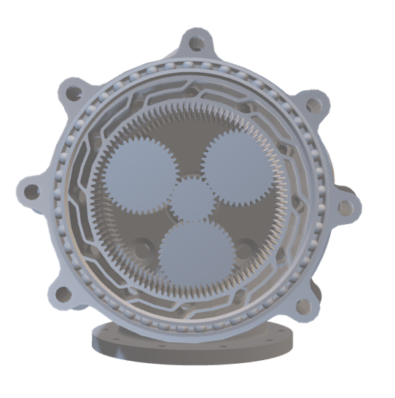
Figure 2. A hybrid gearbox with deflection springs facing in opposite directions from one another.

A hybrid forward-reverse gearbox is part of Concept 78. This will consist of two stacked harmonic gearboxes with a sun gear and four planetary gears in mesh. Four planetary gears will increase torque output while reducing the opportunity for teeth to slip. A stacked gearbox makes it less likely for teeth to drop out of place and prevents the arm from falling from weight without the motor going in reverse. The design will also encompass standard thin ball bearings, which are inexpensive and reduce friction at the shoulder joint. Furthermore, the chassis will be loaded with weights and fastened to a board with bolts to prevent the entire product from tipping or tumbling off the table. It will be secured to the table with various clamps. This concept capitalizes on several issues that were observed in the Phase I design.

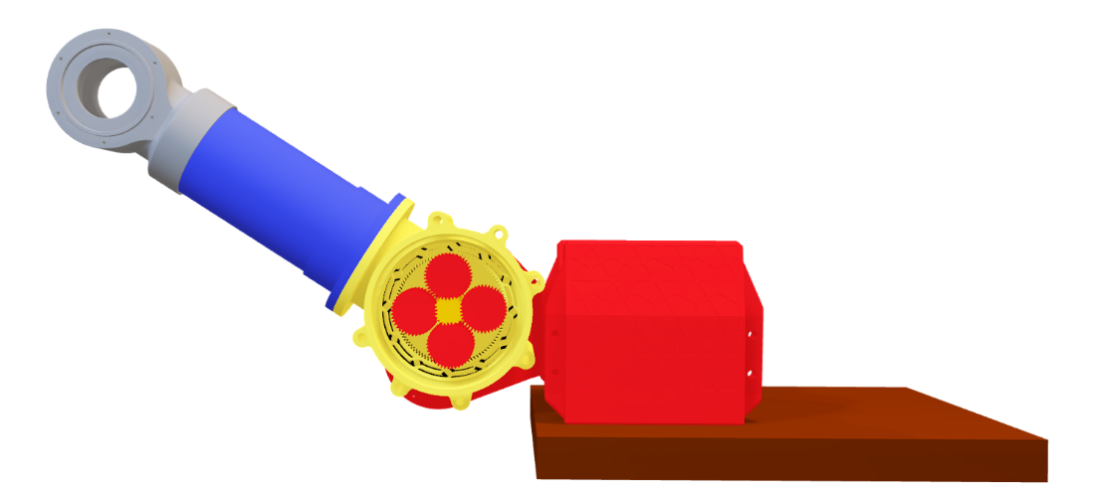Figure 3. A hybrid forward-reverse gearbox consisting of two stacked harmonic gearboxes with a sun gear and four planetary gears in mesh.

A hybrid forward-reverse gearbox, which uses stacked harmonic and planetary gears, will be used in Concept 84. To get a better printed tooth profile from the 3D printers, the gear teeth for this design will be enlarged. Larger teeth would be better than smaller teeth in this application because it is very difficult to print precise tolerances for small teeth. This error would interfere with the ability to mesh properly and increase the likelihood of slipping. The bearing used will be a standard thin ball bearing, which is inexpensive and ideal for our project.

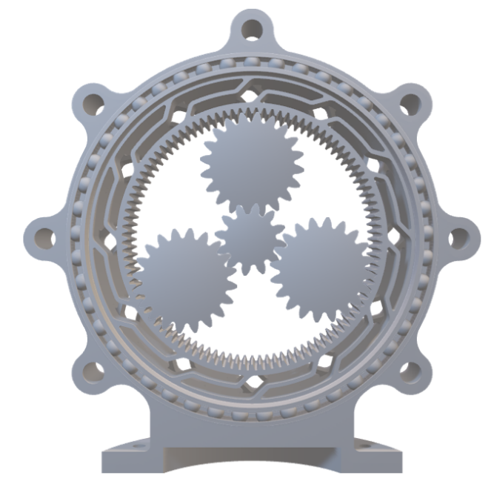
Figure 4. A hybrid forward-reverse gearbox, which uses stacked harmonic and planetary gears with larger gear teeth.

1.6 Concept Selection
House of Quality.
The concept selection process began with a House of Quality chart. Based on our interpreted customer needs, requirements were deduced and simplified, which were tabulated in rows. These requirements included: lightweight, high load capacity, easy to reproduce, durable, body compatibility, range of motion, and efficient bearings. The engineering characteristics, which are derivatives of our targets and metrics, were then tabulated in columns against these requirements. The engineering characteristics included: increasing the load capacity, load distribution, range of rotation, mechanical advantage, ease of assembly, and control of the weight- while decreasing the rotational speed and volume of material. Additionally, an engineering characteristic we considered was keeping the mechanical energy the same: in other words, conserving the energy.
In order to rank the importance of these engineering characteristics, a score of 1, 3, or 9 was used. This exaggerated range allowed us to more easily define the importance of our characteristics. From our table, it was found that the ranking of importance from greatest to least was as follows: increasing the load capacity, increasing the load distribution, conserving the mechanical energy, increasing the mechanical advantage, increasing the range of rotation, increasing the weight control, decreasing the rotational speed, increasing the ease of assembly, and decreasing the volume of material. The House of Quality chart is shown in Table 7 below.

Table 7
House of quality chart.
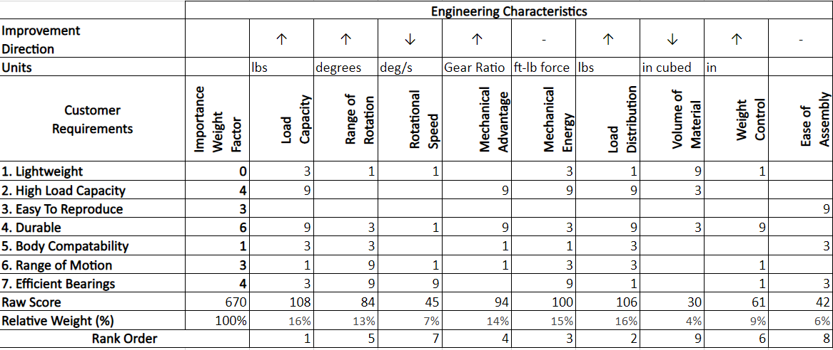
Using this House of Quality chart, our most important engineering characteristics were selected and used to make our Pugh chart. We chose to take the top five engineering characteristics and drop the others from further consideration, as the top five were deemed the most important. In addition, the remaining engineering characteristics, while still valuable, were not critical to the ultimate success of our product. The bottom four engineering characteristics all had a relative weight under 10%. For this reason, they were dropped and not included in our Pugh chart.

Pugh Chart.
While there were a multitude of good ideas for our project, ultimately there can only be one design. To help us narrow down our ideas and select a design, a Pugh chart was constructed. Our medium and high fidelity concepts were compared with one another, and all were compared against a datum. The datum we selected for the Pugh chart was the Phase I arm and shoulder: the predecessor and original design for the RE-RASSOR. The concepts included for comparison were Concept 14, Concept 78, Concept 84, Concept 2, Concept 11, Concept 23, and Concept 65. These concepts remained unnamed and instead were described by their respective numbers for simplicity purposes. The selection criteria used included: load capacity, load distribution, mechanical energy, mechanical advantage, and range of rotation.
Upon careful consideration of each design, it was deduced that the design with the greatest number of pluses against the datum were Concept 78 and Concept 84- both of which were tied with four pluses. The remaining designs fell just short in comparison, with many of them coming in with two or one plus. However, the concept with the least number of plusses was Concept 65, coming in with zero plusses.
Across the board, all the concepts tallied up just one minus. However, the concept with the greatest number of similarities was Concept 65, with a total of four. While in theory the truss design was an innovative idea that uses less material and distributes loads well, the design is similar in every selection criteria category compared to our datum. Because of this, we will not be moving forward with this design, as we want our product to be an enhancement to Phase I- not just a different method of reaching the previous goal.
The concepts with the best plus to minus ratio were Concepts 78 and 84, which both came in with a ratio of 4:1. The remaining concepts have a relatively high plus to minus ratio, of 2:1, except for Concept 65, which had a ratio of 0:1. For these reasons, Concepts 78, 84, 14, and 2 were taken for further comparison. We then constructed another Pugh chart, this time comparing the 4 previously mentioned concepts against one another. This chart can be seen below.

Table 8
Pugh chart.
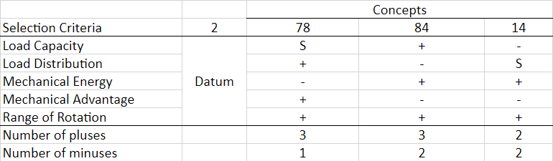
We chose Concept 2 to be the datum since this allowed for an array of potential pluses and minuses for the other concepts. Concept 78 ultimately had the least number of minuses and best plus to minus ratio.

Analytical Hierarchy Process.
For the next portion of the concept selection process, several Analytical Hierarchy Process (AHP) charts were made. The initial AHP charts evaluated and compared the selected engineering characteristics using the AHP’s rating for pairwise comparison. This chart uses a 1, 3, 5, 7, and 9 rating scale: whereby a rating of 1 indicates the selection criteria in the row is of equal importance to the selection criteria in the column, and a rating of 9 indicates the selection criteria in the row is significantly more important than the selection criteria in the column. From the Criteria Comparison Matrix we found that load distribution was considered the most important since it had the lowest sum of 2.73 and range of rotation was the least important as it had the highest sum of 21.00. This information can be used when selecting the final concept by making sure that the device optimally distributes the loads that it will experience when lifting the weight. Furthermore, the Criteria Comparison of the AHP passes the consistency check, which has a consistency ratio of less than 0.1, validating that there was no bias.

Table 9
AHP criteria comparison matrix.
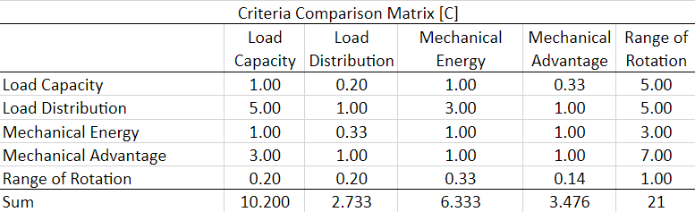
The next AHP charts that were used were essentially a series of comparison charts, which compare each of the three selected concepts from the Pugh chart against one another for one specific selection criteria. This process was repeated a total of five times, once for each of our selection criteria. We then use the data from these charts to make the normalized concept comparison charts, which then allows us to make the final rating matrix. From this matrix, we find the alternative value for each concept. The concept with the highest alternative value was Concept 78 with a score of 0.583. Concept 84 came in at a value of 0.316, and Concept 14 came in with a total of 0.101. The final rating matrix is shown below.

Table 80
Final rating matrix.
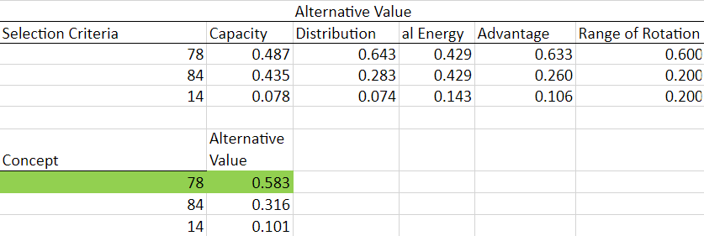
Final Selection.
The final selection chosen is Concept 78, the concept which performed the best in the final Pugh chart. Moreover, in the analytical hierarchy comparison charts, Concept 78 outperformed the other concepts in nearly every category for selection criteria, only falling short in one. Additionally, this concept has the highest alternative value, which is a key indicator of its victory over the other concepts.
This idea is an overall enhancement of the Phase I design, as it capitalizes on flaws and errors observed in the construction and operation of the original model. Concept 78 will include a forward and reverse hybrid gearbox, allowing the RE-RASSOR arm to move in a controlled manner both up and down due to an enhancement in how the gearbox compresses the gears and prevents tooth skipping. The four planetary gears, when combined, will create a larger torque ratio and consequently provide more mechanical advantage, allowing us to lift more weight and reach our ultimate goal. The thin ball bearings used will allow for easier assembly as well as a smooth range of rotation, while optimizing the space used in the gearbox due to its smaller dimensions. A weighted box, in conjunction to the grounding of the system to a large baseplate, will allow for a reduction in stresses, an increase in stability, and an overall better method to distribute the large loads expected.
For the complete charts that enabled us to reach this final selection, please see the Tables D-N in appendix C at the end of this document.

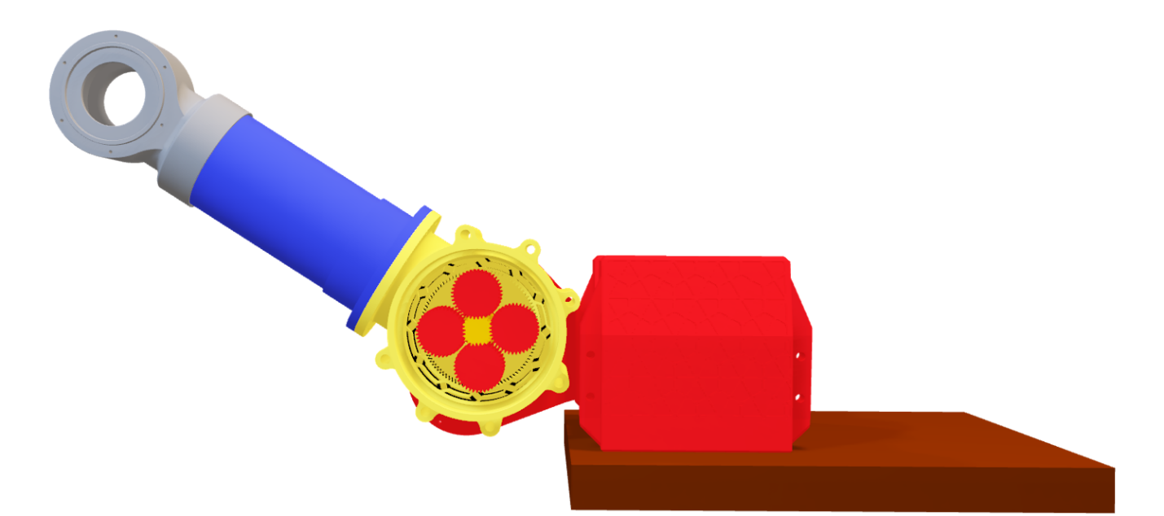Figure 5. Final Concept Selection – Concept 78 (Phase II Big Baseplate).

1.8 Spring Project Plan
With the end of Chapter One being the end of Senior Design I, Team 512 has prepared to move forward with implementing one design. A breakdown of the assignments to come in Senior Design II, and who is responsible for every assignment, can be found in Table 11.
Table 91
Spring project plan.
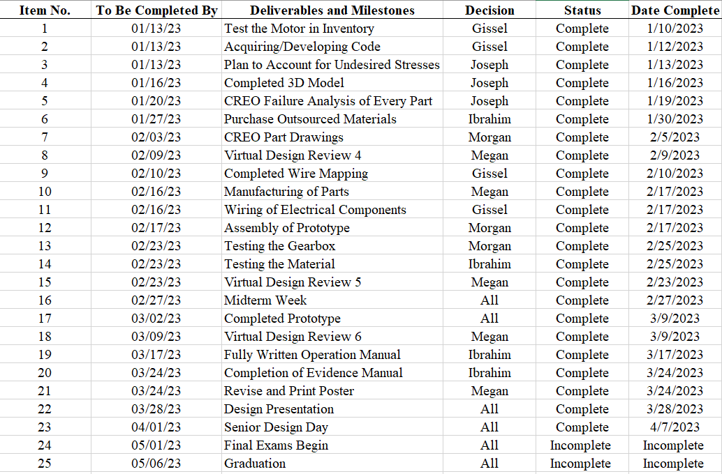
Please note that the status and date complete column have been updated since the creation of this table. This table was added to this document on April 16, 2023, thus a majority of the tasks have been completed.

Chapter Two: EML 4552C

2.1 Spring Plan

Project Plan.
The plan for the spring semester is to take all the individual parts from the RE-RASSOR Shoulder Phase II project and assemble the entire thing into one final product. For complete steps on how to assemble the product, see the Operation Manual in the appendix.
Upon completion of the assembly, the team looks to test the design. We will first manually test the gearbox to ensure our design works properly. We will also test our arm to make sure it is able to withstand the load. These two tests will be done prior to the full assembly, that way we can make changes as necessary before everything is put together. Afterwards when everything is put together, we will be begin testing the product to ensure that it can lift weight.

Build Plan.
The test procedure for the arm is as follows:
1. Locate the arm, the knuckle, the shoulder flange piece, a wooden plank, and the correct size nuts and bolts. The knuckle should be press fit onto the arm
2. Using the cross section of the arm as a reference, drill the correct number of holes at the correct diameter into the wooden plank. This step is meant to prepare holes into the plank.
3. Place the shoulder flange piece over the freshly drilled holes in the wooden plank. Then place the arm over the shoulder flange piece. Ensure that the holes of the wooden plank, the shoulder flange piece, and the arm are all concentric and line up with one another.
4. Push the bolts through the holes that way the arm sticks out from the plank and becomes like a cantilever beam. On the other side of the plank, tighten the nuts onto the bolts as appropriate.
5. Clamp the wooden board with the arm now attached to a table so it is vertical. The arm should be sticking out horizontally.
6. Loop the handle of a bucket through the knuckle. Then place weight into the bucket in increments of 2.5 lbs. Examine for failure each time weight is added into the bucket.

The test procedure for the entire assembly is as follows:
1. Put the motor into the motor housing, the planetary and sun gears into the harmonic gears, and the bearings onto the shoulders. Place the shoulders at either end, then sandwich the motor housing and gearbox together. Tighten the shoulder with bolts and nuts in the appropriate locations. Place the arm and knuckle onto the shoulder flange, tighten down with bolts and nuts. See Operation Manual for more detailed information.
2. Wire motor and Arduino to motor driver, then wire motor driver to a power supply. See Operation Manual for more detailed information.
3. Loop the handle of a bucket through the knuckle. Secure the handle back onto the bucket that way the knuckle holds it up.
4. Turn on the power supply. Run the code to the Arduino. This should cause the motor to begin spinning its shaft. Consequently, the arm should begin to rotate up, then come to a stop while it is lifted. The arm should then begin to rotate down before coming to a stop.
5. Place a 2.5 lb. weight into the bucket, then run the code. Allow operation of the arm with this load attached. Inspect shoulder/arm for fluid movement, and ability to lift weight up and down.
6. Add an additional 2.5 lb. weight into the bucket and restart the operation of the shoulder and arm. Again, inspect the assembly for proper function.
7. Continue to repeat the operation with more and more weight, ensuring to increment in low amounts until failure. Once failure is reached, examine and record what happened.

2.2 Restated Project Definition and Scope
Team 512’s senior design capstone project is to design a scaled down model of NASA’s Regolith Advanced Surface Systems Operations Robot (RASSOR) arm, for Research and Education (RE). The Phase II design will improve on RE-RASSOR Phase I by increasing the load capacity while decreasing the product weight, lowering costs, and providing a simple educational demonstration of how the RASSOR robot arm operates on the lunar surface.
This project's primary objective is to enhance the RE-RASSOR Phase I Design and meet the requirements given by Team 512’s sponsor. The Phase II design must be straightforward and simple enough for educators to replicate. As a result, the final product must be entirely 3D printed using predominantly Polylactic Acid (PLA) material, a non-expensive thermoplastic. An additional goal for this project is to reduce the mass and cost of the product by using less material in the design, while keeping the lifting capacity of the arm intact. The arm must be able to lift 25 pounds, more than double the Phase I design. Another key goal is to avoid repeating the major issues that the previous team encountered: burning out the motors, gear teeth not meshing properly, and dynamic scaling issues. Team 512 will modify the existing harmonic planetary gearbox concept as Phase I but enhance the individual gear designs to get better results. The team will also consider using a different gearbox design entirely as a backup plan in the event the modified harmonic planetary gearbox does not work as intended or meet its critical targets.

2.3 Results
The result of the gearbox test was a success. At various manually cranked speeds, it was demonstrated that the gears all rotate smoothly and effectively. Additionally, it was observed that the gear teeth do not skip, which was a critical enhancement that was incorporated into the Phase II gearbox. The splines on the harmonic gears provided an appropriate amount of compression onto the planetary gears. The data obtained from the gearbox test is tabulated below.
Table 102
Data obtained from testing the gearbox at various speeds.
Speed | Damage | Notes
Slow | No | Rotation of gears is fluid in both clockwise and counterclockwise motion
Moderate | No | Rotation of gears is fluid in both clockwise and counterclockwise motion
Quick | No | Rotation of gears is fluid in both clockwise and counterclockwise motion

The result of the arm test was a success. At various weights, it was demonstrated that the arm was more than capable of lifting and holding weight. The arm did not experience any dynamic motion; however, it showed that the arm could comfortably withstand different static loading conditions. The group was confident the arm could hold even more weight, however all the available weights were already used and placed into the bucket, so the testing was stopped at 32.5 lbs. The newly designed arm was a critical enhancement that was incorporated into the Phase II design. The data obtained from the arm test is tabulated below.
Table 113
Data obtained from testing the arm with various weights.
Weight | Damage | Notes
2.5 lbs. | No
5.0 lbs. | No
7.5 lbs. | No
10.0 lbs. | No
12.5 lbs. | No
15.0 lbs. | No | Small creaking noise heard, assumed from wood
17.5 lbs. | No
20.0 lbs. | No
22.5 lbs. | No
25.0 lbs. | No | PLA material holds up well, no apparent cracking or failure
27.5 lbs. | No
30.0 lbs. | No
32.5 lbs. | No | Small creaking noise heard, assumed from wood

The result of the full assembly test was ultimately a failure. While it was demonstrated that the arm was capable of lifting and holding weight up to 10 lbs., it struggled at this threshold. When the arm was loaded with 12.5 lbs., it was observed that the arm would hardly lift at all before succumbing to the moment that was experienced at the knuckle, eventually dropping the load before attempting to lift it once more. An interesting observation was that despite the arm falling back down due to the load, the planetary gears still rotated, as did the sun gear. The data obtained from the arm test is tabulated below.
Table 124
Data obtained from testing the system.
Weight | Arm Lift | Arm Drop | Notes
2.5 lbs. | Successful from starting point, up to 70 degrees from horizontal | Smooth, retuned to original position
5.0 lbs. | Successful from starting point, up to 70 degrees from horizontal | Smooth, retuned to original position
7.5 lbs. | Successful from starting point, up to 70 degrees from horizontal | Smooth, retuned to original position
10.0 lbs. | Sufficient from starting point, up to 70 degrees from horizontal | Sufficient, returned to original position | Struggled quite a bit on the way up and down. Barely managed under load
12.5 lbs. | Unsuccessful, did not reach past horizontal | Sudden and without warning | Arm is trying to move up, but continuously falls. Gears still rotate

2.4 Discussion
Immediately after the end of the test, a failure analysis was conducted to see what the root cause was. Several factors could have contributed to the failure of the assembly to lift any amount of weight past 10 lbs., including the bearing, the method of grounding, or the placement of the motor.
Because we made a makeshift ball bearing out of a 3D printed ring and BB’s, it was thought that potentially the bearing was incapable of withstanding the radial and axial loads that were being experienced as more weight was lifted. Furthermore, because the method of grounding allowed for the shoulder blades to hang off the table, it was inferred that a significant amount of the reaction forces at the joint were being used to suspend the shoulder in place, rather than being used completely to lift the weight and counter the moment that the load caused at the knuckle. Continuing that thought, because of the way we constructed our motor housing, the motor would rotate with the shoulder as the arm moved up and down, rather than remaining grounded.
While all of these factors may have contributed to the failure of the assembly, the root cause was deemed to be our gearbox. Upon closer inspection and more careful observation at high loads, the harmonic gear would compress in such a way that when a large enough load was placed, the harmonic gear would fall out of mesh with the planetary gears at another location, causing several skips to occur. This large skip would disengage the planetary gears from the harmonic gear, which ultimately led to the arm falling. Because the harmonic gear was not connected to the system at that instant, it was prone to fall due to the force of gravity that the weight and bucket have.
Lifting 25 pounds is a critical target for this project, and although the design has lots of merit, it is unable to achieve what it’s meant to do. For this reason, the planetary gearbox design was abandoned and instead the team transitioned to a cycloidal gearbox design.
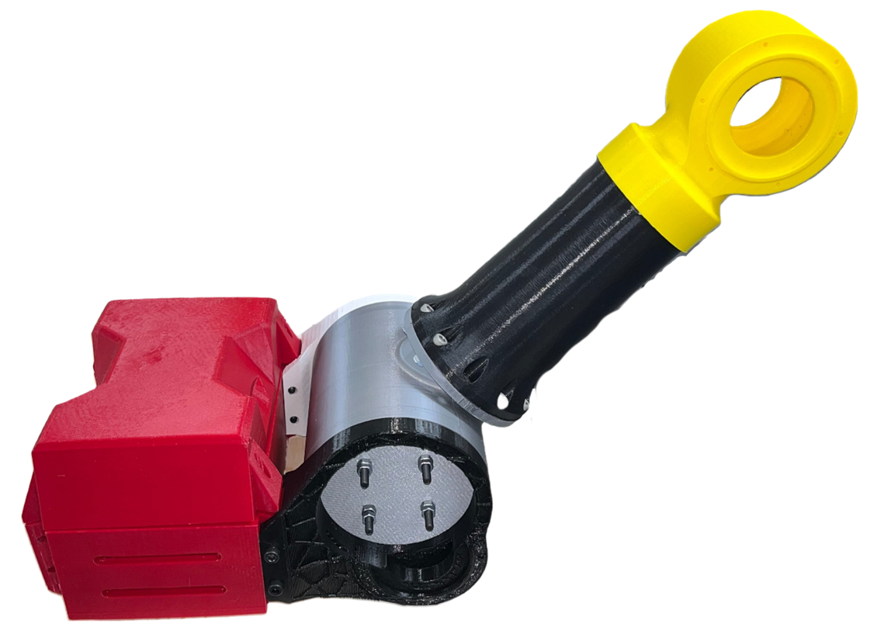
Figure 6. Cycloidal gearbox design.

The cycloidal gearbox utilizes mostly the same parts as the planetary gearbox, such as the chassis, arm, and knuckle. The shoulder blades have been slightly modified, eliminating the bolt head slot that is no longer needed and decreasing the external diameter of the circular extrusion. The inside of the shoulder flange T-joint is entirely different. The shoulder flange T-Joint consists of a cycloidal base, cycloidal disk, input shaft, output shaft, and cycloidal cover.
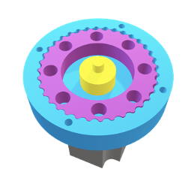
Figure 7. Cycloidal gearbox attached to the NEMA 23 motor.

The cycloidal base is a motor mounted base with an internal cycloidal gear. The cycloidal gear is placed into the cycloidal base. The input shaft is an eccentric shaft press fit into the cycloidal disk and output shaft, offsetting the cycloidal disk by 1 millimeter. The output shaft is a disk with pins that go into the cycloidal disk. The cycloidal cover compresses the cycloidal gearbox together. The cycloidal base has 36 teeth, and the cycloidal disk has 35 teeth. These two parts combine to form a gear ratio of 35:1. This gearbox design was tested and able to lift 15 pounds successfully. This arm moved fluidly and as expected, without skipping.

2.5 Conclusions
The Phase II design learned from the issues that Phase I had and corrected them. While the Phase II design was not able to lift 25 pounds, it is important to mention the achievements that were made with this project. The reproduction cost was reduced greatly and met the project goal of being less than $50.00 (PLA cost only). The assembly was also simplified with the introduction of 3D printed bearings, which held BBs secure in place, preventing them from falling out while parts are being put together. Furthermore, the code used to drive the motor was developed to allow for gradual increases and decreases in velocity, causing acceleration to be smoother and consequently jerk to be nonexistent. An ideal motor driver was located which prevented overheating from happening, and the motion of the planetary gears were made smoother in both directions due to the introduction of the dual spline harmonic gear. The planetary gears themselves were made better by increasing the module and reducing the number of teeth, allowing for a cleaner print with better tolerancing. A carrier device was also utilized to keep the planetary gears always spaced evenly apart, which was an enhancement that was not previously seen.
All in all, the progress that was made with the harmonic planetary gearbox made for a better, simpler to use product for our end user. In the future, the cycloidal gearbox can become the gear that is able to lift 25 pounds. Preliminary testing showed that the weight lifted using this gearbox had no issues in its movement, whereas the previous gearbox struggled. In fact, the cycloidal gearbox can comfortably lift 15 pounds and, to an extent, can even lift 17.5 lbs. This makes the team confident that this gearbox could lift more weight with no problem, with current projections showing that this gearbox can achieve a torque ratio of 1225:1. Furthermore, the optimal infill density for every part can be discovered, which would maximize strength of each individual part while saving material. The cycloidal gearbox needs to be validated further before it is fully approved for use. As it stands, the RE-RASSOR shoulder is yet to be complete; however, the future is bright for the product.

2.6 Future Work
Future groups working on the RE-RASSOR Shoulder project can aspire to increase the functionality and productivity of the design. The point of failure was identified within the design of the harmonic spline. Upon attempting to lift 12.5 pounds, there was an evident cracking sound. After opening the tested assembly, no parts appeared to be broken. Therefore, it was assumed that the cracking sound came from the infill of the harmonic spline. In addition, the video displays that the gears continued moving while the arm was not lifting. This is evidence that the gears may have been slipping. Future work on the design of the spline is necessary in two major areas: the infill percentage and the width of the spline patterns. The higher the infill percentage, the lower the flexibility of the part. The shorter the spline design, the lower the flexibility of the part. Future teams can create an experimental method to identify the ideal infill percentage and spline pattern for this harmonic spline. Additionally, future work could take place in identifying the lowest infill necessary for each individual part, while maintaining an operational assembly. By decreasing the infill of each part, it would decrease the amount of material used, thus decrease the cost.
The future work of the cycloidal gearbox includes increasing the gear ratio to increase the torque and thus be able to lift a larger load. Although there is not data to present currently, there is high potential for this gearbox design to be successful. By altering the design to stack two of the gearboxes in series, this will create a gear ratio of 1225:1. An increased gear ratio should have the torque necessary to be able to lift 25 pounds.

Appendices

Appendix A: Code of Conduct
Mission Statement
Team 512 will utilize the engineering disciplines and knowledge that have been gathered over the last several years to produce the most efficient and optimized solution as given by our sponsors. The problem described is designing and manufacturing a better gearbox, housing, and arm that can withstand substantial amounts of torque and stress. Team 512 will do its utmost to uphold the reputations of both our sponsor and the FAMU-FSU College of Engineering.

Outside Obligations
Morgan Causey is currently working remotely taking civil engineering contracts from his boss this previous summer. He spends at most 5 hours a week on these contracts.

Megan Kimsey is currently a teaching assistant working 15 hours a week. In addition, she is president of Tau Beta Pi Engineering Honor Society, where she spends about 15-20 hours a week planning and attending various meetings.

Ibrahim Nabulsi is currently a co-owner of a local business working between 12-35 hours a week. He helps run day-to-day operations, manage inventory, and assists in all aspects of the business. In addition, he also is a manager at Southern Scholarship Foundation, where he must plan and attend meetings.

Gissel Reynoso is currently a teaching assistant for Mechanics and Materials Lab and Intermediate Mechanics and Materials II. She works Monday through Friday, 20 hours a week.

Joseph Vogl does not have any obligations.

Team Roles
Duties that do not fall under the designated roles will be delegated between members based on likes and interests listed below. Tasks that do not fit under a specified person will be evenly divided and agreed on.

Morgan Causey: Mechanical Systems Engineer
Morgan Causey brings to the team his experience of problem solving, budgeting, and client communication. He served as an Intern Computer Aided Design and Drafting (CADD) Technician for Sigma Consulting INC this previous summer. In his internship he often encountered problems that required unique solutions to meet legal standards. Additionally, he calculated expenses for every project he worked on. He enjoys doing math, working with CREO Parametric, and creating PowerPoint presentations. For this project he will be performing system calculations, budgeting, and assisting with design.

Megan Kimsey: Systems Engineer
Megan Kimsey brings to the team experience with additive manufacturing after interning at the Innovation Hub and currently taking the Intro to Additive Manufacturing technical elective. She also has 3D modeling experience after interning in engineering design with ITW, and working as a teaching assistant for Mechanical Engineering Tools Lab. She has developed communication and presentation skills as a Technical Engineering Sales Intern with Ecolab this past summer. She also enjoys expressing her creativity in PowerPoints. For this project, she will be working with Joseph on designing parts using Creo Parametric, creating engineering drawings, and manufacturing the parts.

Ibrahim Nabulsi: Testing Engineer
Ibrahim Nabulsi brings to the team experience and knowledge from a wide array of industries and backgrounds. He has experience conducting tests on various equipment and parts from his time completing a Co-Op with Lockheed Martin as well as his internship with the Florida Department of Transportation. Additionally, he has knowledge on both safety protocols and project management methods, familiarity with power tools, and an eagerness to work with his hands through his internship with Kiewit. He enjoys reading and writing and is comfortable presenting material to an audience.

Gissel Reynoso: Mechatronics Engineer
Gissel Reynoso brings to the team her knowledge and experience of design, rapid prototyping, and 3D Printing. She currently works in a research lab where she is trained to use a laser cutter, vacuum former, and has foundational knowledge in the use of multiple types of 3D-Printers. Furthermore, she will work with hardware, such as motors and sensors, as well as Arduino, which is software that will help code said motors and sensors.

Joseph Vogl: Design Engineer
He will work on designing parts and creating engineering drawings for the project using CREO Parametric software. He enjoys designing his personal projects in his free time. When home for summer he enjoys flying planes, showing his ability to perform under pressure.

Communication
Microsoft Teams will be the primary form of communication between team members, where all important documentation pertaining to the project will take place. If a document is posted in the Microsoft Teams that requires immediate attention from a specific member, the person posting the document will also email it to that specific team member. There will be a shared Microsoft Teams calendar with any important meetings or events.

The text message group chat will be utilized to send reminders, ask questions that need to be answered quickly, or to schedule when the group needs to meet outside of normal meeting hours. Members will acknowledge that they saw a message by responding within 24 hours, which can include “liking” the message. Communication should be clear, concise, and effective, in the interest of respecting one another’s time.

Every member will come to each meeting prepared with what was agreed on at the meeting prior. More than one person will proofread assignments before a final draft is turned in.
All assignments will be completed 24 hours prior to the due date, to prevent procrastination and leave time for any team revisions. Group assignments due on Fridays will be finished by Thursday, therefore, team members who are checking the work can do so by the due date. After a member completes a task, they will text in the group chat confirming their task has been completed. All work for each task will be completed by the agreed-on date and time. If work is not completed (without a university valid excuse) by these agreed on timeframes, the member who did not complete their work will be given a warning documented in our notebooks, and on the second violation Team 512 will contact the Teaching Assistants and Dr. McConomy to come to a solution. One member will oversee submitting each assignment. After this member submits, they will text in the group chat confirming the assignment has been submitted on time.

With the sponsor, email and Discord will be the primary form of communication. One person will be designated to communicate, and the entire team will be copied on every email. Furthermore, Zoom, or other video conferencing applications, will be used to meet with sponsors and advisors if we cannot meet in person. These applications will also be used when necessary for video calls when group members are working remotely.

Dress Code
Dress code is business professional for presentations. Business professional dress includes blazer and slacks. The dress code is casual for sponsor and adviser interactions.

Attendance Policy
Standard group meetings will be held Tuesdays and Thursdays. Meetings on Tuesdays and Thursdays will be held before and after normal class time, if class time is not sufficient. Team 512 plans for biweekly meetings with their adviser and sponsor.

Attendance will be taken at the beginning of all meetings and will be tracked in our notebooks. Everyone must attend every class and every planned meeting or have a valid excuse. Valid excuses are considered university valid excuses. If a member is sick, that member still must try to attend a meeting via Zoom. If someone is not able to attend a meeting due to illness, they need to catch up on their own time.

Meeting scheduling will not conflict with anyone’s class or work times. If a meeting is planned when someone cannot attend due to a valid excuse, class, work, or prebooked travel, there is no consequence; however, they need to get caught up on their own time.

If someone is deemed not necessary to be in a meeting, everyone must agree they do not need to attend. If someone does not attend a meeting and does not make the rest of the group aware of their absence, or if someone does not attend a meeting and does not have a valid excuse, the missing member will be given a warning documented in our notebooks, and on the second violation we will contact the Teaching Assistants and Dr. McConomy to come to a solution.

Meetings will not be held on Saturdays or three-day holiday weekends due to common travelling. We will try not to meet on Friday nights or Sundays but will resort to that if three out of five members feel it is necessary.

External support will be offered when four team members agree the fifth member is putting in their best effort but is not able to meet expectations at that time.

How to Notify the Group
For quick reminders, the group chat can be used to send notifications. For important project related notifications, email should be used as a paper trail, therefore always saved and easily accessible. Time sensitive things should be placed in the group chat.

Any scheduling conflicts will be put into the Teams calendar 48 hours in advance. Everyone must notify the group via text message up to 24 hours in advance of missing a meeting. An emergency is a valid excuse, and this rule does not apply.

In times of urgency, all team members preferred method of contact is through phone call.

If a team member is upset with another member for any reason, how each member would like to be addressed is listed:

- Morgan Causey does not have a preferred method in terms of whether he is addressed in person or via the internet. He just wants conversations to be kept civil.
- Megan Kimsey would like to be addressed in an individual setting. She would prefer a face-to-face conversation or email describing the reason one is upset, how the issue can be resolved, what the upset party needs from her, and when they need it by.
- Ibrahim Nabulsi would like to be addressed privately through a face-to-face conversation, a one-on-one phone call, or a direct message through text. Any form of communication is fine, so long as it is addressed on an individual level. Constructive criticism is much appreciated.
- Gissel would like to be addressed in person one-on-one or through a professional email explaining to her what she has done to upset you and how she can improve the situation.
- Joseph Vogl does not mind how he is addressed when conflicts arise.

Professional Responses
Team 512 will speak positively about its members and project when speaking with professionals and sponsors. No profanity or slang will be used. Constructive criticism is offered if it increases the productivity of the team's work. Members will respect other team members and assign tasks that leverage their strengths to ensure success. Whether it is during a presentation or a meeting with the sponsor or advisor, everyone will speak and respond in a professional and respectful manner. If a question is asked and the answer is not known, we will follow up after we have a firm answer. When we are faced with criticism, we will not get defensive. Instead, we will take it into consideration and see where we can improve the project.

Statement of Understanding
Each signature below represents that team member’s understanding and agreement with every statement written in this document.

________________________________________
Morgan Causey

________________________________________
Megan Kimsey

________________________________________
Ibrahim Nabulsi

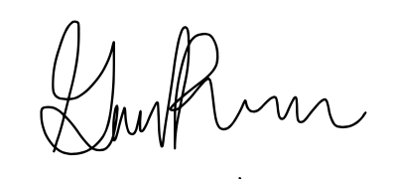
________________________________________
Gissel Reynoso

________________________________________
Joseph Vogl

What We Do Before Contacting Dr. McConomy or the Teaching Assistants
If we need advice on how to complete the project, we will seek help from our advisor before we contact Dr. McConomy. If there is major conflict, Team 512 will meet up as a whole and try our best to create a solution internally.

If someone breaks the contract on their third time, does not do the work that is under the scope of their team role, or fails to meet deadlines on their second consecutive time, we will have a meeting discussing this issue.

We will also be resourceful and consider our options through research and making true attempts at our work before consulting with the Teaching Assisstants or Dr. McConomy. After we have finished our work, we will consult them to ensure that the assignment has been completed properly.

At What Point We Contact Dr. McConomy
If we need advice on how to complete the project, and we have already sought help from our advisor, but our advisor cannot assist us, then we contact Dr. Mcconomy.

If there is major conflict that we met on and cannot resolve, we will email the Teaching Assistants explaining the conflict and seeking their help. If the Teaching Assistants do not know how to help, we will contact Dr. McConomy.

If someone breaks the contract three times, does not do the work that is under the scope of their team role, or fails to meet deadlines two consecutive times, we will contact Dr. McConomy.

What We Want Dr. McConomy to do When We Come
Team 512 asks that Dr. McConomy help guide disputes in a professional and productive manner. By doing so, Dr. McConomy will help Team 512 create a solution if someone does not do their work, does not follow the agreed upon rules, or does not meet deadlines. Furthermore, if an assignment is not on time due to conflict that Dr. McConomy is aware of, Team 512 asks that he offer an extension.

How to Amend
To amend, more than one team member must agree a change needs to be made. Any amendments must be anonymously voted on in a poll, where the majority rules. Amendments can also be made if someone must leave school for the semester for any reason.

Appendix B: Functional Decomposition

Table B13
Summary of interpreted needs, including the questions asked to the customer, the customer’s statements, and the interpreted needs.
Questions: | Customer Statements: | Interpreted Needs:
What are the requirements of the project? | The project requires heavy lifting capability from a gearbox made of entirely 3D printed parts. This is an educational model of NASA’s RASSOR, meant to be replicated at an inexpensive price. You will need a stepper motor, gearbox, 40-60 pounds of torque capability, reduction gears, and cheap bearings. | The product lifts a certain amount of weight and is entirely 3D printed. The product is inexpensive.
What is the goal of RE-RASSOR Phase II? | The goal of Phase II is to take the design from last year’s team and increase the weight carrying capabilities. | The product can lift a larger load than Phase I’s design, which had a lifting capability of 15 pounds.
What is our budget, and what is the ideal cost of the final product? | The final product should cost no more than $50 to reproduce, but the overall project budget is $909. | The product will be inexpensive.
What is the age limit? | It will be used by high school students, possibly middle school students. | Those in sixth grade and above will be assembling and operating the product.
Is there a maximum weight limit? | The final product cannot weigh more than NASA’s RASSOR, about 1000 pounds. | The product will weigh under 1000 pounds.
What are the dimensions? | It can have an array of dimensions, as long as the final product can fit into the existing shoulder piece. The flange of the mating piece cannot be changed. | The product meets dimension requirements and is compatible with the existing flange.
Does the color of the PLA matter? | The prototype can consist of any colors. | Any color of PLA may be used.
What is the expected range of motion of the arm? Are we holding the weight in place, once off the ground? | The arm should be able to move from a 0-degree angle to a 90-degree angle. The weight must be held in place once lifted off the ground. | The arm can lift the weight and hold it in place at various angles.
How would you like the arm to be operated? | The arm should not utilize a switch. You will use the software created by the UCF RASSOR Arm team to program the stepper motor, starting it and stopping it slowly, and having motion at an acceleration curve. | A computer program will be used to operate the motor.
What is the biggest obstacle in this project? | In the past, the high amount of torque caused damage to the parts made of PLA. A lot of force is used for having 3D printed parts. | The product design will withstand large forces and loads.
What were some undesirable aspects of Phase I? | Phase I had a 3D printed bearing that did not function to expectations. The bearing needs to be steel and needs to be inexpensive. Their gearbox would slip, and the gear teeth would not mesh properly. | Bearings will function smoothly.
What do we have to lift? | The arm will need to lift a concentrated weight of at least 25 pounds. | The arm will lift a concentrated mass of 25 pounds or more.
Are we expected to work with other teams? | You should work with the UCF RASSOR Arm team to test the software their team creates. | The product will use the UCF software to function.
How long should the arm be? | The product should roughly be the size of your arm from elbow to wrist, about 12 inches. | The arm length resembles the length of the average person’s arm.

Figure B1. Functional decomposition hierarchy chart.

Table B2
Cross-reference table.
Functions | Systems
 | Channel | Provision | Control Magnitude | Convert | Support | Connect
Lift Weight | X | X |  | X |  | X
Rotate from 0 to 90 Degrees | X
Move at Controlled Speed | X |  | X
Control Weight | X | X | X | X | X | X
Protect Arm from Weight Collision | X |  | X |  | X | X
Run Operation | X | X | X | X
End Operation | X | X | X | X
Provide Mechanical Advantage | X | X | X | X
Conserve Mechanical Energy | X | X |  | X
Secure In Place |  |  |  |  | X | X
Withstand Large Loads |  | X |  | X | X
Join with the Shoulder Flange |  |  |  |  |  | X
Assemble Within Dimension Requirements |  |  |  |  |  | X
Attach Weight | X |  |  |  | X | X

Appendix C: Target Catalog

Table C1
Targets and metrics based on functions from functional decomposition.
Summary of Targets and Metrics
Function: | Metric: | Target: | Description:
Lift Weight | Weight | 25 Pounds | The product will lift 25 pounds or more.
Rotate from 0 to 90 Degrees | Angle | 90 Degrees | The arm will rotate from a 0-degree position to a 90-degree position.
Move at Controlled Speed | Angular Velocity | 4.5 deg/sec | The arm will move at a speed that keeps the weight under control, rotating 90 degrees in 20 seconds, or 4.5 degrees per second.
Provide Mechanical Advantage | Torque Ratio | 18:1 | The gearbox will provide a mechanical advantage to the system, with a torque ratio of 188to 1.
Control Weight | Distance | ≤ 2 Inches | The arm will prevent the weight from swaying by maintaining 2 inches or less between the weight’s center of mass and the center axis of the connecting mechanism.
Protect Arm from Weight Collision | Distance | ≥ 1 Foot | The arm will be protected from the weight by using a connecting mechanism with a minimum length of 1 foot.
Run Operation | Electric Potential Voltage | ≤ 5 Volts | The Arduino will be signaled for less than or equal to 5 Volts to be sent into the system, then the operation will begin.
End Operation | Electric Potential Voltage | 0 Volts | A signal will be sent to the Arduino, powering it down to 0 Volts, thus halting the operation.
Conserve Mechanical Energy | Energy | 50 foot-pound force | The mechanical energy of 50 foot-pound force provided will be conserved throughout the system to allow the motion to continue.
Secure in Place | Displacement and Rotation | ≤ 0.5 Inches  ≤ 5 Degrees | The arm will be fastened to some sort of ground with the intention to remain in place during operation. It will not translate by more than 0.25 inches in either direction, totaling a linear range of 0.5 inches. It will not rotate more than 5 degrees.
Withstand Large Loads | Tensile Strength | 7250 psi | The 3D-printed parts will not crack upon lifting a large load; therefore, the forces will not cause a tensile stress of 7250 psi or more.
Join with the Shoulder Flange | Diameter | 2.5 Inches | The arm will fit within the dimensions of the shoulder flange, with a diameter of about 2.5 inches.
Assemble Within Dimension Requirements | Length | 12 Inches | The arm will be about the size of a human’s arm, ranging from approximately 10-15 inches.
Attach Weight | Force | 25 Pounds | The arm will be able to attach weight to be lifted. The point of contact with the arm will be able to withstand the force applied, of 25 pounds.

Table C2
Targets and metrics not related to functional decomposition.

Summary of Other Targets and Metrics
Category: | Metric: | Target: | Description:
Assembly | Time | < 1 Hour | The assembly of the product will take less than one hour.
Assembly | People Required | ≤ 2 People | The assembly will be simple enough that two or less people are required to put it together.
Assembly | Amount of Parts | < 40 Parts | The entire arm assembly will have less than 40 total parts total.
Reproduction Expenses | Currency | ≤ 50 U.S. Dollars | The cost to reproduce the PLA aspects of the product will cost less than or equal to 50 U.S. dollars total.
Research Expenses | Currency | ≤ 400 U.S. Dollars | The total cost of our research process will cost less than or equal to 400 U.S. dollars.
Inexpensive Bearings | Percentage of Reproduction Budget | < 20 Percent | The cost of the bearings used in our product will be less than 20% of our total reproduction cost.
Same Imperial Bolts | Diameter | 1/4 Inch | The product will utilize the same imperial sized bolts throughout the assembly, ¼ inch.
Same Imperial Nuts | Diameter | 1/4 Inch | The product will utilize the same imperial sized nuts throughout the assembly, ¼ inch.
Durable | Infill | ≤ 30 Percent | The PLA parts will be durable to withstand large loads. The infill of each 3D-printed part will be 30 percent or less.
Portable | Weight | ≤ 10 Pounds | The entire assembly is to be less than or equal to 10 pounds, making it lightweight and portable.
Load Distribution | Weight | 25 Pounds | The product will be able to distribute the various forces and stresses throughout the arm that the 25-pound weight causes.
Functional Bearing | Rotational Velocity | 4.5 deg/sec | The rotational velocity of the bearing will be able to move at 4.5 degrees per second.
Age Limit | Years | ≥ 10 Years Old | The product will be created so anyone above the age of 10 can assemble and operate it.
Size of Gearbox | Volume | < 90 Inches³ | The entire gearbox must fit within the volume of the given shoulder joint and arm, combined is calculated to be a volume of 90 inches³.

Appendix D: Concept Selection

Table D1
Binary Comparison, used to obtain importance weight factor of customer needs.

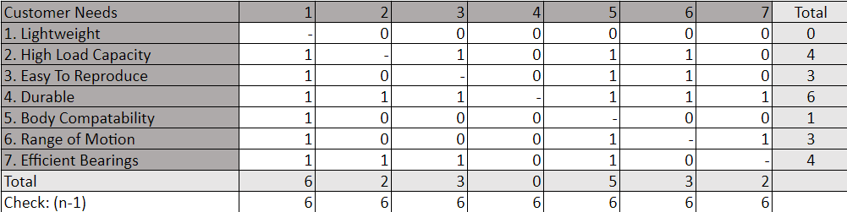

Table D2
House of Quality, used to rank the order of our Engineering Characteristics and filter out the characteristics that are not critical to the project's success.

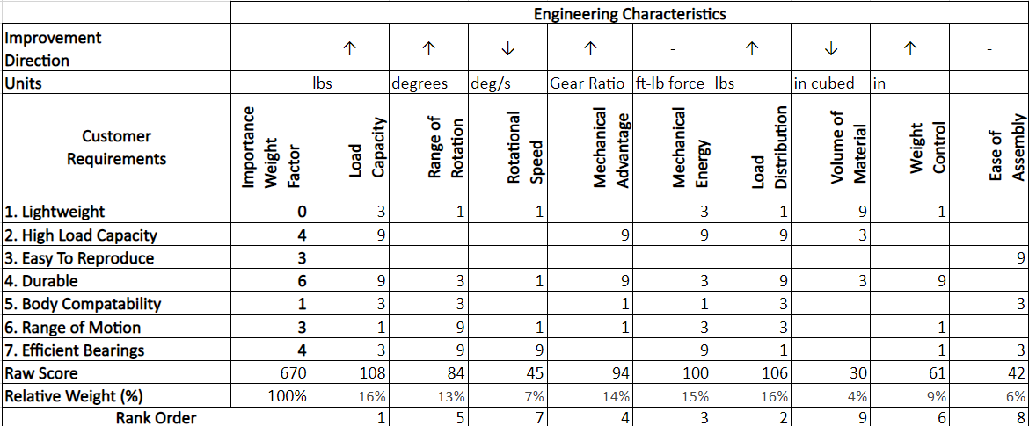

Table D3
Pugh Chart, used to compare our medium and high-fidelity concepts to the datum (a benchmark for what already exists).

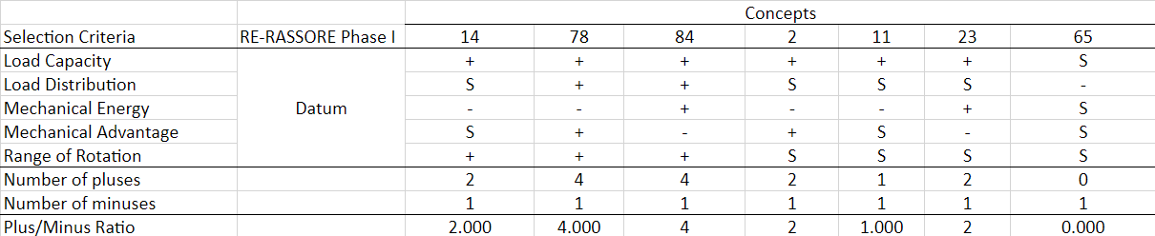

Table D4
Pugh Chart, used to compare our top performing concepts against one another (using one of the concepts as a new datum)

Table D5
Analytical Hierarchy Process Chart, used to compare our selection criteria against one another.

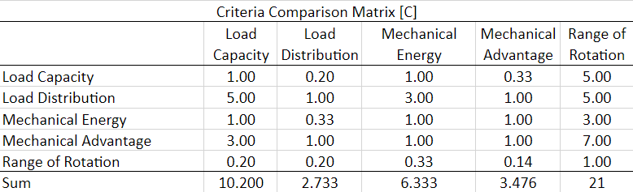

Table D6
Analytical Hierarchy Process Chart, used to normalize the data obtained in Table H.

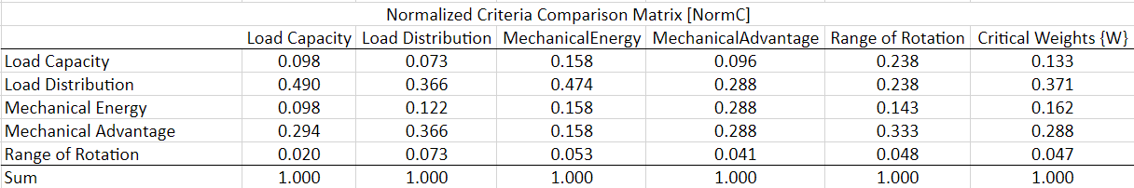

Table D7
Analytical Hierarchy Process Chart, used to ensure the team was consistent in its ratings of the selection criteria.

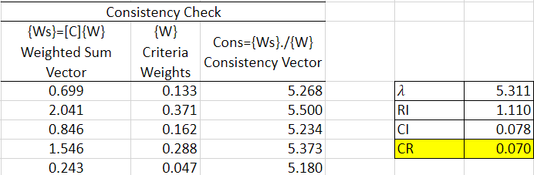

Table D8
Analytical Hierarchy Process Chart, used to compare the top performing concepts against one another in each individual selection criteria category.

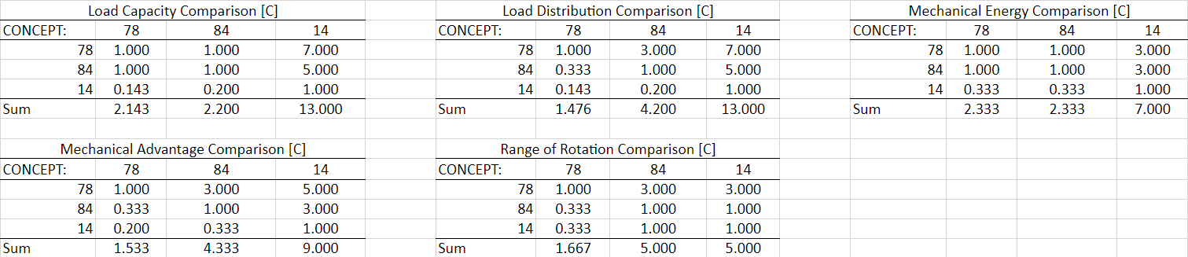

Table D9
Analytical Hierarchy Process Chart, used to normalize the data obtained in Table K.

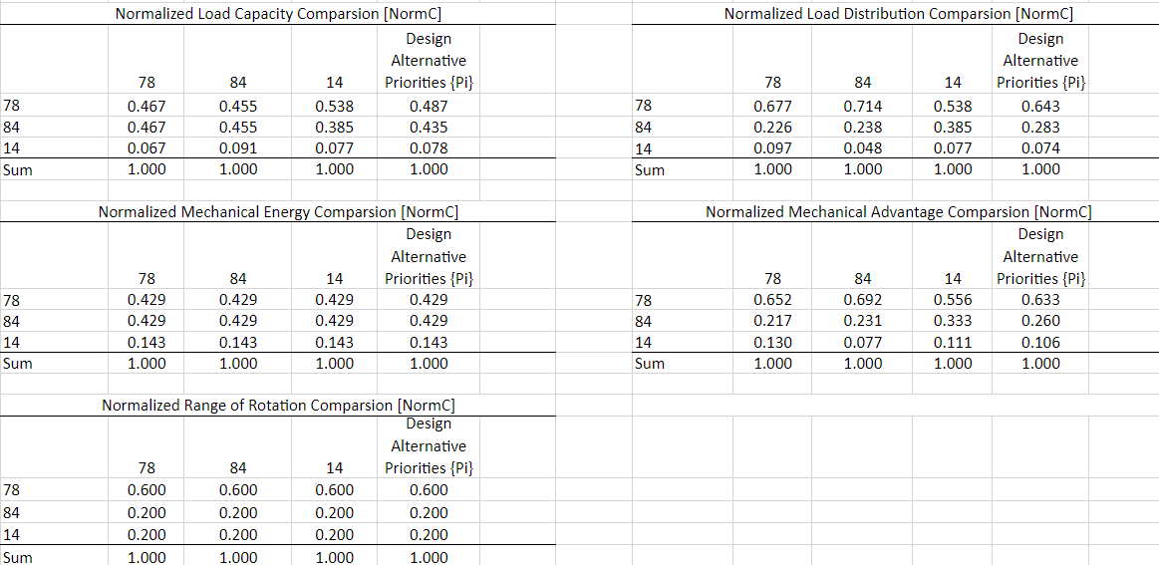

Table D10
Analytical Hierarchy Process Chart, used to ensure the team was consistent in its ratings of the comparisons of concepts.

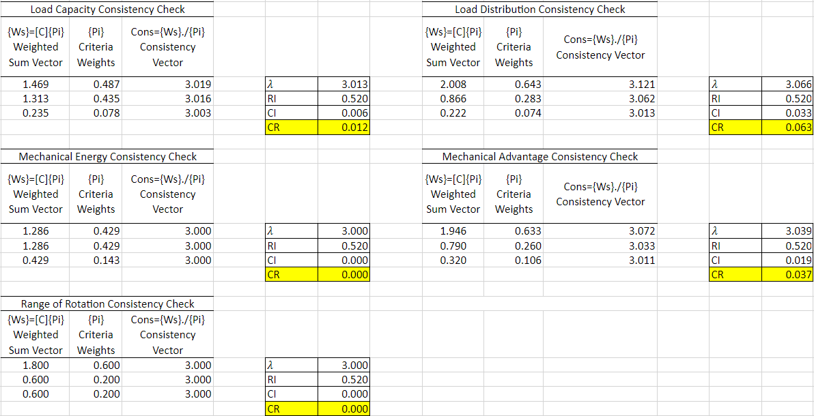

Table D11
Final Rating Matrix, used to calculate the alternative values for each concept and validate a winning concept that will be selected for the project.

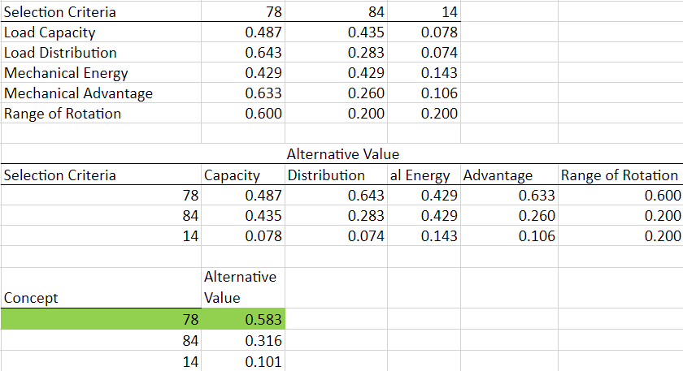

Appendix E: Operations Manual
Project Overview
The objective of this project is to create a 3D-printed, motorized, scaled down version of NASA’s RASSOR shoulder and arm to help introduce STEM concepts in middle and high schools. RE-RASSOR stands for Research and Education – Regolith Advanced Surface Systems Operational Robot. This is an element of a robotics initiative developed by the Florida Space Institute and Florida Space Grant Consortium.
The RASSOR was deployed by NASA on the lunar surface to excavate, haul, and dump regolith on the moon. The research and education initiative, coming from the Florida Space Institute and the Florida Space Grant Consortium, is based on NASA's Mini-RASSOR, developed in the SwampWorks Laboratory (an environment for rapid, innovative, cost-effective exploration mission solutions). The Mini-RASSOR was created to allow for substitution of parts for mission-oriented pieces as necessary and if desired. ​3D-printed substitutions were developed across several universities in Florida (including the FAMU-FSU College of Engineering) which has reduced the cost of the complete rover from about $15,000 to about $800.

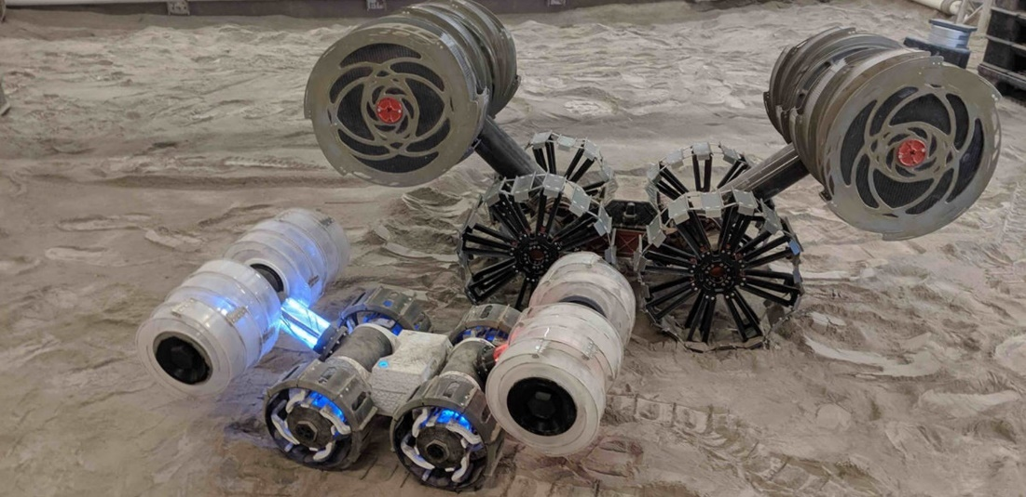

Figure 1. NASA’s Mini-RASSOR (front left) compared to NASA’s RASSOR (back right).

The project sponsor, the Florida Space Grant Consortium, shares their existing 3D-printable (STL) part files with the student engineering team. These files are what the team is constrained to build within.
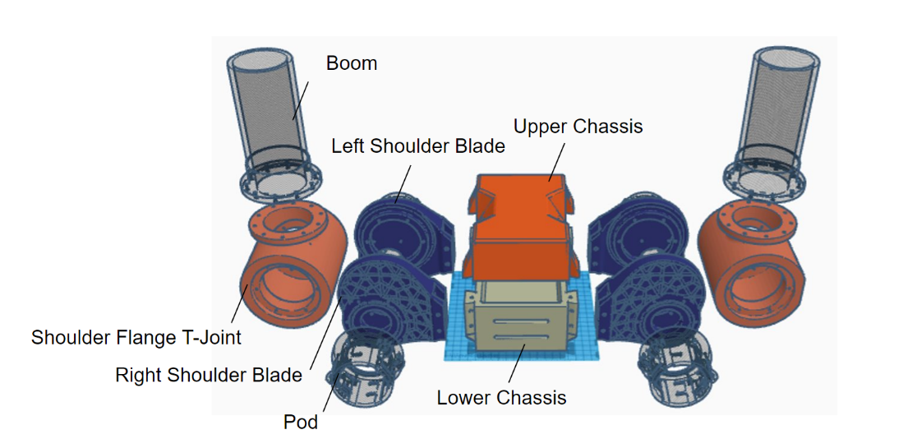
Figure 2. Florida Space Grant Consortium’s RE-RASSOR 3D-printable (STL) files.

The team adds a motor and a gearbox system that fits within the Shoulder Flange T-Joint. The motor, used to power the gearbox, moves based on computer code. The gearbox increases the torque that comes from the motor. This torque allows for the upward and downward motion of the arm so it can lift weight. Team members use Computer Aided Design to model and test the parts within the gearbox. The engineering students calculate the proper sizes for the gears and housing. Then, testing the motion of the gears takes place to make sure they turn easily. The team also tests the amount of force that the arm and shoulder can withstand, determining if the system can lift 25 pounds.

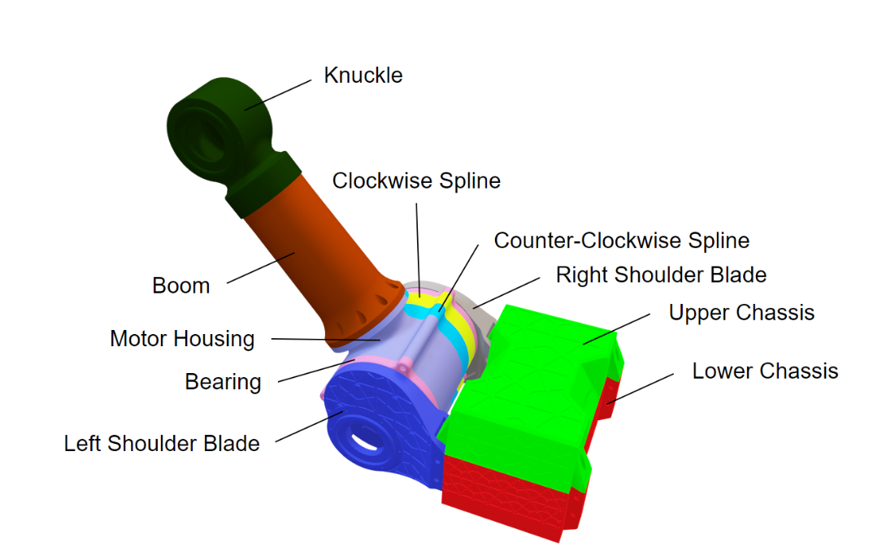

Figure 3. 3D Model of Senior Design Team 512’s completed RE-RASSOR shoulder and arm assembly.

Schools can easily reproduce Senior Design Team 512’s completed RE-RASSOR shoulder and arm assembly using a 3D printer. The parts can be printed in classrooms using easy to access, readily available printing files. After the parts print, students can follow this simple operation manual to assemble and work the RE-RASSOR model. Upon assembly, the educational model can lift up to 25 pounds. Showing how the RASSOR works gives students exposure to real life technology, inspiring these students to choose STEM related fields as part of their future endeavors.

Component Description

​ 3D-Printed Components
- Left Shoulder Blade – This part is placed on the left side of the shoulder joint, and it functions to hold the entire assembly together, attach the shoulder assembly to the chassis, as well as allow for rotation of the arm. The left shoulder has an inner casing for a bearing built into the outer surface of the extruded circular section. The slot shaped like a portion of a circle, ranging from the top of the part to the dovetail, is to allow for passing of the boltheads during rotation of the arm. The crescent shaped hole in the part is to allow wires to pass through.
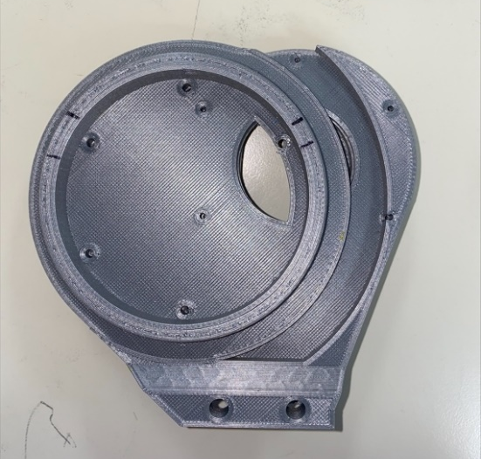
Figure 4. Left Shoulder Blade.

- Right Shoulder Blade – This part is similar in structure, shape, and function to the left shoulder blade. The difference here is that the extruded circular section of this shoulder joint incorporates gear teeth that mesh with the gearbox located inside.
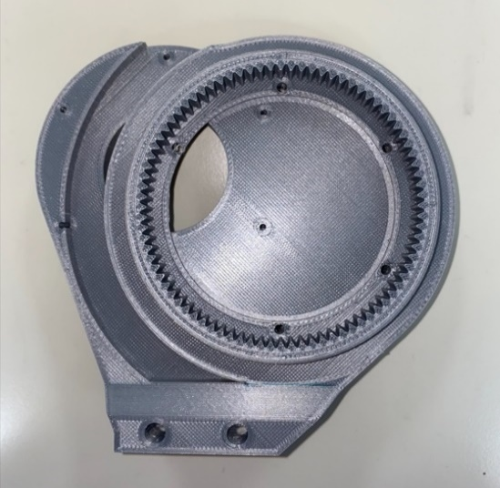
Figure 5. Right Shoulder Blade.

- Harmonic Gear with Clockwise Spline – This component is what holds the planetary and sun gears together. It incorporates a clockwise spline, that way when the planetary gears inside are rotating around the ring of the harmonic gear, there is flexibility of the harmonic gear as well as a compressed fit onto the planetary gears.
Figure 6. Harmonic Gear with Clockwise Spline.

- Harmonic Gear with Counterclockwise Spline – This component has identical function as the previously mentioned harmonic gear, however the spline displays a counterclockwise direction. This allows the planetary gears to have better compression in both directions, reducing the chances of gear teeth skipping during the upward and downward motion of the arm.
Figure 7. Harmonic Gear with Counterclockwise Spline.

- Planetary Carrier – This component allows the user to correctly space the planetary gears 120 degrees apart from one another during assembly.
Figure 8. Planetary Carrier.

- Planetary Gears – These three gears are spaced 120 degrees apart around the ring of the harmonic gear, with the sun gear meshing with all three. The planetary gears have 36 teeth and a module of 1. The planetary gears are 2 inches in height.
Figure 9. Planetary Gears.

- Sun Gear – This one gear attaches to the shaft of the motor, which sits directly in the center of the harmonic gears. Like the planetary gears, the sun gear is also 2 inches in height; however, they have 12 teeth and a module of 1.
Figure 10. Sun Gear.

- Thin Ball Bearing – The quantity of this part in our assembly is two, attaching to both the left and right shoulder blades. The bearing outer casing sits around the extruded circular section on the inner part of each shoulder blade. This mentioned section of the shoulder blade has an incorporated groove around the outside. With this mentioned groove and the groove in the inner section of the bearing, BBs can be press-fitted in between and inserted. This thin ball bearing design allows for the rotation of the shoulder.
Figure 11. Outer Casing of the Thin Ball Bearing.

- Boom and Knuckle – The boom (or arm) and knuckle together make up the arm of the RE-RASSOR. The boom is what attaches the shoulder to the knuckle, and the knuckle is where the drums (which excavate regolith) would be placed on the actual RASSOR robot. The line which connects the weight to the arm is looped and tied around the knuckle.
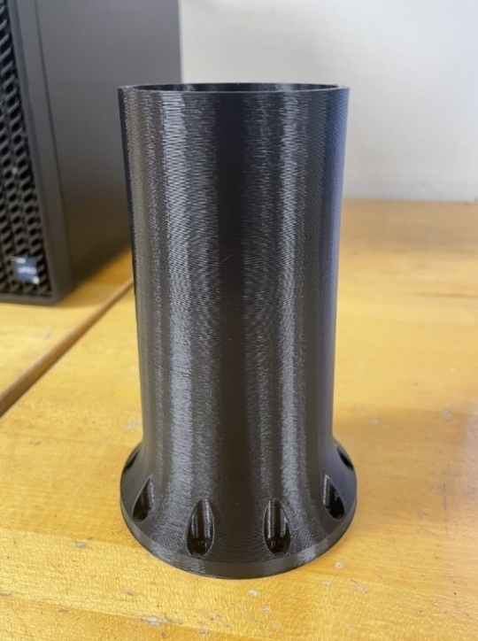
Figure 12. and 13. Boom and Knuckle (respectively)

- Motor Housing – This part is included in the shoulder joint and is strictly meant to hold the motor and house it in a secure place. It has 5 holes; 4 small holes that screw the motor to the part, and 1 hole that allows for the shaft of the motor to fit through and connect to the sun gear.
Figure 14. Motor Housing.

- Chassis – This part is a direct model of the RASSOR chassis. It was obtained directly from the 3D-printable files given to the team via the Florida Space Institute and the Florida Space Grant Consortium.
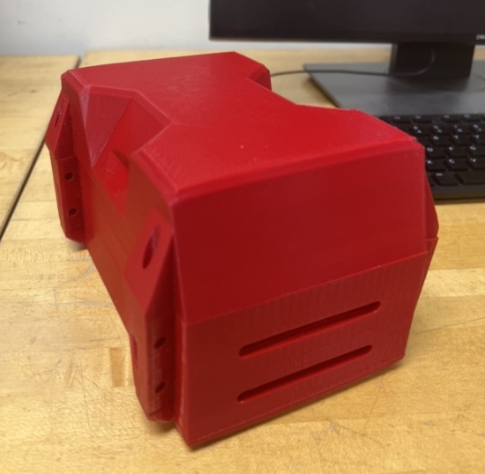
Figure 15. Chassis.

Fastener Components
- Alloy Steel Socket Head Screw – Made of Black Oxide, M5 x 0.8 mm Thread, and 130 mm Long. This screw is utilized to hold the Shoulder Flange T-Joint together.
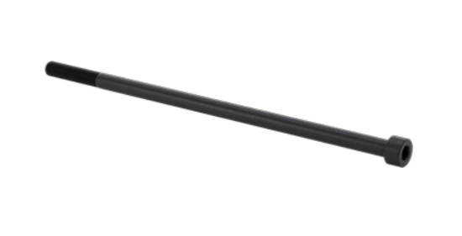
Figure 16. Shoulder Joint Screws.

- Alloy Steel Socket Head Screw – Zinc-Flake Coated, M5 x 0.8 mm Thread, and 14 mm Long. This screw is utilized to hold the Boom (arm) to the Shoulder Flange.
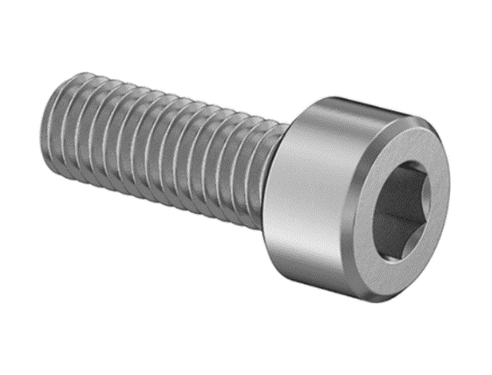
Figure 17. Boom (Arm) Screws.

- Alloy Steel Socket Head Screw – Made of Black-Oxide, M5 x 0.8 mm Thread, 40 mm Long, Fully Threaded. This screw it utilized to secure the shoulder assembly to the dovetails of the chassis.
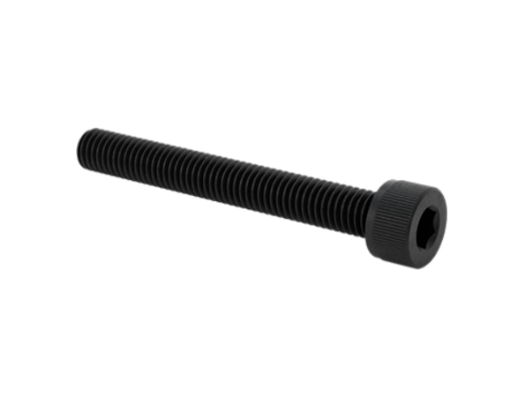
Figure 18. Dovetail Screws.

- Steel Thin Hex Nut – Low-Strength, Zinc-Plated, M5 x 0.8 mm Thread. This nut is utilized to compress each part and fasten the screws into plate.
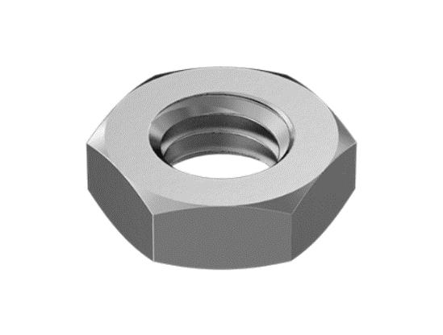
Figure 19. Nuts.

Electrical Components
- Arduino MEGA Microcontroller – This device is a microcontroller board which will store the code and actuate the motor, in addition to controlling the safe operation of the arm as it lifts the weight and slowly puts it back down.
Figure 20. Arduino MEGA Microcontroller.

- NEMA 23 Motor – This is a small stepper motor that has a max torque of 1.9 Newton-meters and has a rated current of 2.8 Amperes. The shaft rotates 1.8 degrees per step (200 steps/rev).
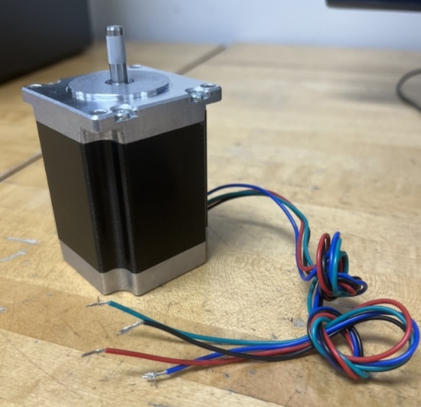
Figure 21. NEMA 23 Motor.

- TB6600 Motor Driver – This device acts as the transmission between the Arduino and the motor. It supplies the correct number of volts and amps that the motor needs, and works under the control of the Arduino and the stored code within.
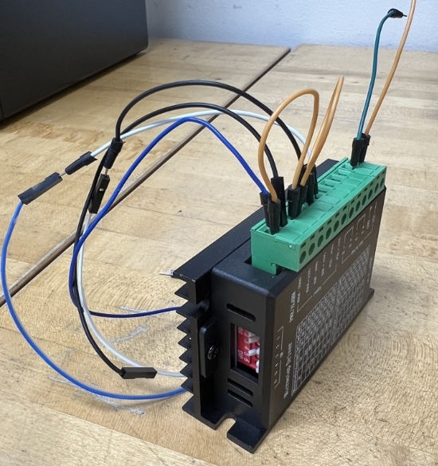
Figure 22. TB6600 Motor Driver

- Male-Male Jumper Wires – These additional wires are required outside of the ones that come pre-connected to the stepper motor. The wires are necessary to connect the power supply to the motor driver, as well as from the motor driver to the Arduino.
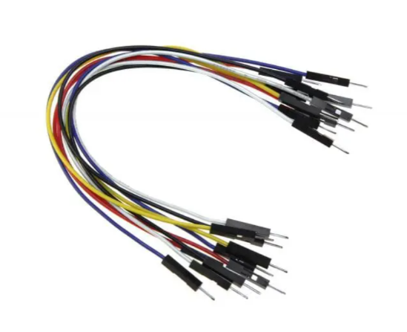
Figure 23. Male-Male Jumper Wires

Other Components
- Bullet Balls (BBs) – These are utilized within the bearing casing, creating a thin ball bearing that allows the arm to rotate up and down within the shoulder blade.
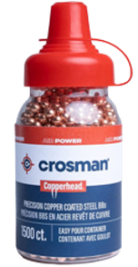

Figure 24. Bullet Balls (BBs)

- Lubricant for Bearings – This food grade lubricant is used for the bearings because it has an oil-based consistency, allowing it to seep between the BBs. By lubricating the bearings, it helps to reduce friction between the PLA and the BBs.
Figure 25. Lubricant used on the bearings

- Lubricant for Gears – This food grade lubricant is used for the gears because it has a thicker consistency, providing more surface contact on the gears. By lubricating the gearbox system, it helps to prevent ware on the gears.
Figure 26. Lubricant used on the gears

- Plastic Dowel Pins – The dowel pins are used as locators to ensure that the parts assembling together to create the Shoulder Flange T-Joint align.
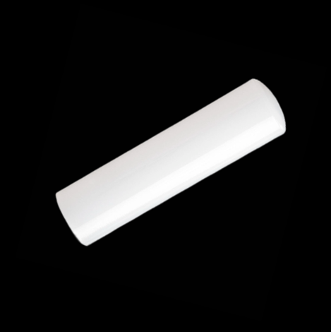
Figure 27. Dowel Pins

- Bucket and Weight – This bucket is attached to the knuckle (otherwise known as the end of the arm) with 25-pound rated fishing line. The weight is located inside the bucket, and the line is attached at the center of the handle of the bucket.
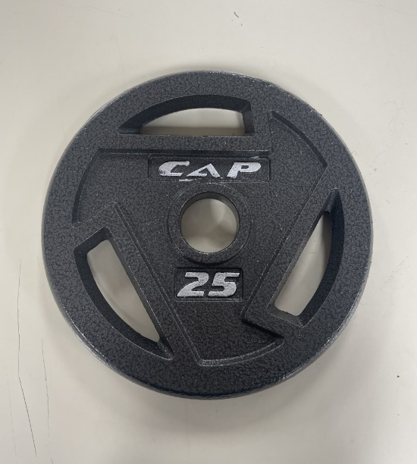
Fig 28. and 29. Bucket for Weight and Purchased 25-Pound weight (respectively)

Wiring Diagram
Below is the wiring diagram by which the Arduino and motor connect, as well as the power supply which keeps the electrical components working and operational.
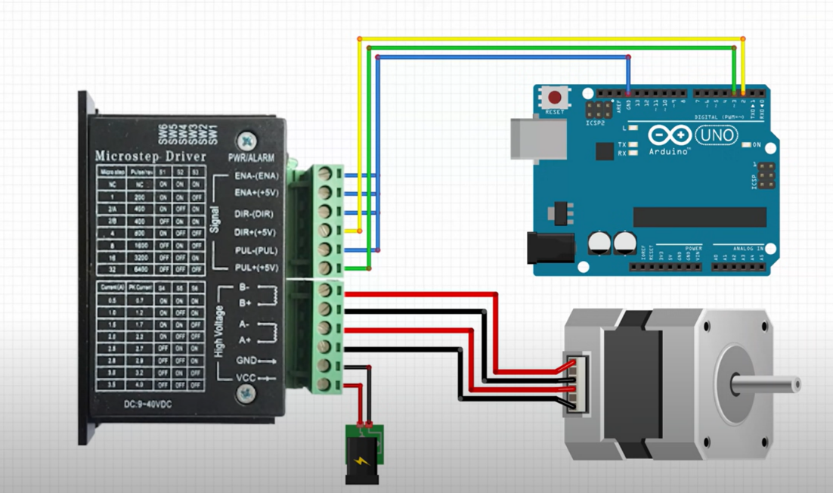
Figure 30. Arduino Wiring Diagram

Code for Arduino MEGA Microcontroller
Below is the code for the Arduino, which powers the NEMA 23 motor for the RE-RASSOR Shoulder Phase II Project. The code allows for the motor shaft to slowly begin accelerating, obtaining a slow and gradual velocity before it reaches a maximum constant velocity. Then it begins decelerating, causing the velocity to slowly and gradually decrease. At this point, the arm is stopped at maximum angle for maximum lift. Then, the motor begins rotating in the opposite direction to allow for a safe and slow drop of the weight that is attached.

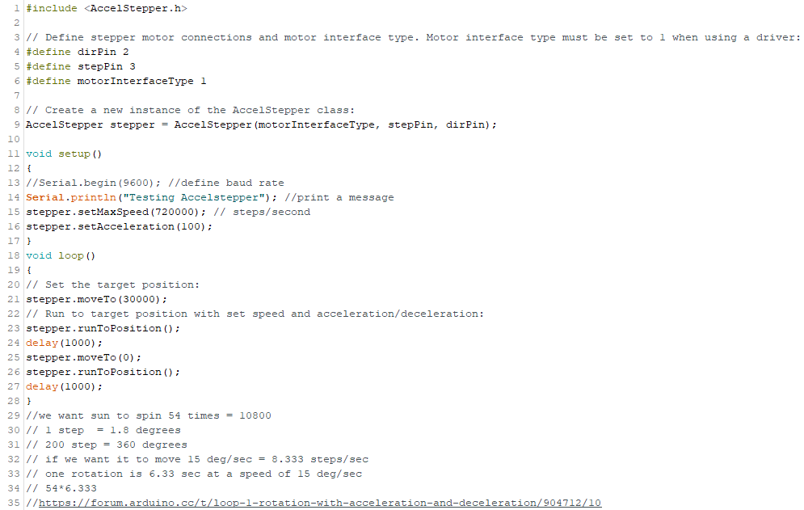
Figure 31. Arduino Code.

Required Tools
There are few tools and components required for assembly of the RE-RASSOR Shoulder Phase II. The team recommends using the exact ones that are listed. Team 512 makes no guarantee of components other than the ones listed here working successfully for the intended purpose. See below for the complete list:
- Allan Wrench
  - M5, 2.5 mm: Pittsburgh SAE & Metric Long Reach Hex Key Set, 36 pc.
- Screwdriver
  - Optional: Pittsburgh Ratcheting Screwdriver Set, 34 pc.
- Screws
  - Alloy Steel Socket Head Screw: Black Oxide, M5 x 0.8mm Thread, 130mm long
  - Alloy Steel Socket Head Screw: Black Oxide, M5 x 0.8mm Thread, 40mm long
  - Alloy Steel Socket Head Screw: Zinc-Flake Coated, M5 x 0.8mm Thread, 14mm long
- Nuts
  - Steel Thin Hex Nut: Zinc-Plated, M5 x 0.8mm Thread
- Clamps
  - Optional: 4/6/8/10 in Quick Grip Ratchet Bar Clamps
- Dowel pins
  - Acetal Dowel Pins: 3/32” Diameter, 1/2" Long
- BBs
  - Crosman Copperhead 4.5mm Copper Coated BBs: EZ-Pour Bottle, 1500 ct.
- Lubricant
  - Super Lube Multipurpose Synthetic Grease: PTFE, White, 3 oz
  - Super Lube Synthetic Lightweight Oil: PTFE, White, 4 oz
- Electrical
  - CNC Stepper Motor Nema 23: Bipolar, 2.8A, 269oz.in/1.9Nm, CNC Mill Lathe Router
  - Stepper Motor Driver TB6600: 4A, 9-42V, Nema 17 Stepper Motor Driver CNC Controller Single Axes Phase Hybrid Stepper Motor for CNC/4257 86 Stepper Motor
  - Power Supply: DC 12V, 2A
  - Arduino Board: Mega 2560

Integration

3D-Printing Parts
This product is intended for ages 11 and up. Team 512 assumes the adult using this product for instruction has basic knowledge of how to operate their 3D-printer. If one has never used their 3D printer before, please familiarize yourself with 3D-printing and start by printing a simple calibration cube, which can be found on Thingiverse.com.
In order to create the RE-RASSOR Shoulder Phase II Project, one must begin by 3D-printing the components. All the STL files for the 3D-printed components ready to be printed can be found here: https://web1.eng.famu.fsu.edu/me/senior_design/2023/team512/. Download the zip file, click “Extract”, then open each file in a 3D-printing slicing software. Team 512 recommends using the slicing software called “Ultimaker-Cura” to slice each part, but this specific software is not required. Note, your 3D printer must be set up with the software before you can download the STL files. Separately upload each file to the slicing software, then slice using these settings:
- Left Shoulder Blade
  - Infill: 20%
  - Wall Thickness: 0.8
  - Layer Height: 0.2
- Right Shoulder Blade
  - Infill: 20%
  - Wall Thickness: 0.8
  - Layer Height: 0.2
- Harmonic Gear with Clockwise Spline
  - Infill: 20%
  - Wall Thickness: 0.4
  - Layer Height: 0.2
- Harmonic Gear with Counterclockwise Spline
  - Infill: 20%
  - Wall Thickness: 0.4
  - Layer Height: 0.2
- Planetary Carrier
  - Infill: 20%
  - Wall Thickness: 1.2
  - Layer Height: 0.2
- Planetary Gears
  - Infill: 20%
  - Wall Thickness: 1.2
  - Layer Height: 0.2
- Sun Gear
  - Infill: 20%
  - Wall Thickness: 1.2
  - Layer Height: 0.2
- Thin Ball Bearing
  - Infill: 20%
  - Wall Thickness: 0.4
  - Layer Height: 0.2
- Boom and Knuckle
  - Infill: 70%
  - Wall Thickness: 1.6
  - Layer Height: 0.3
- Motor Housing
  - Infill: 20%
  - Wall Thickness: 0.8
  - Layer Height: 0.3
- Chassis
  - Infill: 20%
  - Wall Thickness: 0.4
  - Layer Height: 0.3
Please note, Team 512 recommends using these exact settings, and not altering any other settings for simplicity purposes. Each part should be oriented with the maximum surface area touching the bed. If there are areas of the part that do not mesh with the bed, one will need to enable supports. Once 3D-printing is complete, there should be 16 total parts created. Some parts will require the removal of supports. Note that parts can be made of various colors, not the ones that are explicitly specified in this instruction manual.

Assembly
Below is step by step instructions for how to take each part and component and turn it into a full-fledged assembly. Follow each step closely and take caution at every point. It is recommended that at least two people put it together.

Step 1: Begin by placing the motor into the motor housing. Align the shaft through the central hole of the housing, as well as the four holes on each corner of the motor. Apply the screws through the 4 corner holes to secure in place. Tighten with the required tool.
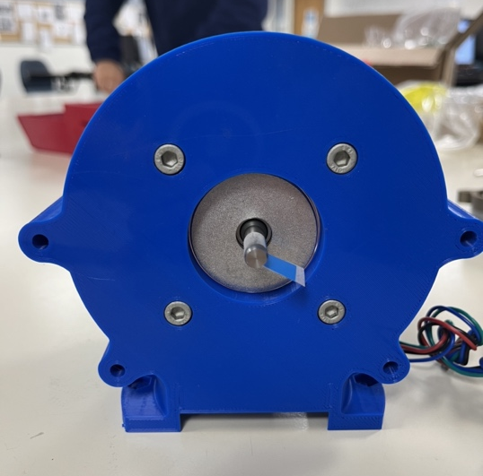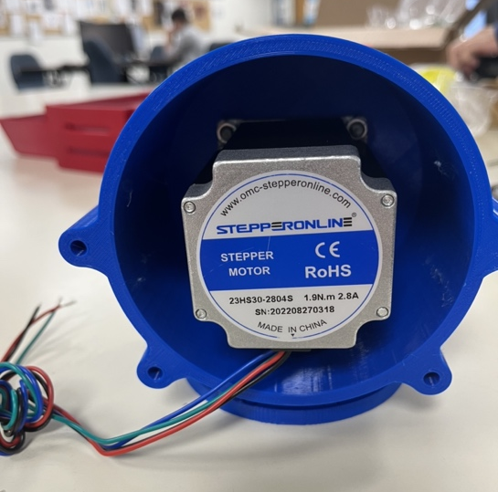
Figure 32. And 33. Front and back of Motor Housing with motor (respectively).

Step 2: Begin assembling the gearbox. Locate the three planetary gears (black) and sun gear (yellow). Use the planetary carrier (yellow) to space and secure the planetary gears 120 degrees apart from one another. With the gear teeth meshed properly, insert the sun gear into the center.
Figure 34. And 35. Front and Back of Planetary Gear Assembly

Step 3: Locate both harmonic gears (blue and white). Place the dowel pins in the holes on the white harmonic gear (the piece with a slice of the shoulder flange attached). Then, stack the side of the blue harmonic with the lip onto the side of the white harmonic with the corresponding lip, ensuring the dowel pins go through both harmonics and that the surfaces are flush with one another. Note, the bolt holes should line up exactly for both harmonic gears.
Figure 36. Harmonic Gear with clockwise spline versus Harmonic Gear with counterclockwise spline.

Step 4: Gently press the planetary and sun gears together inside of the stacked harmonic gear. Ensure that the gear teeth of the planetary gears and the gear teeth on the harmonic mesh well together. Once the gears are pressed together, remove the planetary carrier using any tool to pry it off. Note, make sure the gears stay in place when removing the planetary carrier.
Figure 37. Planetary gearbox assembly.

Step 5: Attach the bearings (red and gold) to each shoulder blade (grey). Place the outer ring of the bearing over the extruded circular section of each blade. Begin press fitting BBs into the groove that now exists between the bearing ring and the shoulder blade. It is advised to press enough BBs to nearly fill the entire ring of the bearing, but not completely, allowing for smoother motion. Then, add dowel pins in the appropriate holes of the bearings.
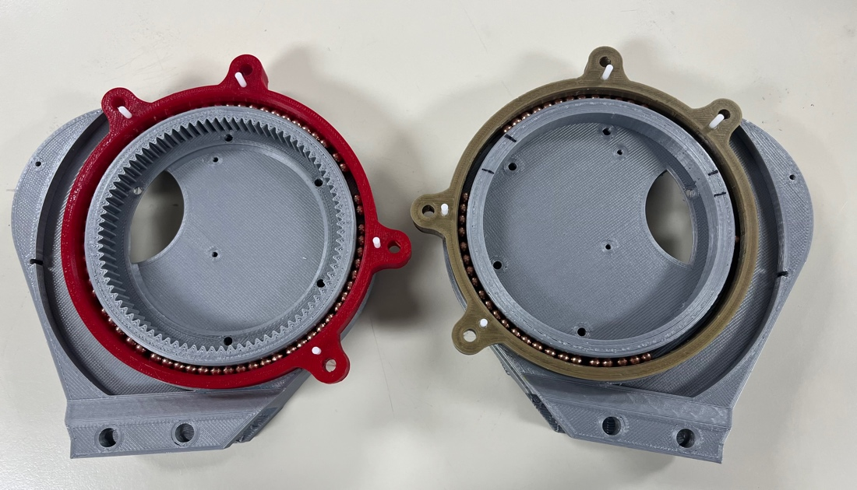
Figure 38. Shoulder blades with bearings attached.

Step 6: With the gearbox fully assembled, press the remaining portion of the planetary gears into the gear found on the side of the right shoulder blade. Ensure that the holes align properly. The planetary gears should be flush with the exterior surface of the harmonic gear; however, the sun gear should be poking out. This is because the sun gear will attach to the shaft of the motor.
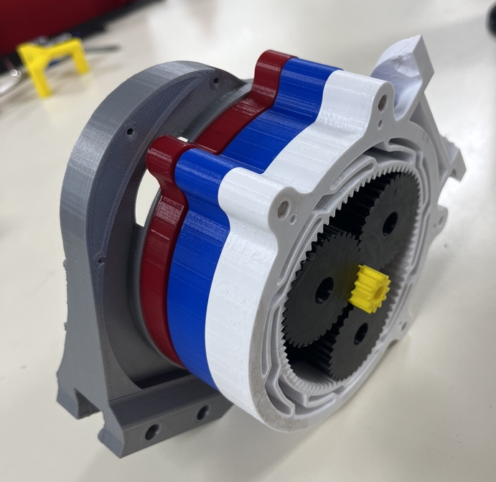
Figure 39. Full gearbox assembly.

Step 7: Place dowel pins on the outward surface of the newly completed gearbox. Align the dowel pin holes on the motor gear housing with the dowel pins that were just placed. Push down on the motor gear housing. If done correctly, the shaft of the motor should fit nicely and smoothly in the hole on the sun gear. Do not use too much force, as it is crucial not to damage the shaft of the motor. Ensure the shaft properly connects with the sun gear.
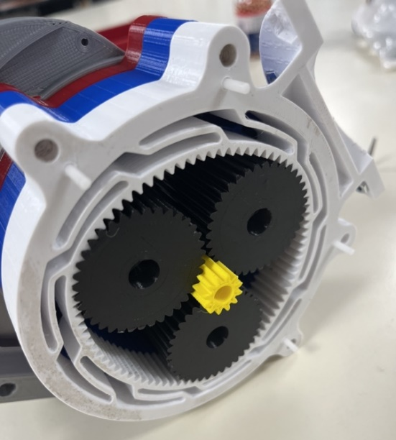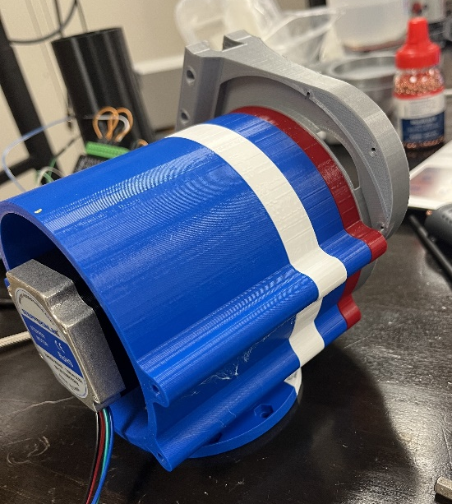
Figure 40. and 41. Dowel pins on the outward surface of the newly completed gearbox, and shoulder assembly including motor housing (respectively)

Step 8: Attach the end of the motor housing to the bearing on the other shoulder blade. Align the dowel pins on the shoulder blade onto the opposite end of the motor housing. This will line up all bolt holes across the newly completed shoulder joint. Note, the various sections of the shoulder flange should all be pointing outward and away from the chassis. Now, thread the 130 mm long screws through all four bolt holes, then apply a nut at the end to secure the entire shoulder together.
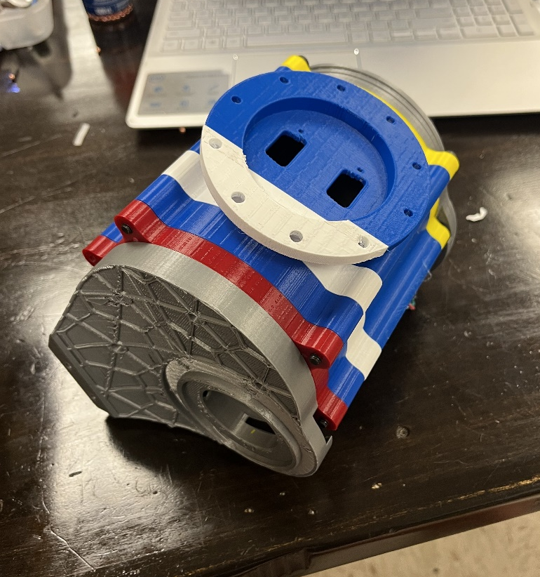
Figure 42. Completed shoulder joint assembly.

Step 9: Slide the shoulder blades onto the chassis using the dovetails as a guide. Once they are properly guided onto the chassis, use the 40 mm long screws to secure the shoulder blades in place.
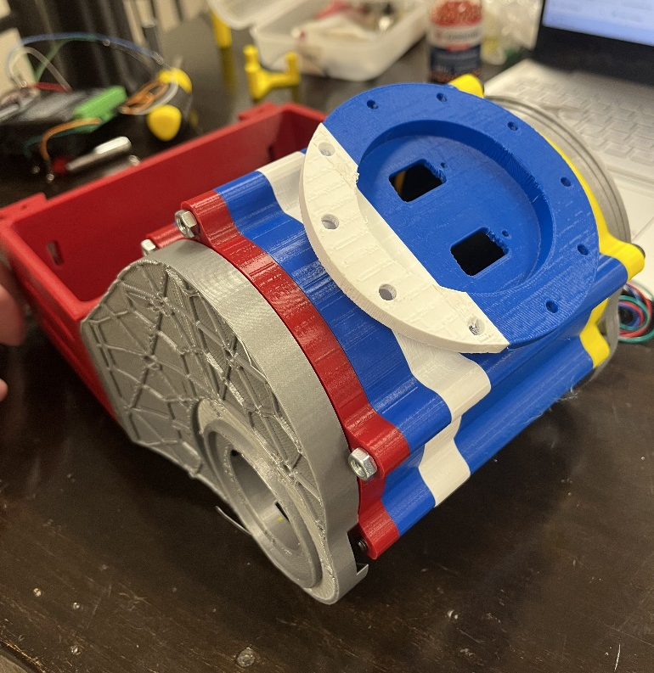
Figure 43. Completed shoulder joint assembly attached to the chassis.

Step 10: Press fit the hex nuts into the extruded hex shape on the underside of the shoulder flange. Then align the holes of the shoulder flange and arm flange properly. Afterwards, stick screws down through the holes while placing a finger underneath to hold the nut in place. Tighten using the required tool. Lastly, press fit the knuckle onto the boom.
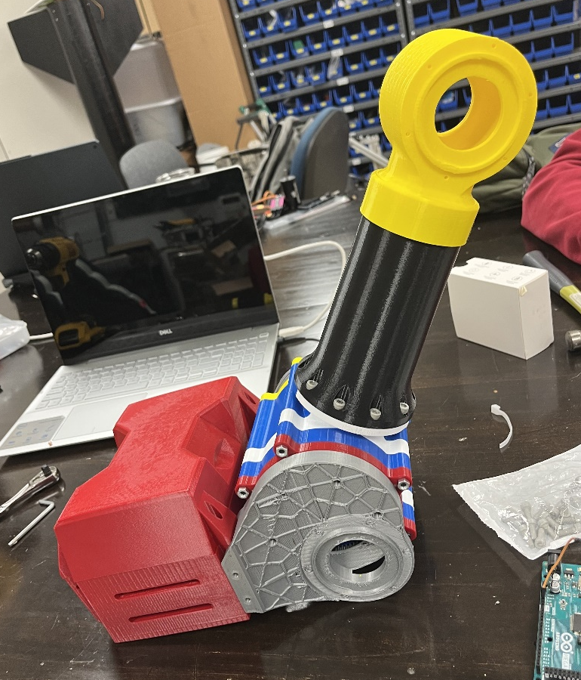
Figure 44. Completed RE-RASSOR arm and shoulder assembly.

Step 11: Wire the motor to a power supply. Refer to the wiring diagram above in the operation manual. Then connect the Arduino as instructed in the diagram. Make sure to upload the given code for the Arduino. Ensure the proper motor drivers and proper power supply are used.

Operation
To safely operate the assembly, there are several important factors to consider. They are wiring the motor correctly to the power supply, using the Arduino as intended and integrating it with the other electrical components, properly putting the parts together, and hooking the weight on to the arm.
To correctly wire the motor to the power supply (as well as the wiring for other additional components) make sure to follow the wiring diagram closely. This diagram is provided in the previous pages of the operation manual. Visit the section, “Wiring Diagram” for more information and details on this process. To avoid any potential injury, make sure the power is off when putting wires together or taking them apart.
To use the Arduino as intended, simply download the provided file by going onto our website at https://web1.eng.famu.fsu.edu/me/senior_design/2023/team512/. Or, simply open the Arduino application and start a new file. Once open, you will see a section that reads “void setup()” and a section that reads “void loop()”. You can copy and paste our code, or make adjustments to it, to fit your needs. In any case, make sure to save the file. With the Arduino board connected to the computer, click “Sketch” then click “Upload” after the file has been properly saved. This will let the Arduino know exactly how to operate the motor, and at what speeds, times, and direction the motor shaft should move. Follow along with the referenced wiring diagram to see how this device is integrated with the rest of the electrical components.
To properly put the parts together, please ensure that nothing is being forced. All parts should mate relatively easy, so if they do not fit properly this could be an issue of a bad print. Please see the later section on troubleshooting for more information on this matter. Note that forcing parts together could create a pinch point. To avoid self-injury or bodily harm, inspect parts for any errors in the finish before pushing too hard or applying too much force. Keep your hands and fingers away from such points and always think before doing. Read the instructions for assembly carefully and follow them closely. Additionally, use the lubricants as necessary and apply a generous amount to the gears and to the bearings to allow for smoother motion.
To safely attach the weight to the arm, it is recommended to use fishing line. Any bucket will do, but it is important the bucket be one that is strong enough to hold up to 25 pounds. The user should tie a secure and tight knot at the center of the handle of said bucket. Make sure that it is a knot that cannot be undone easily. Then, place weight into the bucket. A single 25-pound weight is preferred, but smaller weights can be added in. If the approach of multiple small weights is taken, be sure that the smaller weights are stacked as neatly as possible and placed into the bucket as central as possible in order to reduce the chances that the bucket wobbles or moves around while being lifted. Exceeding 25 pounds is not recommended. It is critical that the bucket and weight at the end of the cable be as uniform as possible and experience little to no movement while being lifted otherwise the system may experience failure, which may potentially cause injury. The other end of the cable can be looped through the hole of the knuckle, then tied using a secure knot. The length of the cable will depend on what table the system is placed on, how tall the table is off the ground, and what kind of bucket is used. We recommend using a length that is about the distance from the bucket handle when the bucket is placed on the floor, to about a foot above the table. Before operating, the chassis should be clamped to the table and weight should be added to the hollow inside in order to secure the system to ground.
To start, turn on the power supply. Send the signal to the Arduino. The code which was provided will be able to tell the motor shaft exactly how it needs to move. It will have a slow start, then increase its speed, then come to a slow stop. This provides for smooth acceleration curves which will prevent any jerking motion while the arm is moving with the weight. The motor shaft will then begin rotating slowly in the opposite direction to place the weight back on the ground after it has been lifted. While the arm is moving and the weight is being lifted, be sure to keep feet away from underneath the weight to avoid any potential injury.

Troubleshooting
There are several potential aspects of the project where error may be encountered. Below is a list of potential issues that may be encountered while assembling the RE-RASSSOR Shoulder Phase II project with their suggested remedies.

Issue #1: Poor-Quality 3D-Printed Part
- Remedy: Team 512 recommends printing the STL files that are provided, without making any changes. Changing the given files can be grounds for error in the prints. Only experienced and trained professionals should consider adjusting any of the 3D models.
- Remedy: Check your 3D-printer to make sure it is leveled correctly. Without the proper z-axis alignment, a part will not stick to the printer bed as expected.
- Remedy: Check the temperature of your 3D-printer bed and nozzle. Make sure that the temperatures used are the same as the temperatures recommended by the manufacturer for the PLA used.
- Remedy: Try to print the poor-quality part in a different orientation. You may have chosen an orientation that was not best suited for each part.

Issue #2: Gearbox or Bearings Not Working Properly
- Remedy: Team 512 recommends using the provided lubricants as they are food safe, electronic safe, and non-toxic. Applying these lubricants to the gears and to the bearings can allow for smoother motion, as well as reduce friction. Apply as necessary but note, this may be messy.

Issue #3: Ware/Cracking of the 3D-Printed Parts
- Remedy: Due to the mechanical properties of PLA and depending on usage, gears may eventually wear down and be unable to perform the same. One can reprint fresh gears to replace the worn-down ones.
- Remedy: Due to the mechanical properties of PLA and depending on usage, the dovetails of the chassis may eventually crack due to fatigue. One can reprint a fresh chassis to replace the cracked chassis. Team 512 recommends adding weight to the chassis during operation, to help secure the system to a ground.

Issue #4: Print is Warping
- Remedy: For some 3D-printers, heat may not evenly be distributed to the bed, resulting in large parts having edges that may not stick. Try using a glue stick directly on the bed prior to starting large prints.

Issue #5: 3D-Print is Incomplete
- Remedy: Check the nozzle of your 3D-printer to make sure it is not clogged. Clogging of the nozzle can prevent material extrusion.
- Remedy: The PLA going into the extruder may have snapped. Check the roll of PLA and ensure that it is being properly fed into the extruder.

Issue #6: Shoulder Joint Screws Do Not Fit
- Remedy: Lubricate the screws with the oil-based lubricant to help them glide through the bolt-holes easier.

Appendix F: Engineering Drawings
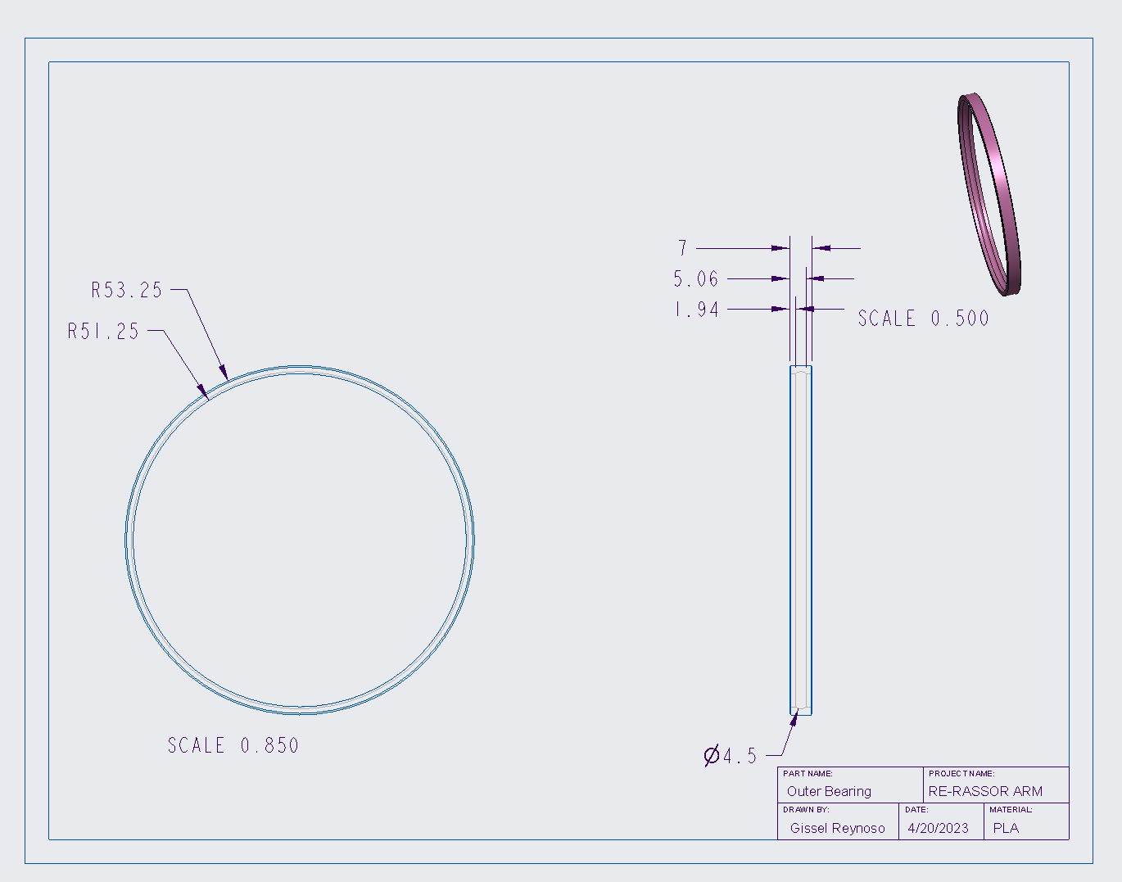
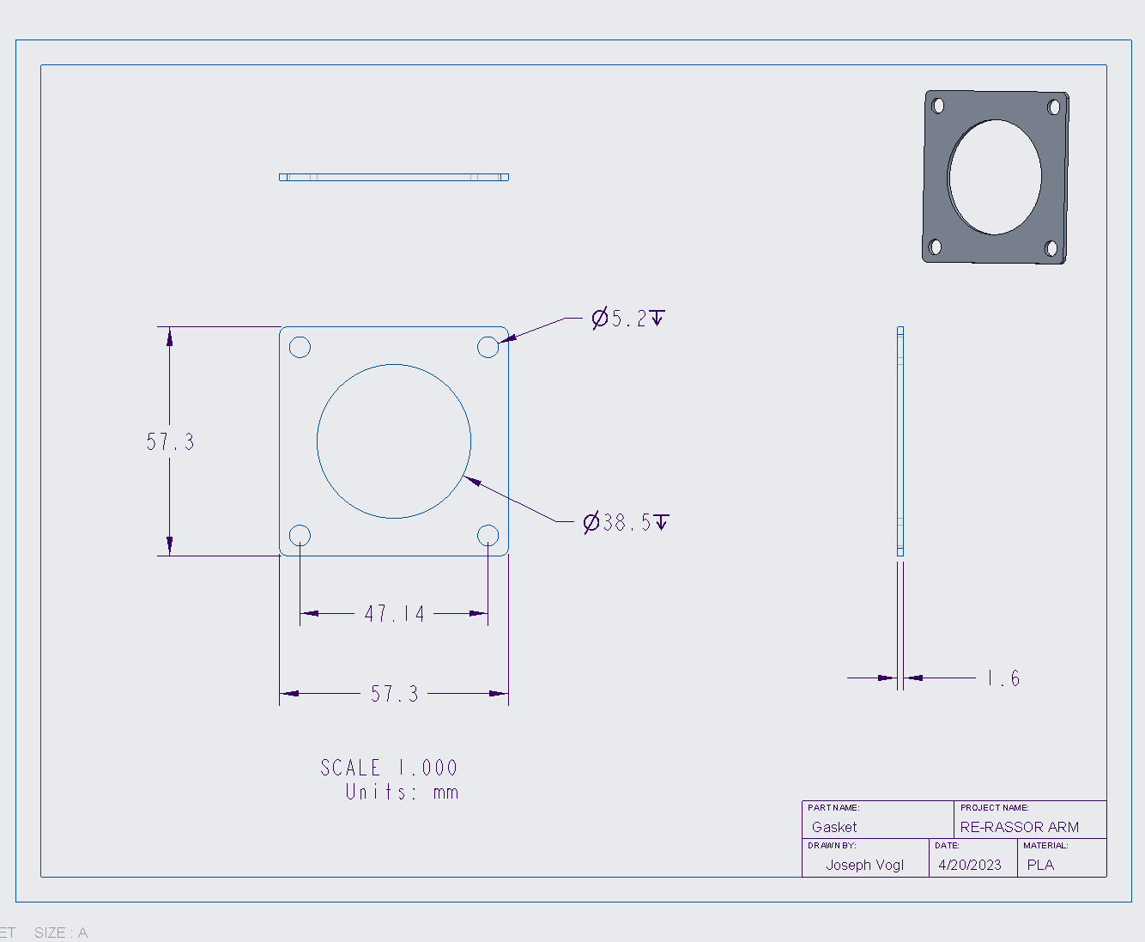
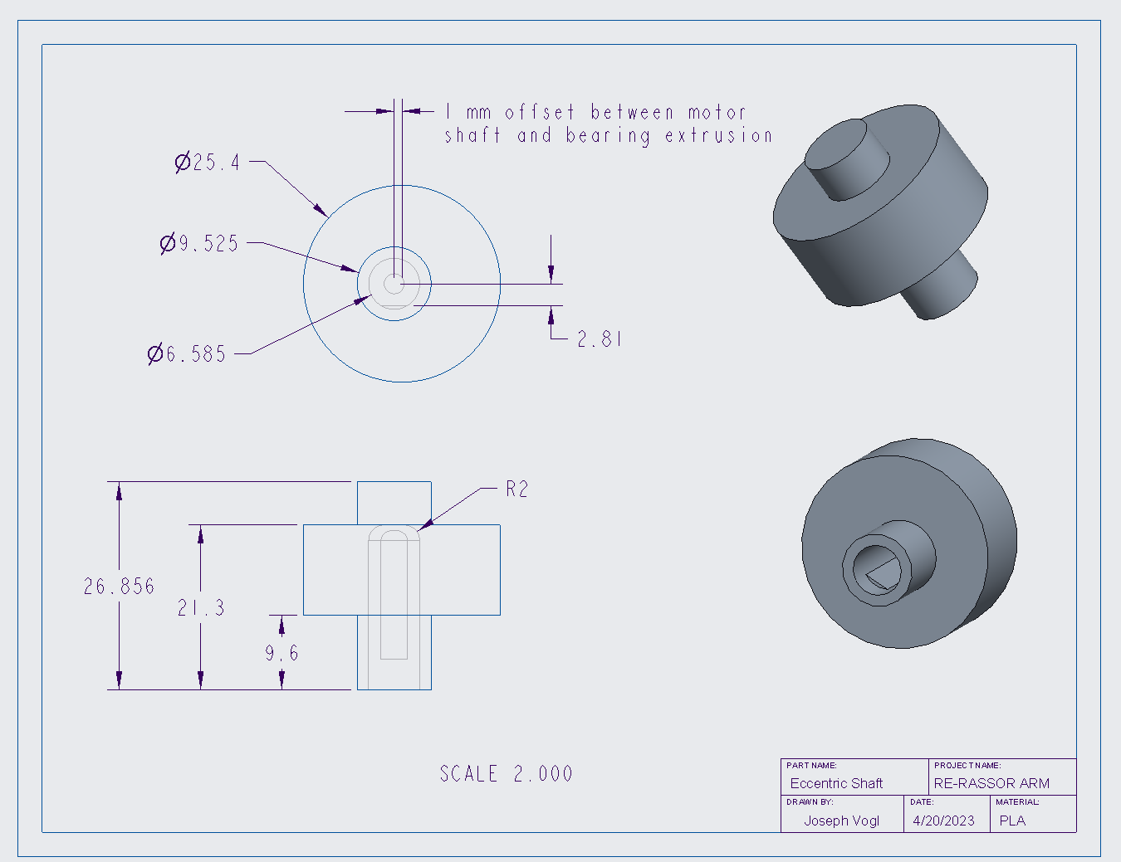
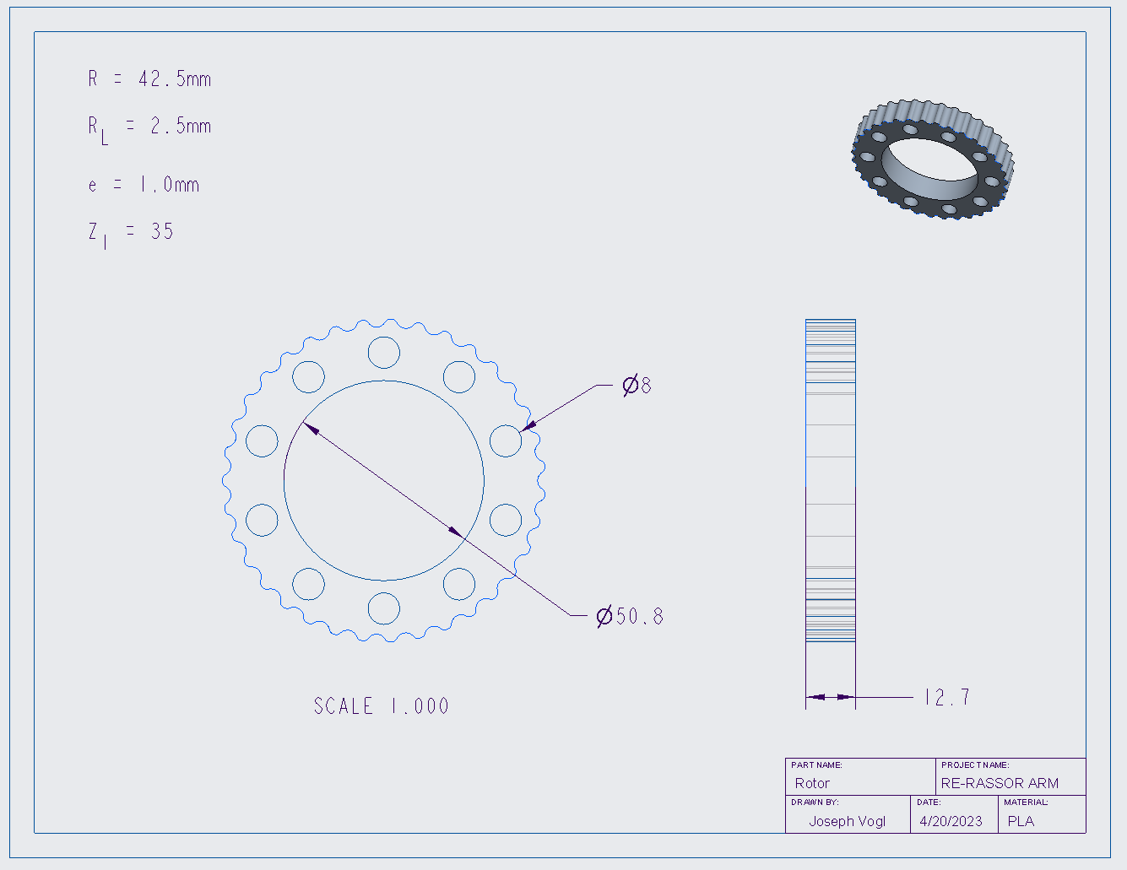
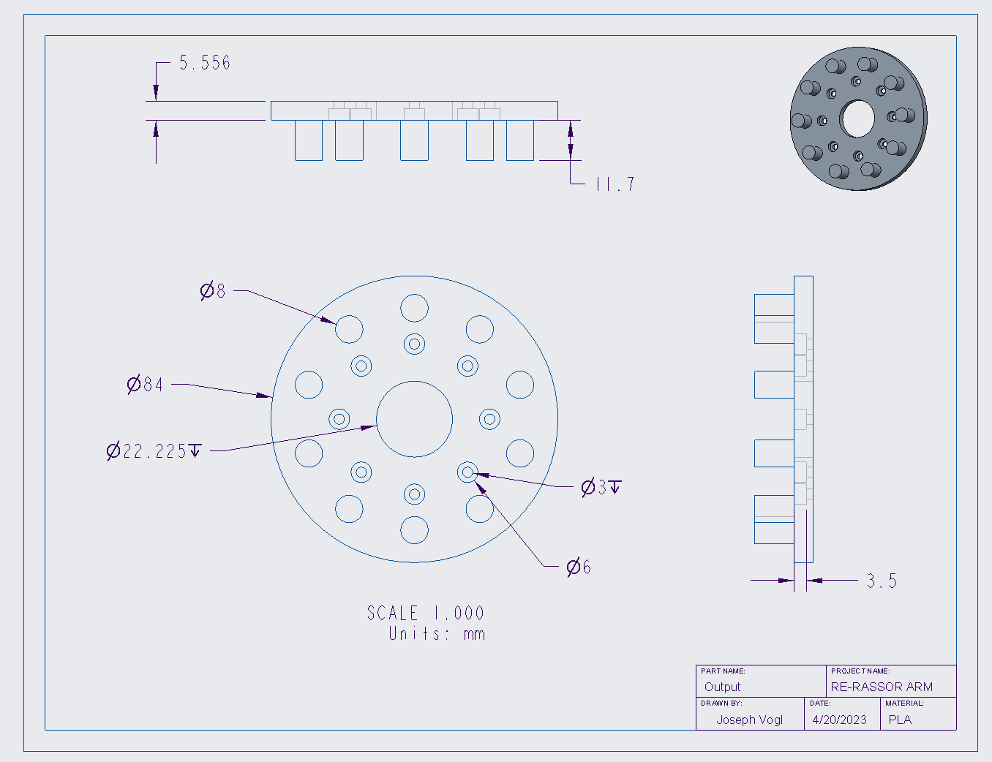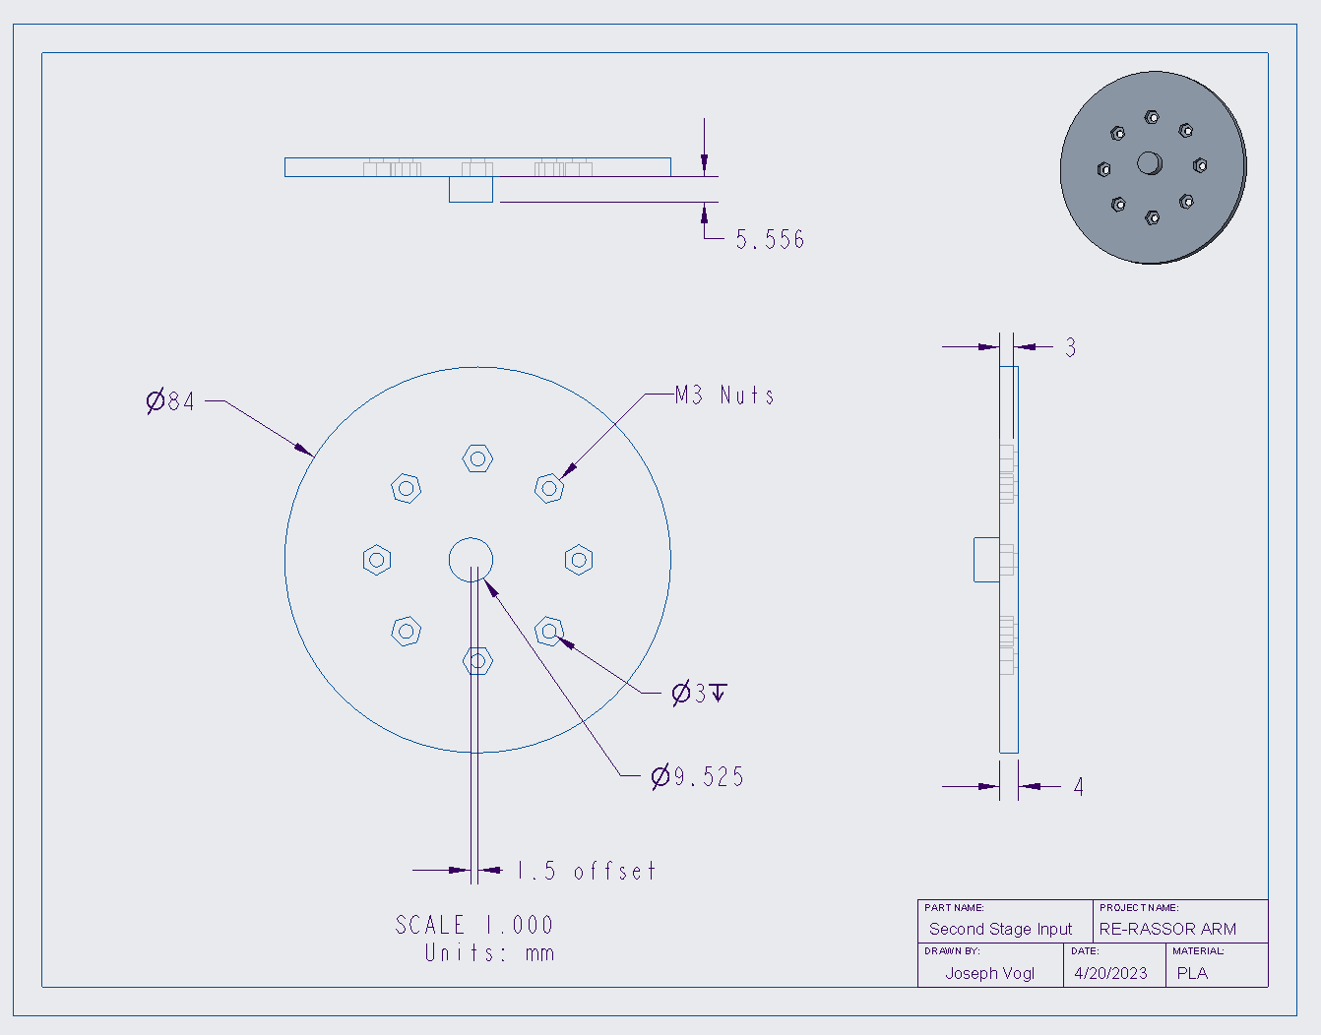
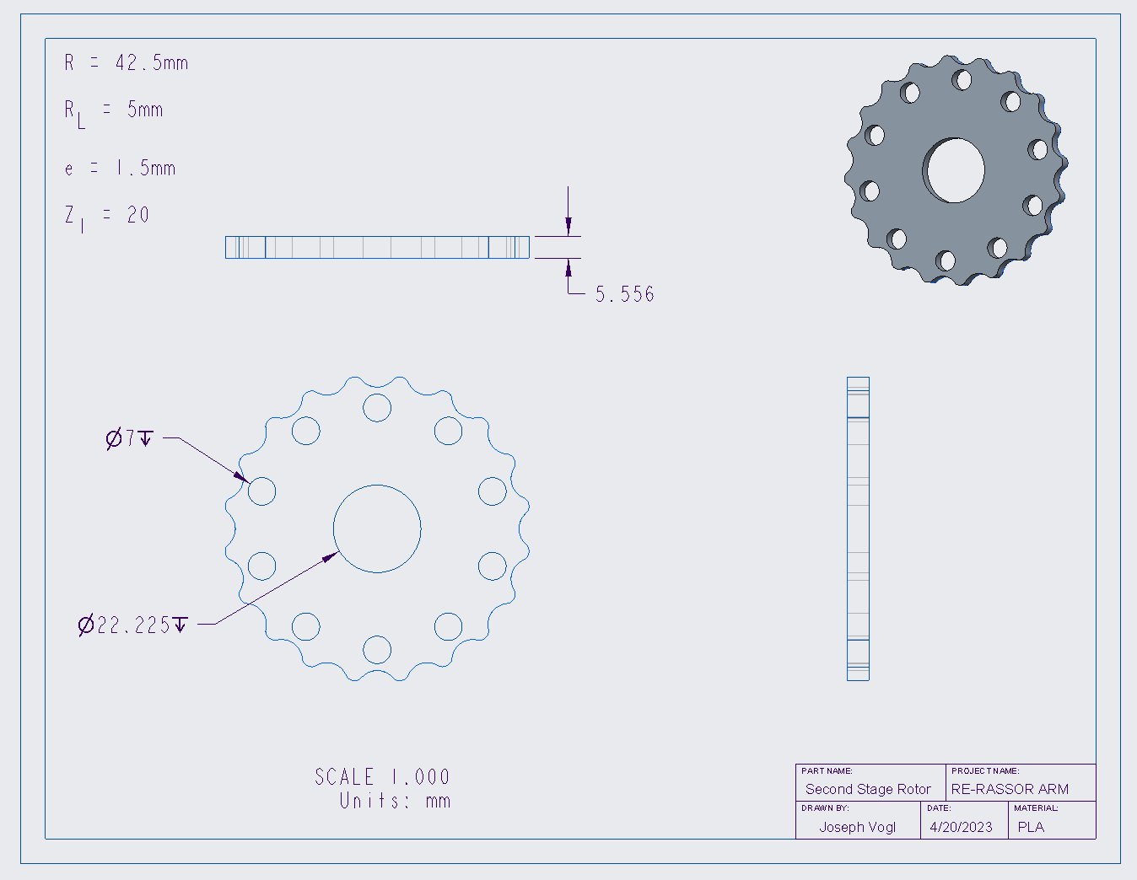

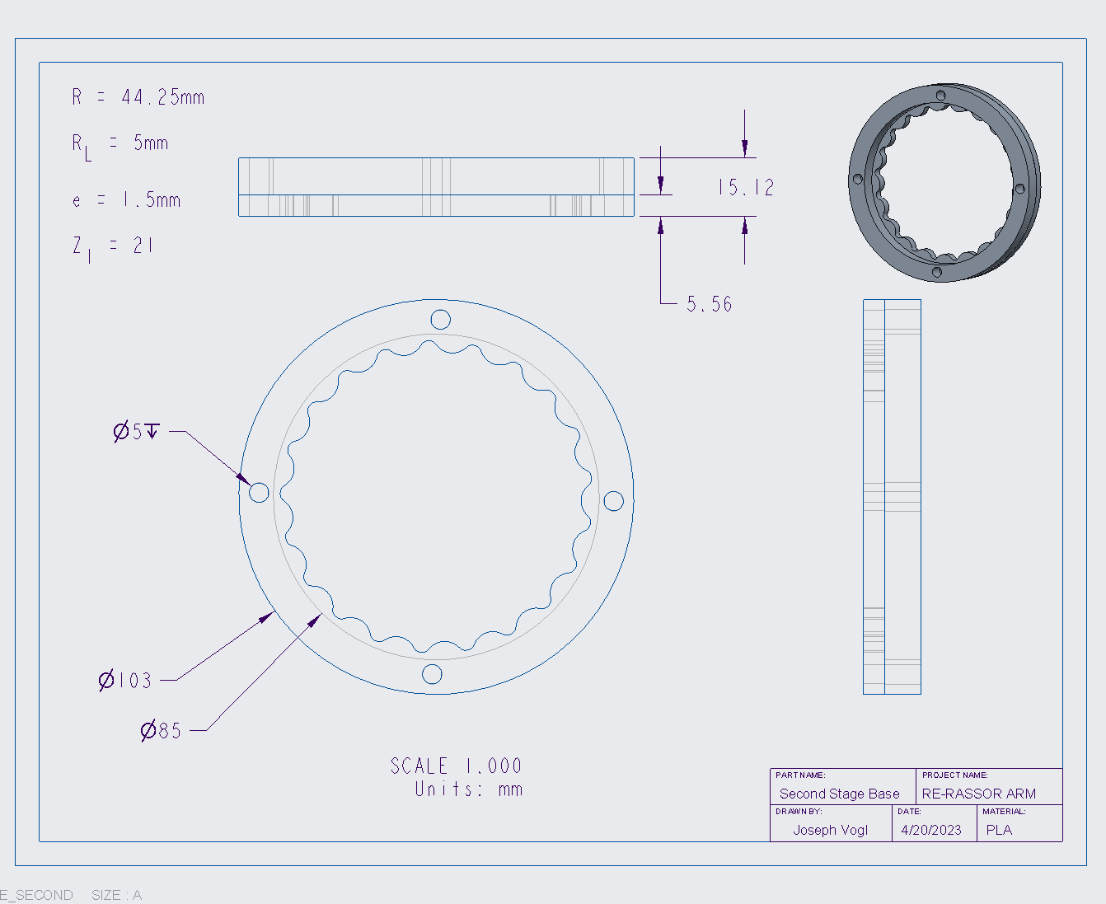

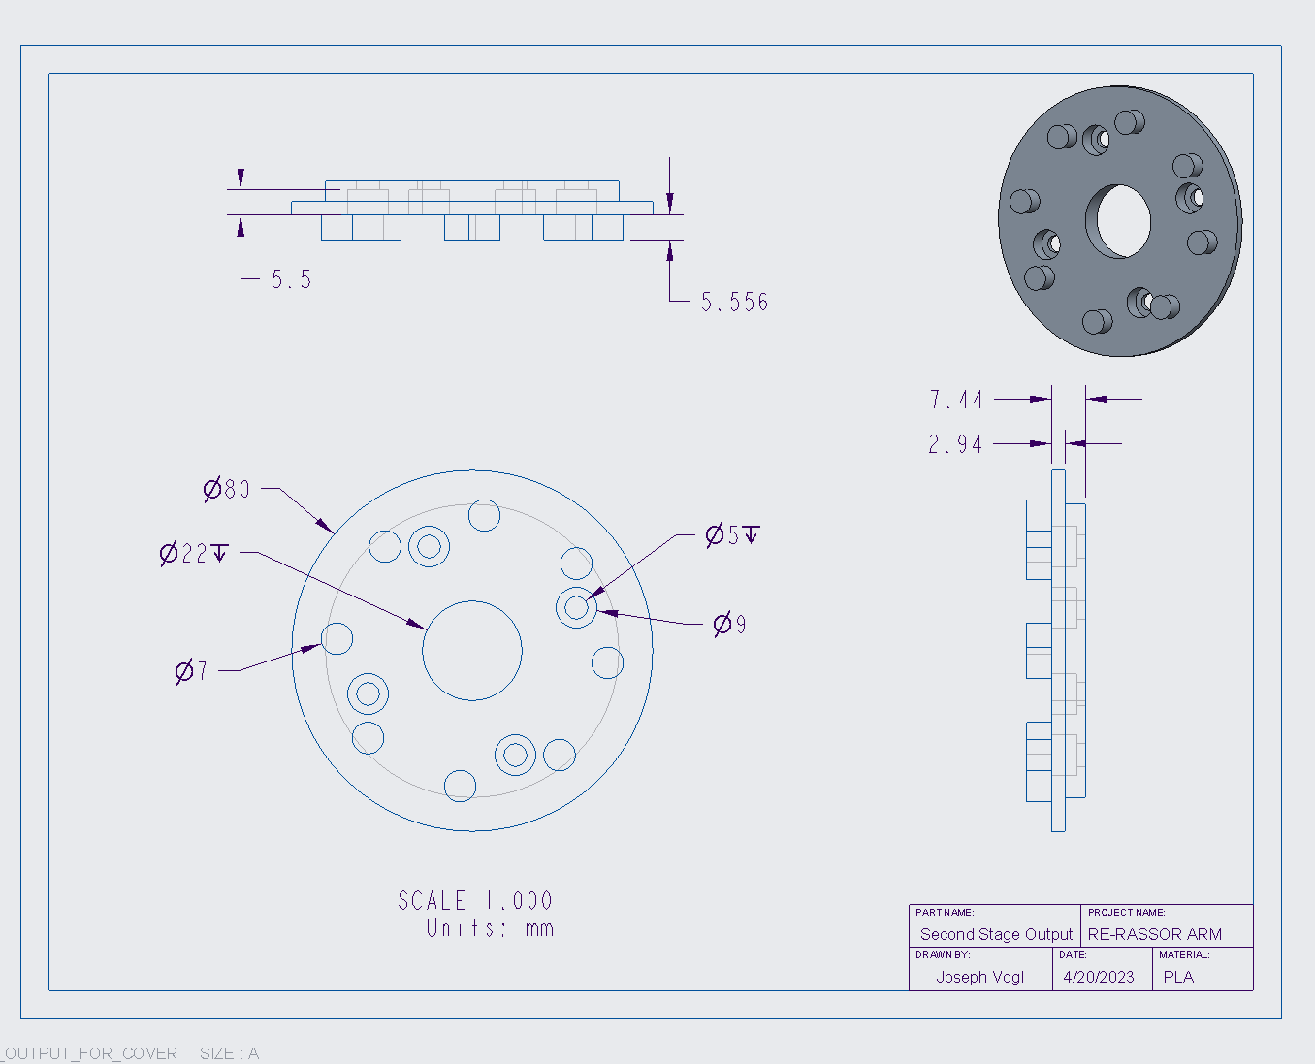

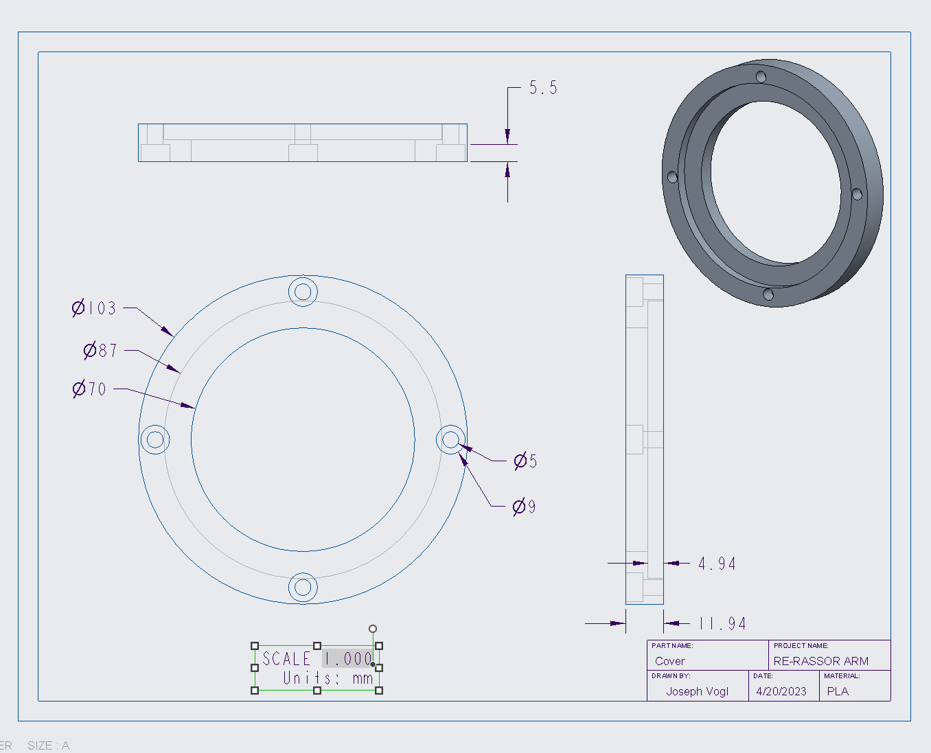

Appendix G: Calculations
Planetary Gearbox Calculations Using MATLAB
%% Conversions
clc
close all
clear all
pounds=25;
angle = 90:-1:0;
length = 12*cosd(angle); %in inches
length_meters = length / 39.37;
Newtons = pounds * 4.448;
Torque_arm = Newtons * length_meters; %Nm
torque_motor = 1.9; %Nm
Reduction_Ratio_Needed = Torque_arm / torque_motor
Reduction_Ratio_Needed_Max = max(Reduction_Ratio_Needed)
plot(angle,Torque_arm, 'LineWidth', 2) % Not sure if this is correct
grid on
title('Torque Needed Throughout Operation')
xlabel('Angle of the Arm (Horizontal to Vertical)');
ylabel('Torque Needed in Nm');
Ring_Teeth = 84;
Spline_Teeth = Ring_Teeth - 4;
Sun_Teeth = 12;
Number_of_Planets = 3;
Reduction_1 = (Ring_Teeth/Sun_Teeth)+1;
Reduction_2 = 1/ ((Spline_Teeth-Ring_Teeth)/Spline_Teeth);
Reduction_Total = Reduction_1*Reduction_2;
k = (Sun_Teeth - Ring_Teeth) / Number_of_Planets;
Num_teeth_Planets = (Ring_Teeth - Sun_Teeth)/2
% fprintf('K value must be positive for for planets to fit equally: %f\n', k)
%
% fprintf('Number must be an integer for %g planets to fit at equal angles\n', Number_of_Planets)
fprintf('The reduction ratio needed to lift 25 pounds is: %.2f\n\n', Reduction_Ratio_Needed_Max);
fprintf('The reduction ratio calculated by using %g teeth on the Sun Gear and %g teeth on the Ring Gear is: %.2f \n\n', Sun_Teeth, Ring_Teeth, Reduction_Total)
if floor(k)==k
fprintf('%g planetary gears will fit equally with %g teeth on the Sun Gear and %g teeth on the Ring Gear\n', Number_of_Planets, Sun_Teeth, Ring_Teeth)
else
fprintf('%g planetary gears wont fit equally\n', Number_of_Planets')
end
%% Gear Calculations
Sun_Teeth = 24;
Ring_Teeth = 84;
Spline_Teeth = Ring_Teeth - 4;
Module = 1;
Pressure_Angle = 25;
% Face_Width = 20;
%
Addendum = 1*Module;
Sun_Pitch_Diameter = Sun_Teeth*Module
Ring_Pitch_Diameter = Ring_Teeth* Module
Spline_Pitch_Diameter = Spline_Teeth*Module
Sun_Outer_Diameter = Sun_Pitch_Diameter + 2*Addendum
Ring_Outer_Diameter = Ring_Pitch_Diameter + 2*Addendum
Spline_Outer_Diamter = Ring_Pitch_Diameter + 2*Addendum
Sun_Base_Diameter = Sun_Pitch_Diameter*cos(Pressure_Angle);
Ring_Base_Diameter = Ring_Pitch_Diameter*cos(Pressure_Angle);
Whole_depth = 2.157*Module;
% Dedendum = Whole_depth-Addendum
Root_diameter_Sun = Sun_Outer_Diameter-(2*Whole_depth);
Circular_tooth_thickness = (pi*Module)/2 % Thickness of tooth at pitch diameter
Phase_1_Tooth_Thickness = (pi*0.75)/2
%% Graveyard
% Sun_num_teeth = 24; %number of teeth for the sun
% Ring_num_teeth = 96; %number of teeth for the ring
% Spline_num_teeth = 93;
% Planet_num_teeth = 36;
% Reduction_1 = Planet_num_teeth / Sun_num_teeth
% Reduction_2 = 1/ ((Spline_num_teeth-Ring_num_teeth)/Spline_num_teeth);
% Total_Reduction_Calculated = Reduction_1 * Reduction_2
% reduction_ratio_2 = (Sun_num_teeth + Ring_num_teeth)/Sun_num_teeth;
% Updated_Reduction_Ratio = (Spline_num_teeth-Ring_num_teeth)/Spline_num_teeth;
% Updated_Reduction_Ratio = 1/ Updated_Reduction_Ratio
% Final-Reduction_ratio = Updated_Reduction_Ratio * (Num_teeth_Planets/Sun_num_teeth) ;

Cycloidal Gearbox Calculations
Shown below are the equations from “Unified Approach to Cycloidal Drive Profile, Stress, and Efficiency Optimization”, which are used to design the multilevel cycloidal gearbox. For more information please use reference [5].The cycloid disk in a cycloid drive has a ($Z_{1})$ number of lobes. Rollers or lobes are represented by ($Z_{2})$, where ($Z_{2})$ is an integer higher than ($Z_{1})$. The rollers have radius ($R_{R})$ and are located a distance R away from the center. From these parameters the gear ratio (GR) is:
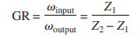
The cycloid profile was mathematically generated using the equations below in Creo Parametric.
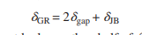

Appendix H: Risk Assessment
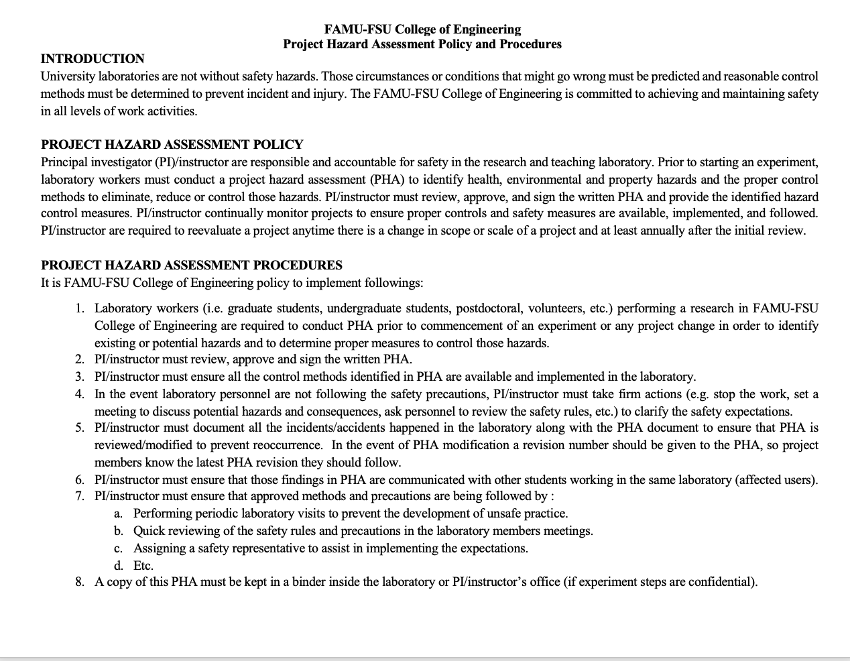
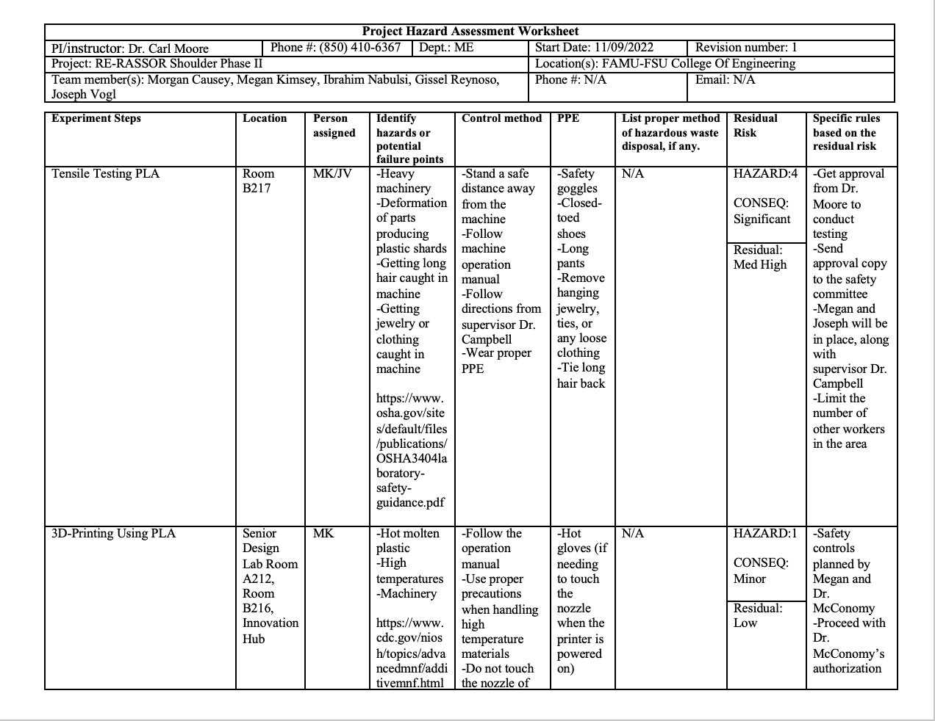

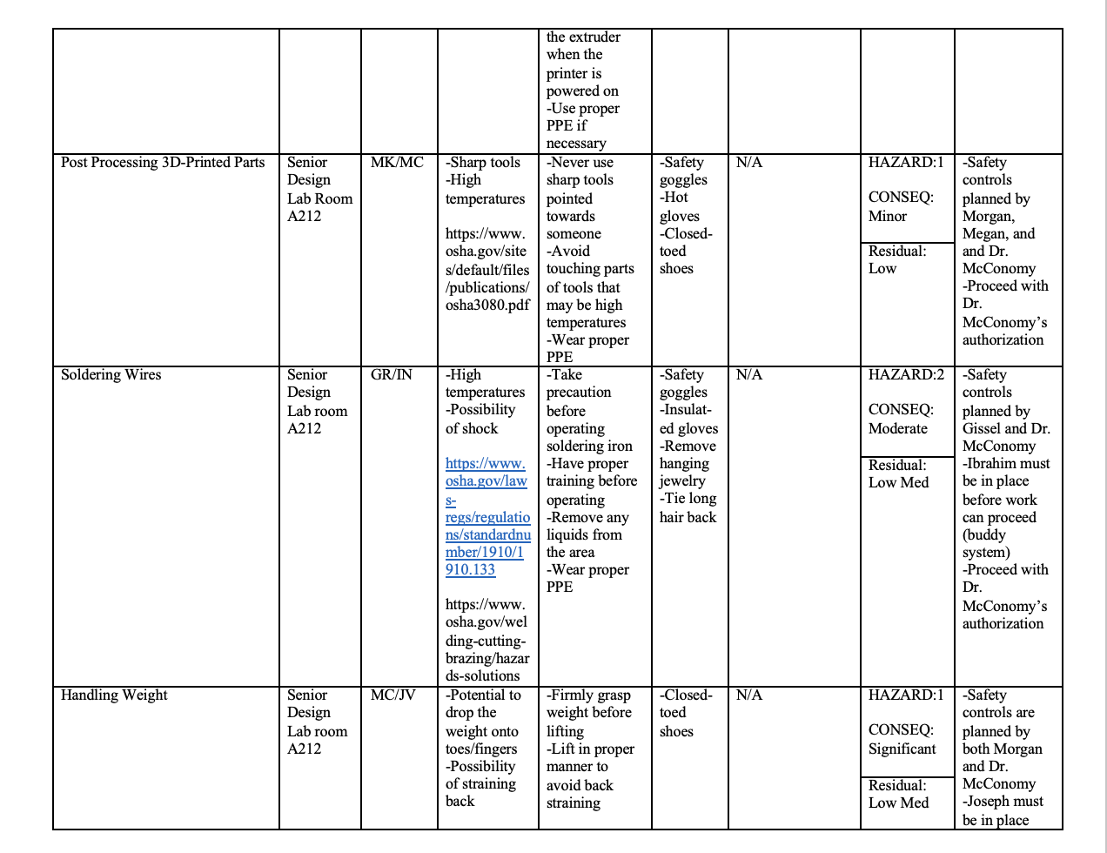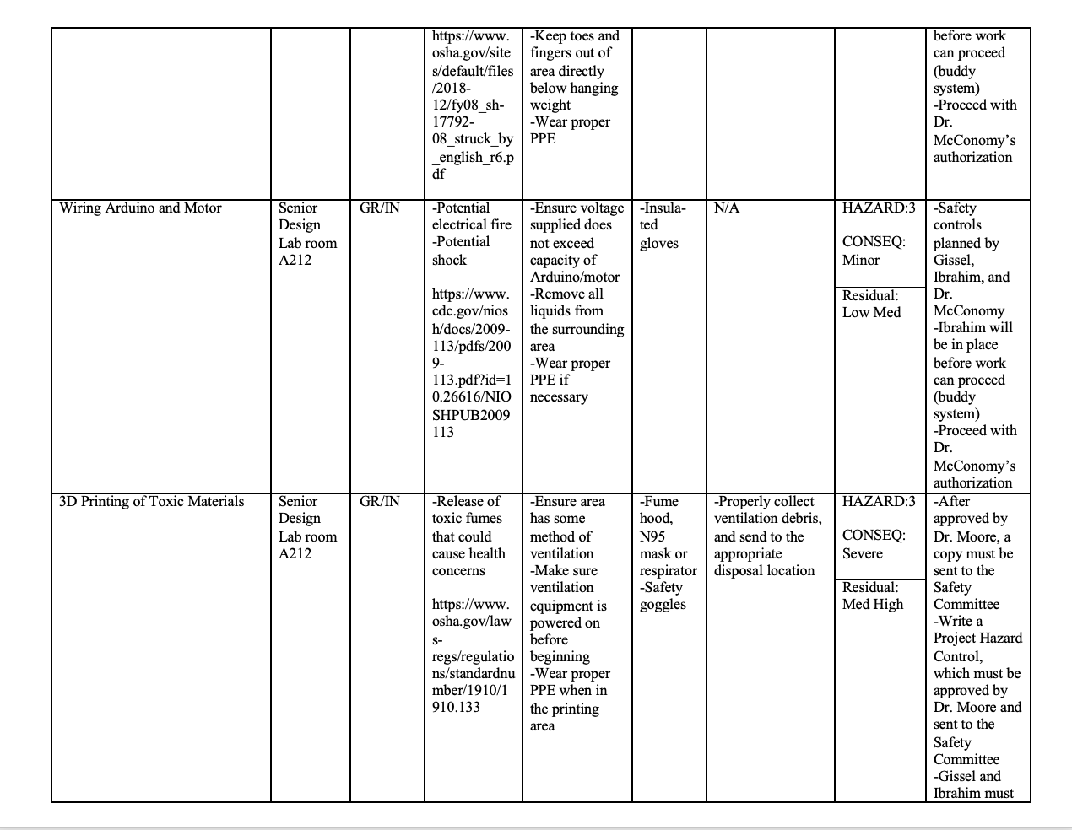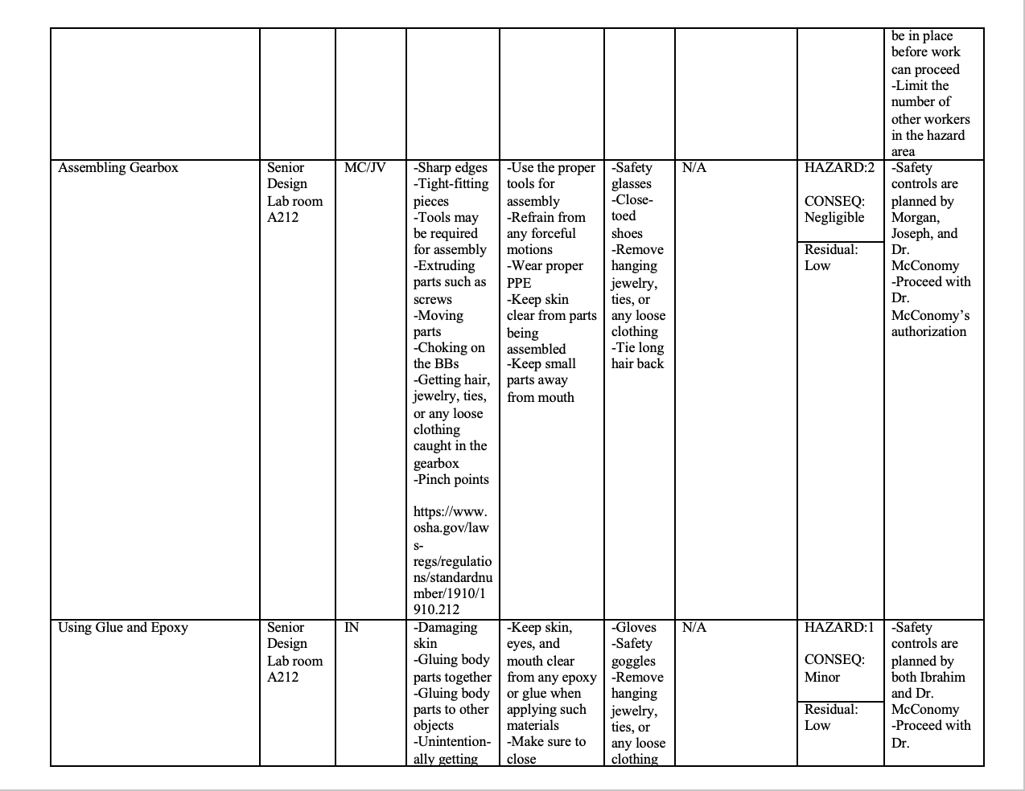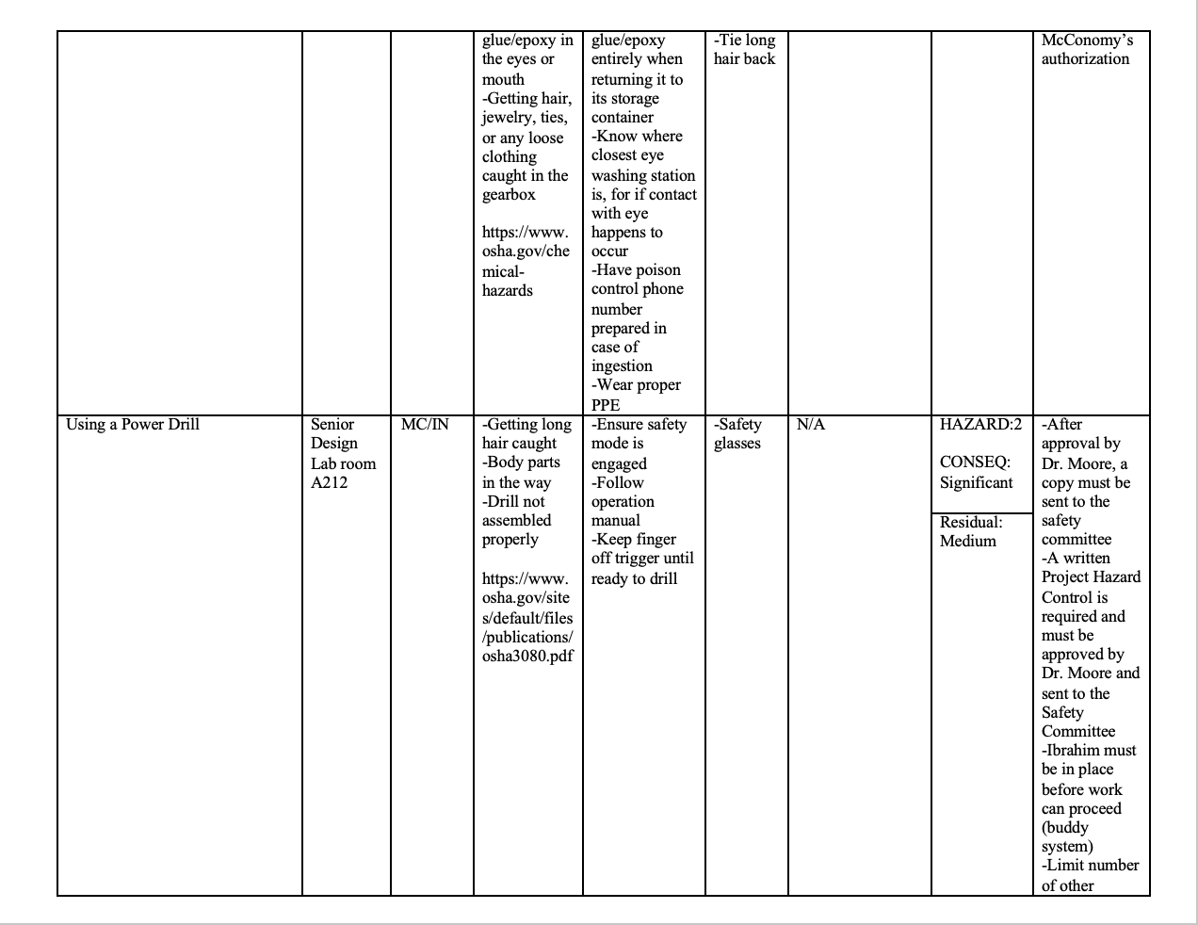
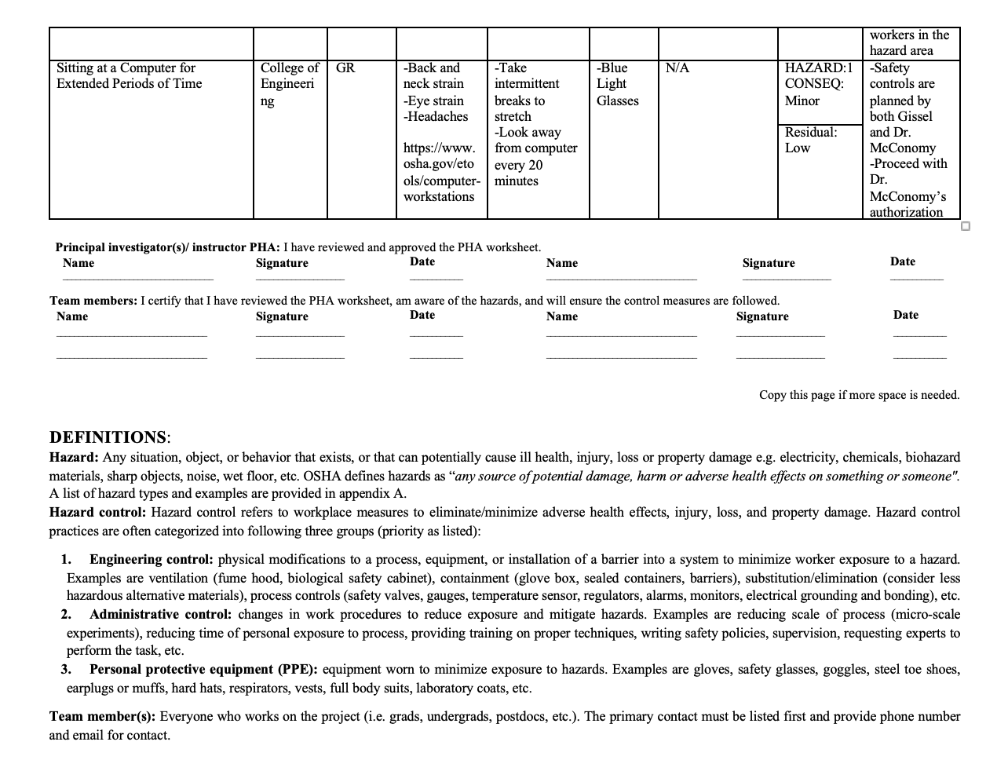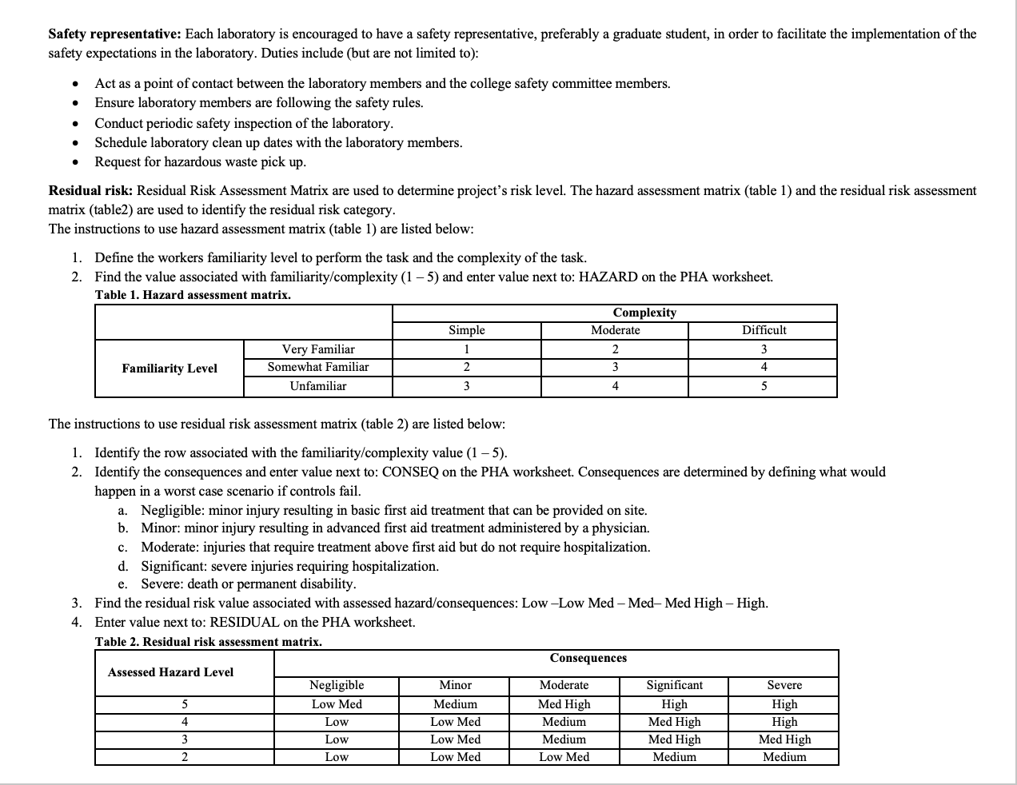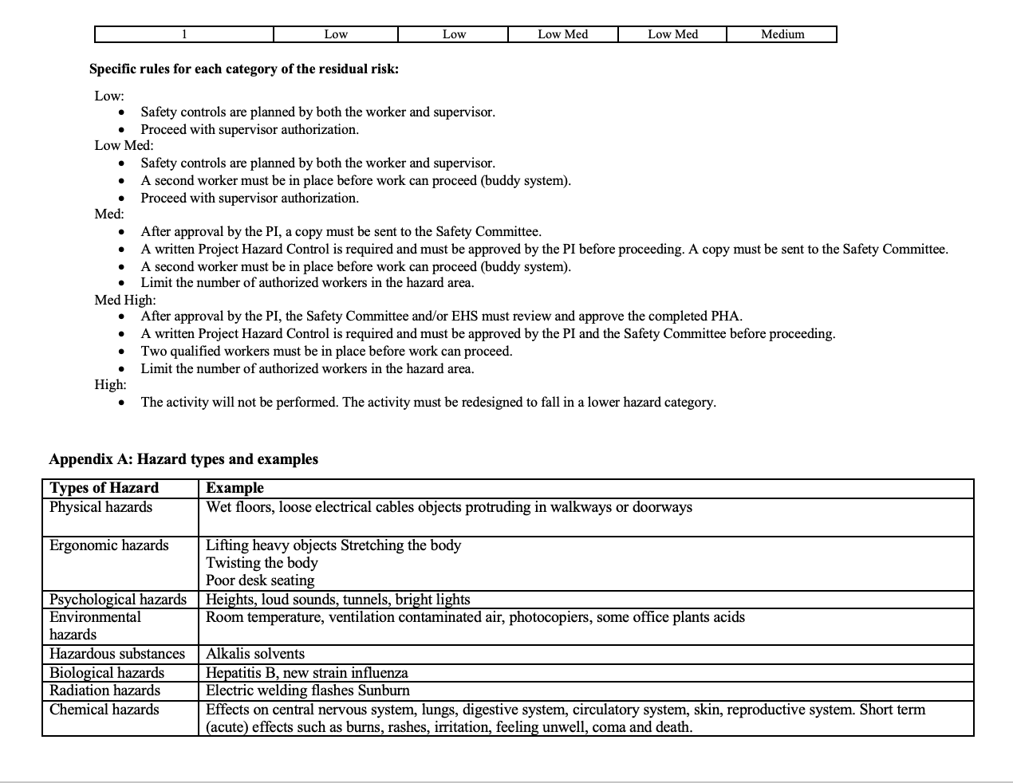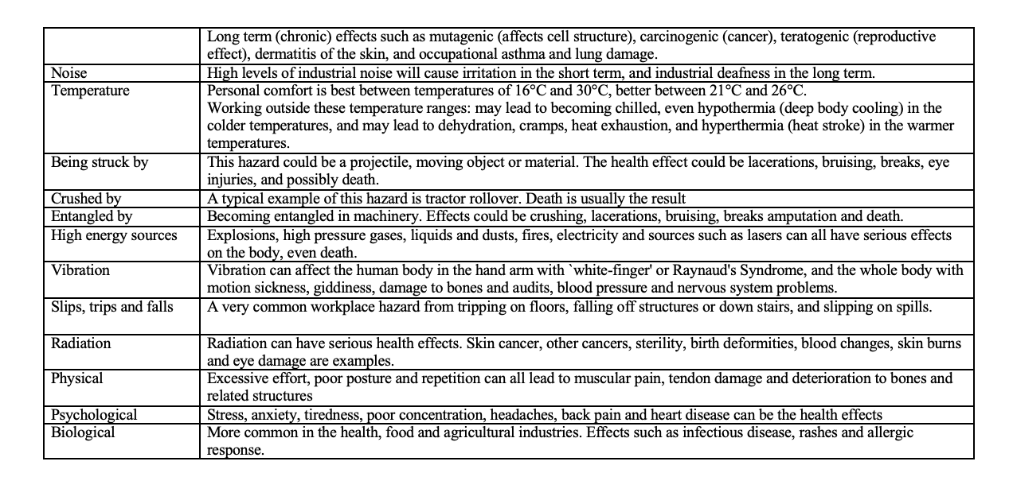
Project Hazard Control- For Projects with Medium and Higher Risks
Name of Project: RE-RASSOR Phase II |  |  |  | Date of submission:
Team Member |  | Phone Number |  | E-mail
Morgan Causey |  | (601) 940-0750 |  | mpc18d@fsu.edu
Megan Kimsey |  | (813) 368-4436 |  | mek18@fsu.edu
Ibrahim Nabulsi |  | (850) 405-4212 |  | ikn18@fsu.edu
Gissel Reynoso |  | (863) 651-4688 |  | gsr20b@fsu.edu
Joseph Vogl |  | (954) 232-8385 |  | jcv17b@fsu.edu
Faculty Mentor |  | Phone Number |  | E-mail
Dr. Carl Moore |  | (850) 410-6367 |  | camoore@eng.famu.fsu.edu
Rewrite the project steps to include all safety measures taken for each step or combination of steps. Be specific (don’t just state “be careful”).
For tensile testing of PLA, members of the group will wear appropriate attire for the lab, which includes closed toe shoes, long pants, tied back long hair, and jewelry will be taken off if it poses a risk of getting caught on anything. Furthermore, proper PPE will be worn during the tests and all tests must happen under the supervision of Dr. Campbell. When 3D printing, all members will wait for the nozzle to cool down before removing parts from the printing bed. However, if something needs to be done to the print bed or the nozzle while it is powered on and hot, the member must wear hot gloves. When post-processing 3D printed parts, members of the group will wear safety goggles, hot gloves, and lab attire. While using a soldering iron, each member will wear safety goggles, appropriate lab attire, and insulated gloves to prevent an accidental burn or shock. Since this project deals with lifting heavy weights, a procedure will be followed to safely lift the weight without causing strain and harm to the user or others around them. Wiring the Arduino will require a power source where all members will ensure the voltage provided by the power source does not exceed the capacity of the Arduino or motor. If 3D printing of toxic materials were to occur, all members are to wear proper lab attire, PPE (which includes a mask, gloves, and safety goggles). Additionally, the material will be properly ventilated and disposed of. While assembling the gearbox all members must wear lab attire and proper PPE, which includes safety goggles. For this project, the use of glue or epoxy may be necessary, and if used, all members again must wear proper lab attire, and proper PPE, which includes gloves and safety goggles. In the case that a power drill is used, all members will wear lab attire and safety glasses or goggles.
Thinking about the accidents that have occurred or that you have identified as a risk, describe emergency response procedures to use.
In the case of getting debris or other material in an eye, team members will rinse their eyes with water in a wash station. In the instance that the user burns themselves with the soldering iron, depending on the severity of the burn, the user will rinse their burn with lukewarm water and will apply burn cream. If the severity of the burn is high, the member will seek medical attention. All other injuries related to using tools such as the power drill, glue, and 3D printers will be evaluated; if there is small injury, a first aid kit will be utilized. However, if it is a more severe injury, members will seek medical attention.

List emergency response contact information:
- Call 911 for injuries, fires or other emergency situations
- Call your department representative to report a facility concern
Name | Phone Number |  | Faculty or Other Emergency Contact |  | Phone Number
Morgan Causey | (601) 940-0750 |  | Dr. Carl Moore |  | (850) 410-6367
Megan Kimsey | (813) 368-4436 |  | Dr. Shayne McConomy |  | (850) 410-6624
Ibrahim Nabulsi | (850) 405-4212 |  | Jared White |  | (561) 768-3722
Gissel Reynoso | (863) 651-4688
Joseph Vogl | (954) 232-8385

Report all accidents and near misses to the faculty mentor.

References
[1] Re-rassor rover. Florida Space Grant Consortium. (n.d.). Retrieved April 17, 2023, from https://floridaspacegrant.org/program/re-rassor/
[2] YouTube. (2022, October 30). 24 Hour torture test of thin PLA 3D printed bearings (200mm inner diameter down to 5mm). YouTube. Retrieved April 16, 2023, from https://www.youtube.com/watch?v=Pj2N08Fq3bA
[3] Mahipal D. Dabhi, Hardik J. Bhatt, Prasant Pandya. (2019). Design and Development of Harmonic Drive for Shredder Machine to Achieve Higher Gear Ratio up to 750:1. IJESC.
[4] Eloy Yague-Spaude. (2021). Computational Design, Simulation of Meshing, and Stress Analysis of Strain Wave Gear Drives. RIT Scholar Works.
[5] Jonathon W. Sensinger. (2010). Unified Approach to Cycloid Drive Profile, Stress, and Efficiency Optimization. ASME.

